UNITED STATES
SECURITIES AND EXCHANGE COMMISSION
Washington, D.C. 20549
SCHEDULE 14A
Proxy Statement Pursuant to Section 14(a) of the
Securities Exchange Act of 1934
(Amendment No. )
Filed by the Registrant ☒
Filed by a Party other than the Registrant ☐
Check the appropriate box:
☐Preliminary Proxy Statement
☐Confidential, for Use of the Commission Only (as permitted by Rule 14a-6(e)(2))
☒Definitive Proxy Statement
☐Definitive Additional Materials
☐Soliciting Material Pursuant to §240.14a-12
Matador Resources Company
(Name of Registrant as Specified In Its Charter)
(Name of Person(s) Filing Proxy Statement, if other than the Registrant)
Payment of Filing Fee (Check the appropriate box):
☒No fee required.
☐Fee paid previously with preliminary materials.
☐Fee computed on table in exhibit required by Item 25(b) per Exchange Act Rules 14a-6(i)(1) and 0-11

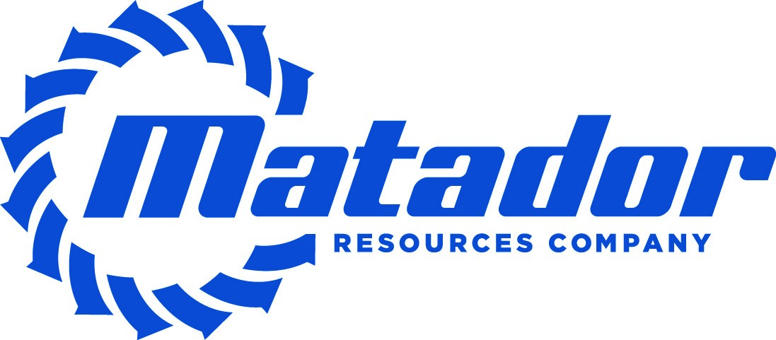 | 2025
Notice of Annual Meeting of Shareholders
and
 | Proxy Statement
June 12, 2025 | Dallas, Texas

One Lincoln Centre
5400 LBJ Freeway, Suite 1500
Dallas, Texas 75240
www.matadorresources.com
NOTICE OF ANNUAL MEETING OF SHAREHOLDERS
To Be Held on June 12, 2025
To the Matador Resources Company Shareholders:
Please join us for the 2025 Annual Meeting of Shareholders of Matador Resources Company. The meeting will be held at
The Westin Galleria Dallas, Fort Worth Ballroom, 13340 Dallas Parkway, Dallas, Texas 75240, on Thursday, June 12,
2025, at 9:30 a.m., Central Daylight Time.
At the meeting, you will hear a report on our business and act on the following matters:
(1)Election of the four nominees for director named in the attached Proxy Statement;
(2)Advisory vote to approve the compensation of our named executive officers as described in
the attached Proxy Statement;
(3)Ratification of the appointment of KPMG LLP as the Company’s independent registered
public accounting firm for the year ending December 31, 2025; and
(4)Any other matters that may properly come before the meeting.
All shareholders of record at the close of business on April 16, 2025 are entitled to vote at the meeting or any
postponement or adjournment of the meeting. A list of the shareholders of record is available at the Company’s
offices in Dallas, Texas.
By Order of the Board of Directors,
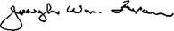
Joseph Wm. Foran
Chairman and Chief Executive Officer
April 28, 2025
YOUR VOTE IS IMPORTANT!
Whether or not you will attend the meeting, please vote as promptly as possible by using the Internet
or telephone or by signing, dating and returning your proxy card to the address listed on the card.
Important Notice Regarding the Availability of Proxy Materials for the
Annual Meeting of Shareholders to Be Held on June 12, 2025:
Our Proxy Statement and the Annual Report to Shareholders for the fiscal year ended December 31, 2024 are
available for viewing, printing and downloading at https://materials.proxyvote.com/576485.
2025 Proxy Statement | Matador Resources Company1

TABLE OF CONTENTS
TABLE OF CONTENTS
 | Page |  | Page
Proxy Statement | 2 | Letter to Shareholders | 46
Proxy Summary | 4 | Executive Compensation | 47
Information About the Annual Meeting | 9 | Compensation Discussion and Analysis | 47
Proposal 1 | Election of Directors | 13 | Strategic Planning and Compensation Committee Report | 65
Director Skills & Experience | 13 | Summary Compensation Table | 65
Nominees | 14 | Grants of Plan-Based Awards Table | 65
Vote Required | 17 | Outstanding Equity Awards at December 31, 2024 | 67
Directors Continuing in Office | 18 | Option Exercises and Stock Vested | 68
Corporate Governance | 24 | Potential Payments upon Termination or Change in  Control | 69
Independence of Directors | 24 | Chief Executive Officer Pay Ratio | 73
Majority Vote in Director Elections | 25 | Pay Versus Performance | 74
Board Leadership Structure | 25 | Director Compensation | 78
Board Committees | 27 | Compensation for 2024-2025 | 79
Board's Role in Risk Oversight | 32 | Director Stock Ownership Guidelines | 79
Environmental, Social and Governance Practices | 32 | Equity Compensation Plan Information | 80
Shareholder Engagement | 34 | Transactions with Related Persons | 81
Communications with Directors | 34 | Security Ownership of Certain Beneficial Owners and  Management | 85
Strategic Planning and Compensation Committee  Interlocks and Insider Participation | 35 | Additional Information | 87
Executive Officers and Other Senior Officers of the  Company | 35 | Shareholder Proposals for the 2026 Proxy Statement | 87
Proposal 2 | Advisory Vote to Approve Named Executive  Officer Compensation | 42 | Director Nominations or Other Business for Presentation  at the 2026 Annual Meeting | 87
Vote Required | 42 | Annual Report on Form 10-K | 87
Proposal 3 | Ratification of the Appointment of KPMG LLP | 43 | Other Business | 88
Fees of Independent Registered Public Accounting Firm  for Fiscal Years 2024 and 2023 | 43 | Annex A Non-GAAP Financial Measures | 89
Report of the Audit Committee | 44
Vote Required | 45
2Matador Resources Company | 2025 Proxy Statement

PROXY STATEMENT
Matador Resources Company
One Lincoln Centre
5400 LBJ Freeway, Suite 1500
Dallas, Texas 75240
www.matadorresources.com
PROXY STATEMENT For
ANNUAL MEETING OF SHAREHOLDERS
To Be Held on June 12, 2025
This Proxy Statement is being mailed on or about April 28, 2025 to the shareholders of Matador Resources Company
(“Matador” or the “Company”) in connection with the solicitation of proxies by the Board of Directors (the “Board”) of the
Company to be voted at the Annual Meeting of Shareholders of the Company to be held at The Westin Galleria Dallas,
Fort Worth Ballroom, 13340 Dallas Parkway, Dallas, Texas 75240, on June 12, 2025, at 9:30 a.m., Central Daylight Time
(the “Annual Meeting” or the “2025 Annual Meeting”), or at any postponement or adjournment thereof, for the purposes set
forth in the accompanying Notice of Annual Meeting of Shareholders. The address of the Company’s principal executive
office is One Lincoln Centre, 5400 LBJ Freeway, Suite 1500, Dallas, Texas 75240.
If you are a shareholder of record, you may vote in person by attending the meeting, by completing and returning a proxy
by mail or by using the Internet or telephone. You may vote your proxy by mail by marking your vote on the enclosed
proxy card and following the instructions on the card. To vote your proxy using the Internet or telephone, see the
instructions on the proxy form and have the proxy form available when you access the Internet website or place your
telephone call.
The named proxies will vote your shares according to your directions. If you sign and return your proxy but do not make
any of the selections, the named proxies will vote your shares: (i) FOR the election of the four nominees for director as set
forth in this Proxy Statement, (ii) FOR the approval, on an advisory basis, of the compensation of the Company’s named
executive officers as disclosed in this Proxy Statement and (iii) FOR the ratification of KPMG LLP as the independent
registered public accounting firm of the Company for the year ending December 31, 2025. Your proxy may be revoked at
any time before it is exercised by filing with the Company a written revocation addressed to the Corporate Secretary, by
executing a proxy bearing a later date or by attending the Annual Meeting and voting in person.
The cost of soliciting proxies will be borne by the Company. In addition to the use of postal services and the Internet,
proxies may be solicited by directors, officers and employees of the Company (none of whom will receive any additional
compensation for any assistance they may provide in the solicitation of proxies) in person or by telephone.
The outstanding voting securities of the Company consist of issued and outstanding common stock, par value $0.01 per
share (the “Common Stock”). The record date for the determination of the shareholders entitled to notice of and to vote at
the Annual Meeting, or any postponement or adjournment thereof, has been established by the Board as the close of
business on April 16, 2025 (the “Record Date”). As of the Record Date, there were 125,201,846 shares of Common Stock
outstanding and entitled to vote.
The presence, in person or by proxy, of the holders of record of a majority of the outstanding shares entitled to vote is
necessary to constitute a quorum for the transaction of business at the Annual Meeting, but if a quorum should not be
present, the meeting may be adjourned from time to time until a quorum is obtained. A holder of Common Stock will be
entitled to one vote per share on each matter properly brought before the meeting. Cumulative voting is not permitted in
the election of directors.
The proxy card provides space for a shareholder to abstain with respect to any or all nominees for the Board. The
affirmative vote of a majority of the votes cast by holders of shares present in person or represented by proxy and entitled
to vote on the election of directors at the Annual Meeting is required for the election of each nominee for director. With
respect to the election of directors in an uncontested election, such as that being held at the Annual Meeting, “majority of
the votes cast” means the number of votes cast “for” the election of such nominee exceeds the number of votes cast
“against” such nominee. See “Corporate Governance—Majority Vote in Director Elections” for additional information
regarding election of directors.
The other proposals require the affirmative vote of a majority of the shares of Common Stock present in person or
represented by proxy and entitled to vote at the meeting. Shares held by a shareholder who abstains from voting on any
2025 Proxy Statement | Matador Resources Company3
or all proposals will be included for the purpose of determining the presence of a quorum. Other than with respect to the
election of directors, an abstention will effectively count as a vote cast against the remaining proposals. Broker non-votes
on any matter as to which the broker has indicated on the proxy that it does not have discretionary authority to vote will be
treated as shares not entitled to vote with respect to that matter. However, such shares will be considered present and
entitled to vote for quorum purposes so long as they are entitled to vote on at least one other matter.
4Matador Resources Company | 2025 Proxy Statement

PROXY SUMMARY
This summary highlights information contained elsewhere in this Proxy Statement. This summary does not contain all of
the information that you should consider, and you should read the entire Proxy Statement carefully prior to voting. For
more complete information regarding our 2024 performance, please review our Annual Report on Form 10-K for the year
ended December 31, 2024.
2025 Annual Meeting of Shareholders
DATE AND TIME |  | LOCATION |  | RECORD DATE |  | VOTING
June 12, 2025 at 9:30 a.m.,  Central Daylight Time |  | The Westin Galleria Dallas  Fort Worth Ballroom  13340 Dallas Parkway  Dallas, Texas 75240 |  | April 16, 2025 |  | Shareholders as of the close  of business on the Record  Date are entitled to vote. Each  share of Common Stock is  entitled to one vote at the  Annual Meeting.
Proposal | Board Recommendation
Election of Four Director Nominees (page 13) | FOR
Advisory Vote to Approve Named Executive Officer Compensation (page 42) | FOR
Ratification of the Appointment of KPMG LLP as the Company’s Independent Registered Public  Accounting Firm for 2025 (page 43) | FOR
2024 Business Highlights
We are pleased to report that 2024 was another exceptional year for Matador, including record operational and financial
results, a growing Delaware Basin acreage position, record proved oil and natural gas reserves and a fixed dividend that
increased again in 2024.
Acquisition and Integration of Ameredev
A key highlight in 2024 was the acquisition of Ameredev Stateline II, LLC ("Ameredev") from affiliates of EnCap
Investments L.P. (“EnCap”) for cash consideration of approximately $1.8 billion, which amount is subject to customary
post-closing adjustments (the “Ameredev Acquisition”). The Ameredev Acquisition added approximately 33,500 contiguous
net acres in the core of the northern Delaware Basin, provided a significant increase in our drilling inventory with 431
gross (371 net) operated locations, including prospective targets throughout the Wolfcamp and Bone Spring formations,
and more than 25,000 BOE per day in production. Since closing the transaction on September 18, 2024, we have been
hard at work integrating the Ameredev properties, and our efforts have already resulted in at least $4 million in drilling and
completion cost synergies. Over the next five years, we expect additional drilling and completion cost synergies of over
$150 million. In addition, we estimate that we have reduced lease operating expenses on the Ameredev acreage by 35%,
or more than $2 million per month, since we began operating the Ameredev assets. The Ameredev Acquisition also
included an approximate 19% equity interest in the parent company of Piñon Midstream, LLC (“Piñon”). Piñon was
acquired by Enterprise Products Partners L.P. on October 28, 2024, and Matador received approximately $115 million
from its share of the sale proceeds in 2024.
2025 Proxy Statement | Matador Resources Company5
Growing Midstream Business
In addition to significant upstream growth, our midstream business remains a critical part of Matador's success. In
December 2024, Matador contributed Pronto Midstream, LLC ("Pronto") to San Mateo Midstream, LLC ("San Mateo"),
which resulted in Matador receiving $219.8 million in cash and the ability to earn up to $75 million in additional
performance incentives (the "Pronto Transaction"). The Pronto Transaction included Pronto's interest in its existing Marlan
natural gas processing plant (the "Marlan Plant") with a designed inlet capacity of 60 million cubic feet per day of natural
gas. The Marlan Plant expansion will add an additional plant with a designed inlet capacity of 200 million cubic feet of
natural gas per day. The Marlan Plant expansion remains on time and on budget and is expected to be online in the
second quarter of 2025. In addition to the financial benefits mentioned above, the Pronto Transaction also provides
increased flow assurance for Matador’s production, primarily in Lea County, New Mexico, and accelerates filling the
Marlan Plant to capacity.
Operational Highlights
Matador achieved record growth in 2024 while continuing to demonstrate excellence in capital efficiency improvement and
technical innovation.
Production Growth
33% |  | 26% |  | 30%
increase in oil  production |  | increase in natural gas  production |  | increase in average  daily oil equivalent  production
Matador's operational highlights included:
•A 33% increase in oil production to a record 36.5 million barrels (“Bbl”) of oil produced in 2024 from 27.5 million Bbl of
oil produced in 2023.
•A 26% increase in natural gas production to a record 155.8 billion cubic feet (“Bcf”) of natural gas produced in 2024
from 123.4 Bcf of natural gas produced in 2023.
•A 30% increase in average daily oil equivalent production to a record 170,751 BOE per day, including 99,808 Bbl of oil
per day and 425.7 million cubic feet (“MMcf”) of natural gas per day, in 2024, from 131,813 BOE per day, including
75,457 Bbl of oil per day and 338.1 MMcf of natural gas per day, in 2023.
•Continued drilling of longer laterals, with an average completed lateral length for operated wells turned to sales in
2024 of approximately 9,300 feet.
•Capital expenditures for drilling, completing and equipping wells (“D/C/E capital expenditures”) for 2024 of $1.32
billion, which was within our estimated range for 2024 D/C/E capital expenditures of $1.15 billion to $1.35 billion as
provided on October 22, 2024.
•Increased efficiencies and capital savings through the introduction of “trimul-frac” operations and continued use of
“simul-frac” operations.
6Matador Resources Company | 2025 Proxy Statement
Capital Resources and Financial Highlights
Matador finished 2024 in the best financial shape in its history with nearly $1.6 billion in liquidity under the Company's
reserved-based lending credit facility (the "Credit Agreement") and a leverage ratio of 1.05x. As a result of this financial
strength and our commitment to return value to shareholders, in the fourth quarter of 2024, the Board of Directors
increased Matador’s annual dividend to $1.00 per year from its prior annual dividend of $0.80 per year.
Financial Strength
$1.6 Billion |  | $1.00 |  | 1.05x
Liquidity under our Credit  Agreement |  | annualized dividend per  share in the fourth quarter |  | Leverage Ratio
Matador's capital resources and financial highlights included:
•The generation of free cash flow in all four quarters of 2024.
•The amendment of our dividend policy in the fourth quarter of 2024, pursuant to which we increased the quarterly
cash dividend from $0.20 per share of Common Stock to $0.25 per share of Common Stock.
•The receipt of $219.8 million in special distributions from San Mateo as a result of the Pronto Transaction.
•The receipt of $23.8 million in performance incentives directly from Five Point Energy, LLC, our joint venture partner in
San Mateo ("Five Point").
•The underwritten public offering of 5,250,000 shares of Common Stock.
•The repurchase of all of the aggregate principal amount of approximately $699.2 million of outstanding senior notes
due 2026 (the "2026 Notes") through our cash tender offer and subsequent exercise of our optional redemption right
in April 2024.
•The issuance of $900.0 million in aggregate principal amount of our 6.50% senior notes due 2032 (the “2032 Notes”).
•The issuance of $750.0 million in aggregate principal amount of our 6.25% senior notes due 2033 (the “2033 Notes”).
•The spring and fall redeterminations under, and amendments of, our Credit Agreement to collectively (i) increase the
borrowing base to $3.25 billion, as compared to $2.50 billion at December 31, 2023, (ii) increase the elected
borrowing commitment to $2.25 billion, as compared to $1.325 billion at December 31, 2023, (iii) increase the
maximum facility amount to $3.50 billion, as compared to $2.00 billion at December 31, 2023, (iv) extend the maturity
date from October 31, 2026 to March 22, 2029 and (v) add five new banks to our lending group.
•The amendment of San Mateo's secured revolving credit facility (the "San Mateo Credit Facility") in November 2024 to
(i) increase the lender commitments from $535.0 million to $800.0 million, (ii) extend the maturity date from December
9, 2026 to November 26, 2029 and (iii) add six new banks to San Mateo’s lending group.
2025 Proxy Statement | Matador Resources Company7
Environmental, Social and Governance Practices (page 32)
At Matador, we are committed to creating long-term value in a responsible manner. Our aim is to reliably and profitably
provide the energy that society needs in a manner that is safe, protects the environment and is consistent with the
industry’s best practices and the highest applicable regulatory and legal standards. In alignment with this goal, Matador's
ESG-related initiatives are embedded into our operational plans and governance principles. Furthermore, they are
overseen and supported by senior management and the Board’s Environmental, Social and Corporate Governance
Committee. Each year we issue Matador’s Sustainability Report, which includes quantitative metrics aligned with
standards developed by the Sustainability Accounting Standards Board (“SASB”). For additional information on the
Company’s ESG-related efforts and performance, see “Corporate Governance—Environmental, Social and Governance
Practices” on page 32. Information included in our Sustainability Report is not incorporated into this Proxy Statement.
Director Nominees (page 14)
Our Board currently has 11 members and is divided into three classes of directors, designated Class I, Class II and Class
III. Directors are elected for three-year terms. The table below provides certain summary information about each nominee
for director named in this Proxy Statement:
Name | Age | Director  Since | Principal Occupation | Committee  Memberships
Shelley F. Appel | 35 | 2023 | Former Senior Investors Relations Officer and Mergers & Acquisitions  Manager, Royal Dutch Shell PLC | CM,MM,P
R. Gaines Baty* | 74 | 2016 | CEO, R. Gaines Baty Associates, Inc. | ESG,E,SPC
Paul W. Harvey* | 66 | 2025 | Former Chief Investment Officer, Vaquero Private Wealth | A,CM,MM
Susan M. Ward* | 66 | 2024 | Former Head, M&A and Commercial Finance, Shell Oil Company | A,ESG,MM,O,P
* | Independent Director
A | Audit Committee
CM | Capital Markets and Finance Committee
E | Executive Committee
ESG | Environmental, Social and Corporate Governance Committee
MM | Midstream and Marketing Committee
O | Operations and Engineering Committee
P | Prospect Committee
SPC | Strategic Planning and Compensation Committee
8Matador Resources Company | 2025 Proxy Statement
Executive Compensation Highlights (page 47)
Our Executive Compensation Philosophy
Our compensation program is designed to reward, in both the short term and the long term, performance that contributes
to the implementation of our business strategies, maintenance of our culture and values and achievement of our
objectives. We reward qualities that we believe help achieve our business strategies such as:
•teamwork;
•recruiting and mentoring future leaders within Matador to drive long-term shareholder value;
•individual performance in light of general economic and industry-specific conditions;
•relationships with shareholders and vendors;
•level of job responsibility;
•industry experience;
•general professional growth; and
•the ability to:
◦manage and enhance production from our existing assets;
◦explore new opportunities to increase oil and natural gas production;
◦identify and acquire additional acreage;
◦improve total shareholder returns;
◦increase year-over-year proved reserves;
◦control unit production costs; and
◦pursue midstream opportunities.
For a discussion of our executive compensation program, see “Executive Compensation—Compensation Discussion
and Analysis” beginning on page 47.
2025 Proxy Statement | Matador Resources Company9

INFORMATION ABOUT THE ANNUAL MEETING
We are furnishing you this Proxy Statement in connection with the solicitation of proxies by the Board to be used at the
Annual Meeting and any adjournment thereof. The Annual Meeting will be held on Thursday, June 12, 2025, at 9:30 a.m.,
Central Daylight Time. We are sending this Proxy Statement to our shareholders on or about April 28, 2025.
All references in this Proxy Statement to “we,” “our,” “us,” “Matador” or the “Company” refer to Matador Resources
Company, including our subsidiaries and affiliates.
What is the purpose of the Annual Meeting?
At the Annual Meeting, shareholders will act upon the following matters outlined in the Annual Meeting notice:
•the election of the four nominees for director named in this Proxy Statement;
•an advisory vote to approve the compensation of our named executive officers as described herein;
•the ratification of the appointment of KPMG LLP as the Company’s independent registered public accounting firm for
the year ending December 31, 2025; and
•any other matters that may properly come before the meeting.
What are the Board’s voting recommendations?
•FOR the election of the four nominees for director named in this Proxy Statement;
•FOR the approval, on an advisory basis, of the compensation of the Company’s named executive officers; and
•FOR the ratification of the appointment of KPMG LLP as the Company’s independent registered public accounting
firm for the year ending December 31, 2025.
Who is entitled to vote?
Shareholders as of the close of business on April 16, 2025 are eligible to vote their shares at the Annual Meeting. As of
the Record Date, there were 125,201,846 shares of our Common Stock outstanding. Each share of Common Stock is
entitled to one vote at the Annual Meeting.
Why did I receive a Notice Regarding the Internet Availability of Proxy Materials in the mail
instead of a full set of proxy materials?
Securities and Exchange Commission (“SEC”) rules allow companies to furnish proxy materials over the Internet. We
have elected to send a separate Notice of Internet Availability of Proxy Materials (the “Notice”) to most of our shareholders
instead of a paper copy of the proxy materials. This approach conserves natural resources and reduces the costs of
printing and distributing our proxy materials while providing shareholders with a convenient way to access our proxy
materials. Instructions on how to access the proxy materials over the Internet or to request a paper copy of proxy
materials, including a proxy card or voting instruction form, may be found in the Notice. In addition, shareholders may
request to receive future proxy materials in printed form by mail or electronically by email by following the instructions in
the Notice. A shareholder’s election to receive proxy materials by mail or email will remain in effect until the shareholder
terminates it.
10Matador Resources Company | 2025 Proxy Statement
How do I vote?
You may:
•attend the Annual Meeting and vote in person;
•dial the toll-free number listed on the Notice, proxy card or voting instruction form provided by your broker. Easy-to-
follow voice prompts allow you to vote your shares and confirm that your voting instructions have been properly
recorded. Telephone voting will be available 24 hours a day and will close at 11:59 p.m., Eastern Daylight Time, on
June 11, 2025;
•go to the website www.proxyvote.com and follow the instructions, then confirm that your voting instructions have been
properly recorded. If you vote using the website, you can request electronic delivery of future proxy materials. Internet
voting will be available 24 hours a day and will close at 11:59 p.m., Eastern Daylight Time, on June 11, 2025; or
•if you received a paper copy of your proxy materials and elect to vote by written submission, mark your selections on
the proxy card, date and sign it, and return the card in the pre-addressed, postage-paid envelope provided.
Why did I receive paper copies of proxy materials?
We are providing certain shareholders with paper copies of the proxy materials instead of a separate Notice. If you
received a paper copy and would no longer like to receive printed proxy materials, you may consent to receive all future
proxy materials electronically via email or the Internet. To sign up for electronic delivery, please follow the instructions
provided in your proxy materials. When prompted, indicate that you agree to receive or access shareholder
communications electronically in the future.
Will each shareholder in our household receive proxy materials?
Generally, no. To the extent you are receiving printed proxy materials, we try to provide only one set of proxy materials to
be delivered to multiple shareholders sharing an address, unless you have given us other instructions. Any shareholder at
a shared address may request delivery of single or multiple copies of printed proxy materials for future meetings by
contacting us at:
Matador Resources Company
Attention: Investor Relations
5400 LBJ Freeway, Suite 1500
Dallas, Texas 75240
Email: investors@matadorresources.com
Telephone: (972) 371-5200
We undertake to deliver promptly, upon written or oral request, a copy of proxy materials to a shareholder at a shared
address to which a single copy of the proxy materials was delivered. Requests should be directed to Investor Relations at
the address or phone number set forth above.
Who will be admitted to the Annual Meeting?
Admission to the Annual Meeting will be limited to our shareholders of record, persons holding proxies from our
shareholders, beneficial owners of our Common Stock and our employees. If your shares are registered in your name, we
will verify your ownership at the meeting in our list of shareholders as of the Record Date. If your shares are held through
a broker, bank or other nominee, you must bring proof of your ownership of the shares. This proof could consist of, for
example, a bank or brokerage firm account statement or a letter from your bank or broker confirming your ownership as of
the Record Date. You may also send proof of ownership to us at Matador Resources Company, Attention: Corporate
Secretary, 5400 LBJ Freeway, Suite 1500, Dallas, Texas 75240, or email: investors@matadorresources.com, before the
Annual Meeting, and we will send you an admission card.
2025 Proxy Statement | Matador Resources Company11
If I vote via telephone or the Internet or by mailing my proxy card, may I still attend the Annual
Meeting?
Yes.
What if I want to change my vote?
You may revoke your proxy before it is voted by submitting a new proxy with a later date (by mail, telephone or the
Internet), by voting at the Annual Meeting or by filing a written revocation with our Corporate Secretary. Your attendance at
the Annual Meeting will not automatically revoke your proxy.
What constitutes a quorum?
A majority of the shares entitled to vote, present in person or represented by proxy, constitutes a quorum. If you vote by
telephone or Internet or by returning your proxy card, you will be considered part of the quorum. The Inspector of Election
will treat shares represented by a properly executed proxy as present at the meeting. Abstentions and broker non-votes
will be counted for purposes of determining a quorum. A broker non-vote occurs when a nominee holding shares for a
beneficial owner submits a proxy but does not vote on a particular proposal because the nominee does not have
discretionary voting power for that item and has not received instructions from the beneficial owner.
How many votes will be required to approve a proposal?
The affirmative vote of a majority of the votes cast by holders of shares of Common Stock present in person or
represented by proxy and entitled to vote on the election of directors at the Annual Meeting is required for the election of
each nominee for director. With respect to the election of directors in an uncontested election, such as that being held at
the Annual Meeting, “majority of the votes cast” means the number of votes cast “for” such nominee exceeds the number
of votes cast “against” such nominee.
With respect to all other matters, the affirmative vote of the holders of a majority of the shares of Common Stock, present
in person or represented by proxy and entitled to vote at the Annual Meeting, is required.
Shares cannot be voted at the Annual Meeting unless the holder of record is present in person or represented by proxy.
Can brokers who hold shares in street name vote those shares if they have received no
instructions?
Under the rules of the New York Stock Exchange (“NYSE”), brokers may not vote the shares held by them in street name
for their customers and for which they have not received instructions, except with respect to a routine matter. The only
matter to be voted on at the Annual Meeting that is considered routine for these purposes is the ratification of the
appointment of our independent registered public accounting firm. Accordingly, brokers may not vote your shares on any
other matter if you have not given specific instructions as to how to vote. Please be sure to give specific voting instructions
to your broker so that your vote will be counted.
How will you treat abstentions and broker non-votes?
Shares of a shareholder who abstains from voting on any or all proposals will be included for the purpose of determining
the presence of a quorum. Other than with respect to the election of directors, an abstention will effectively count as a vote
cast against the remaining proposals. Broker non-votes on any matter, as to which the broker has indicated on the proxy
that it does not have discretionary authority to vote, will be treated as shares not entitled to vote with respect to that
matter. However, such shares will be considered present and entitled to vote for quorum purposes so long as they are
entitled to vote on at least one other matter.
12Matador Resources Company | 2025 Proxy Statement
Who pays the solicitation expenses?
We will bear the cost of solicitation of proxies. Proxies may be solicited by mail or personally by our directors, officers or
employees, none of whom will receive additional compensation for such solicitation. Those holding shares of Common
Stock of record for the benefit of others, or nominee holders, are being asked to distribute proxy soliciting materials to, and
request voting instructions from, the beneficial owners of such shares. We will reimburse nominee holders for their
reasonable out-of-pocket expenses.
Where can I find the voting results of the Annual Meeting?
We will announce preliminary voting results at the Annual Meeting, and we will publish final results in a Current Report on
Form 8-K that will be filed with the SEC within four business days of the Annual Meeting. You may obtain a copy of this
and other reports free of charge at www.matadorresources.com, by contacting our Investor Relations Department at (972)
371-5200 or investors@matadorresources.com or by accessing the SEC’s website at www.sec.gov.
Will the Company’s independent registered public accounting firm be available at the Annual
Meeting to respond to questions?
Yes. The Audit Committee of the Board has appointed KPMG LLP to serve as our independent registered public
accounting firm for the year ending December 31, 2025. Representatives of KPMG LLP will be present at the Annual
Meeting. They will have an opportunity to make a statement, if they desire to do so, and will be available to respond to
appropriate questions.
Where can I contact the Company?
Our mailing address is:
Matador Resources Company
Attention: Investor Relations
5400 LBJ Freeway, Suite 1500
Dallas, Texas 75240
Our telephone number is (972) 371-5200.
2025 Proxy Statement | Matador Resources Company13

PROPOSAL 1
PROPOSAL 1 | ELECTION OF DIRECTORS
The Board currently consists of 11 members and is divided into three classes of directors, designated Class I, Class II and
Class III, with the term of office of each director ending on the date of the third annual meeting following the annual
meeting at which such director’s class was elected. The number of directors in each class will be as nearly equal as
possible. The Class I directors are William M. Byerley, Monika U. Ehrman and Kenneth L. Stewart, the terms of whom will
each continue until the 2027 Annual Meeting of Shareholders or his or her earlier death, retirement, resignation or
removal. The Class II directors are Shelley F. Appel, R. Gaines Baty, Paul W. Harvey, James M. Howard and Susan M.
Ward. Each of Mmes. Appel and Ward and Messrs. Baty and Harvey is a Class II director nominee at the 2025 Annual
Meeting, in each case, to hold office until the 2028 Annual Meeting of Shareholders or his or her earlier death, retirement,
resignation or removal. Mr. Howard’s term will expire at the 2025 Annual Meeting. The Class III directors are Joseph Wm.
Foran, Reynald A. Baribault and Timothy E. Parker, the terms of whom will each continue until the 2026 Annual Meeting of
Shareholders or his earlier death, retirement, resignation or removal.
The Board believes that each of the director nominees possesses the qualifications described below in “Corporate
Governance—Board Committees—Nominating Committee.” That is, the Board believes that each nominee possesses:
•deep experience at the policy making level in business, government or education;
•the availability and willingness to devote adequate time to Board duties;
•the character, judgment and ability to make independent analytical, probing and other inquiries;
•a willingness to exercise independent judgment along with a willingness to listen and learn from others;
•business knowledge and experience that provides a balance with the other directors;
•financial independence; and
•excellent past performance on the Board.

Director Skills & Experience
 | Foran | Parker | Baty | Appel | Baribault | Byerley | Ehrman | Harvey | Howard | Stewart | Ward
Director Skills & Experience
Senior Leadership | • | • | • |  | • | • | • | • | • | • | •
Energy Industry | • | • |  | • | • | • | • |  | • | • | •
Finance & Accounting | • | • |  | • | • | • |  | • | • | • | •
Human Capital  Management | • | • | • |  | • | • | • | • |  | • | •
Legal, Regulatory &  Environmental | • | • |  | • | • | • | • |  |  | • | •
Risk Assessment &  Management | • | • | • | • | • | • | • | • | • | • | •
Strategic Planning | • | • | • | • | • | • | • | • |  | • | •
Corporate Governance &  Ethics | • | • | • | • | • | • | • | • | • | • | •
Capital Markets & M&A | • | • |  | • | • | • |  | • | • | • | •
Demographic Background
Board Tenure | 22 | 7 | 9 | 2 | 11 | 9 | 6 | 0 | 4 | 8 | 1
Age1 | 72 | 50 | 74 | 35 | 61 | 71 | 47 | 66 | 74 | 71 | 66
(1) As of April 16, 2025.
14Matador Resources Company | 2025 Proxy Statement

PROPOSAL 1
Nominees
The information provided below is biographical information about each of the nominees, as well as a description of the
experience, qualifications, attributes or skills that led the Board to conclude that the individual should be nominated for
election as a director of the Company. No director currently holds any other directorships with public companies.

MS. SHELLEY F. APPEL | Former Senior Investors Relations Officer and Mergers &  Acquisitions Manager, Royal Dutch Shell PLC | Class II
 | Biographical Information:
Ms. Appel was appointed to the Board in 2023 after serving as a Special Advisor
to the Board since October 2022. Since January 2021, Ms. Appel has also served
as Matador’s ESG Coordinator. As ESG Coordinator, Ms. Appel is the primary
author of the Company’s annual sustainability report. Following her graduation
from business school at the University of Chicago, Ms. Appel joined Royal Dutch
Shell PLC in August 2017 in the Mergers & Acquisitions group, where she served
as a manager with responsibility for financial analysis—including valuation,
structuring, negotiation and due diligence—for over $18 billion of acquisition and
divestment opportunities. In December 2019, Ms. Appel was promoted to Senior
Investor Relations Officer. In this role, Ms. Appel had responsibility for Shell’s
global Upstream business narrative. She also served as an authorized
spokesperson for Shell at investor meetings and conferences and managed
relationships with North America based investors and research analysts. Following
graduation from Yale and prior to attending the University of Chicago, Ms. Appel
began her career at the parent company of the New York Stock Exchange, NYSE
Euronext, as a business analyst in its Corporate Strategy group. She participated
in the evaluation and implementation of its $11 billion merger with the
Intercontinental Exchange Group and continued in the Corporate Strategy group
of the combined company until June 2015. Ms. Appel holds a Bachelor of Arts
degree, with honors, in Cognitive Science from Yale University and a Master of
Business Administration degree from the Booth School of Business (University of
Chicago). Ms. Appel served as Co-Chair of the Energy Group while attending the
University of Chicago.
Director
Director since: 2023
Independent: No
Age: 35
Committees:
•Capital Markets and Finance
•Marketing and Midstream
•Prospect
 | Qualifications:
Ms. Appel’s extensive knowledge and experience with the Company’s ESG
initiatives and investor relations experience provides the Board valuable insight
and leadership on these matters.
2025 Proxy Statement | Matador Resources Company15

MR. R. GAINES BATY | CEO, R. Gaines Baty Associates, Inc. | Class II
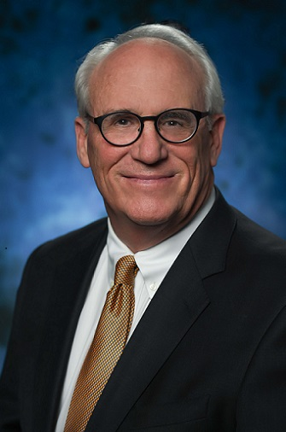 | Biographical Information:
Mr. Baty was appointed to the Board in 2016. He serves as deputy lead
independent director and is chair of the Board’s Strategic Planning and
Compensation Committee. Mr. Baty is CEO of R. Gaines Baty Associates, Inc., a
leading executive search firm he founded in 1982 after working with the IBM
Corporation. With over 30 years of experience, Mr. Baty has provided companies
across the country and in a variety of industries with executive search and
advisory services. Mr. Baty has served as a two-term President of the Society of
Executive Recruiting Consultants and a two-term President of the Independent
Recruiter Group. Mr. Baty is also a published author. Mr. Baty received a Bachelor
of Business Administration degree from Texas Tech University, where he was a
football team letterman, captain and, later, graduate assistant coach.
Deputy Lead Independent
Director since: 2016 | Qualifications:
Independent: Yes | Mr. Baty’s experience and expertise in executive leadership and development  provide our Board with an important and unique perspective on these matters, and  Mr. Baty assists the Board and the Company with recruitment, board  administration, compensation and growth strategies.
Age: 74
Committees:
•Strategic Planning and
Compensation (Chair)
•Executive
•Environmental, Social and
Corporate Governance
16Matador Resources Company | 2025 Proxy Statement

MR. PAUL W. HARVEY | Former Chief Investment Officer, Vaquero Private Wealth | Class II
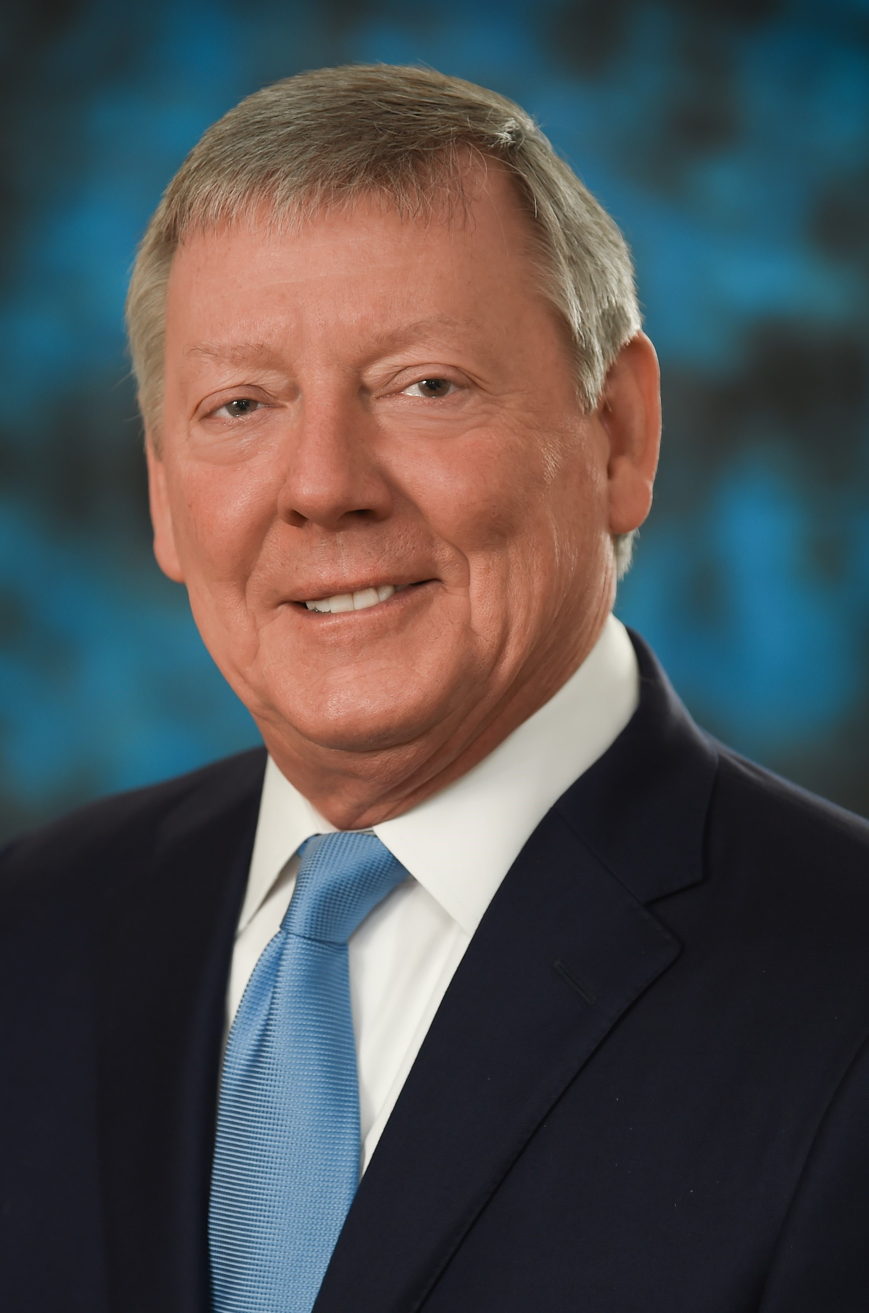 | Biographical Information:
Mr. Harvey was appointed to the Board in 2025. Mr. Harvey is a Private Wealth
Advisor and former Chief Investment Officer of Vaquero Private Wealth. Mr.
Harvey has more than four decades of investment experience as both a portfolio
manager and private wealth advisor with extensive experience in investment
selection, asset allocation and portfolio construction. Before joining Vaquero
Private Wealth, Mr. Harvey was a Managing Director of BlackRock, Inc., leading a
large team of investment professionals responsible for high-net-worth individuals
and institutions in twenty-nine states. In this capacity, he supported the design of
investment solutions that included multi-asset strategies combining active and
passive portfolios along with alternative investments. Previously, he served as
Regional Director and Portfolio Manager with Merrill Lynch Asset Management,
where he developed customized portfolios for individual clients and oversaw a
regional team of portfolio managers. Mr. Harvey earned his Master of Business
Administration degree with a concentration in Finance from Southern Methodist
University’s Cox School of Business and his Bachelor of Business Administration
degree in Finance from the University of Texas at Austin. He holds the Chartered
Financial Analyst designation and has earned the Certified Private Wealth Advisor
certification.
Director
Director since: 2025
Independent: Yes
Age: 66
Committees:
•Audit
•Capital Markets and Finance
•Marketing and Midstream
 | Qualifications:
Mr. Harvey's experience as an investment professional provides the Company
with valuable insight, particularly with respect to investor relations and capital
markets.
2025 Proxy Statement | Matador Resources Company17

MS. SUSAN M. WARD | Former Head, M&A and Commercial Finance, Shell Oil  Company | Class II
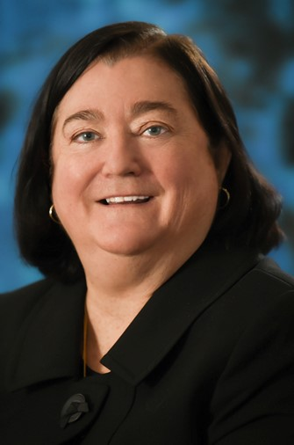 | Biographical Information:
Ms. Ward was appointed to the Board in 2024 and is co-chair of the Board's
Marketing and Midstream Committee. Ms. Ward is a former 12-year Senior
Executive of Shell Oil Company (“Shell”) with over 20 years of service at
retirement in 2019. Her senior roles at Shell included Head, M&A and Commercial
Finance for all of Shell’s businesses in the Americas; Vice President, Chief
Financial Officer and Board member of Shell Midstream Partners, which she
helped take public for Shell in 2014; and Vice President, Upstream Commercial
Finance, Shell International Exploration & Production B.V. while based in The
Hague for Royal Dutch Shell. She also served as a Board member of Shell’s
deepwater drillship joint venture with Noble Corporation. Ms. Ward has been an
independent, non-executive Board member of Crescent Midstream (“Crescent”)
since July 2023. Crescent is an independent energy company providing offshore
and onshore crude oil services in the Gulf of Mexico and Louisiana. She also
served as an Independent Director of publicly traded TransAlta Renewables
headquartered in Calgary, Canada from May 2021 until October 2023 when it was
purchased by its parent, TransAlta Corporation. Prior to joining Shell in 1998, Ms.
Ward worked as an investment banker in the energy sector for 11 years, including
as a Managing Director in the Natural Resources and Energy investment banking
group of UBS Securities. She began her career working for Exxon as a refining
process engineer and subsequently worked in Mobil’s Finance organization at its
New York City headquarters. Ms. Ward earned a Bachelor of Chemical
Engineering degree from Villanova University with honors and a Master of
Business Administration in Finance with distinction from the Wharton School of the
University of Pennsylvania. She has served on Villanova’s Board of Trustees since
2018. She has been a member of the National Association of Corporate Directors
since 2016.
Director
Director since: 2024
Independent: Yes
Age: 66
Committees:
•Audit
•Environmental, Social and
Corporate Governance
•Marketing and Midstream
(Co-Chair)
•Operations and Engineering
•Prospect
 | Qualifications:
Ms. Ward’s extensive experience as a senior executive in the energy industry and
midstream experience in particular provide our Board with industry, management
and leadership insight.

Vote Required
The affirmative vote of a majority of the votes cast by holders of shares present in person or represented by proxy and
entitled to vote on the election of directors at the Annual Meeting is required for the election of each nominee for director.
With respect to the election of directors in an uncontested election, such as that being held at the Annual Meeting,
“majority of the votes cast” means the number of votes cast “for” such nominee exceeds the number of votes cast
“against” such nominee. If you hold your shares through a broker and you do not instruct the broker how to vote, your
broker will not have the authority to vote your shares. Abstentions and broker non-votes will each be counted as present
for purposes of determining the presence of a quorum.
The Board of Directors recommends that you vote FOR each of the nominees.
18Matador Resources Company | 2025 Proxy Statement

PROPOSAL 1
Directors Continuing in Office
Biographical information for our directors who are continuing in office is provided below.

MR. JOSEPH WM. FORAN | Chairman and CEO, Matador Resources Company | Class III
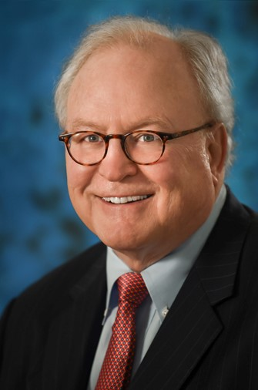 | Biographical Information:
Mr. Foran founded Matador Resources Company in July 2003 and since our
founding has served as Chairman of the Board and Chief Executive Officer and,
through March 31, 2022, Secretary. He is also chair of the Board’s Executive
Committee. Mr. Foran began his career as an oil and natural gas independent in
1983 when he and his wife, Nancy, founded Foran Oil Company with $270,000 in
contributed capital from 17 of his closest friends and neighbors. Foran Oil
Company was later contributed into Matador Petroleum Corporation upon its
formation by Mr. Foran in 1988, and Mr. Foran served as Chairman and Chief
Executive Officer of that company from inception until the time of its sale to Tom
Brown, Inc. in June 2003 for an enterprise value of $388 million in an all-cash
transaction on a Friday. On the following Monday, Mr. Foran founded Matador
Resources Company (Matador II). Today, Matador is one of the top 20 public
exploration and production companies in the country by market capitalization and
one of the top 10 oil and natural gas producers in New Mexico. Mr. Foran is
originally from Amarillo, Texas, where his family owned a pipeline construction
business. From 1980 to 1983, he was Vice President and General Counsel of J.
Cleo Thompson and James Cleo Thompson, Jr., Oil Producers, a large
independent producer. Prior to that time, he was a briefing attorney to Chief
Justice Joe R. Greenhill of the Supreme Court of Texas. Mr. Foran graduated with
a Bachelor of Science degree in Accounting from the University of Kentucky with
highest honors and a law degree from the Southern Methodist University Dedman
School of Law, where he was a Hatton W. Sumners scholar and the Leading
Articles Editor on the Southwestern Law Review. He is currently active as a
member of various industry and civic organizations, including his church and
various youth activities. In 2002, Mr. Foran was honored as the Ernst & Young
“Entrepreneur of the Year” for the Southwest Region. In 2015, he was inducted
into the University of Kentucky Gatton College of Business and Economics Hall of
Fame. In 2019, Mr. Foran received the SMU Dedman School of Law Distinguished
Alumni Award for Corporate Service and was named D CEO Magazine’s 2019
Upstream CEO of the Year. In 2020, he was inducted into the Philosophical
Society of Texas. He was also named to Institutional Investors’ All-American
Executive Team as one of the top chief executive officers in the Small Cap Energy
Division in 2021. In 2024, at D CEO Magazine’s Energy Awards ceremony, Mr.
Foran was awarded the prestigious Legacy Award for lifetime achievement.
Chairman of the Board
Director since: 2003
Independent: No
Age: 72
Committees:
•Executive (Chair)
•Capital Markets and Finance
•Operations and Engineering
•Prospect
 | Qualifications:
As the founder, Chairman of the Board and Chief Executive Officer of Matador
Resources Company, Mr. Foran provides Board leadership, industry experience
and long relationships with many of our shareholders.
2025 Proxy Statement | Matador Resources Company19

MR. REYNALD A. BARIBAULT | President and CEO, IPR Energy Partners LLC | Class III
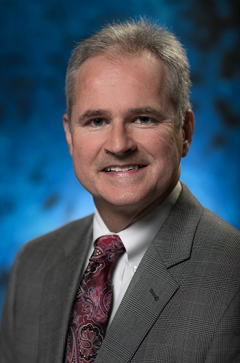 | Biographical Information:
Mr. Baribault was elected to the Board in 2014 and is chair of the Board’s
Operations and Engineering Committee and Prospect Committee. He served as
lead independent director of the Board from 2016 to 2019. In 2007, he co-founded
North Plains Energy, LLC, which operated in the North Dakota Williston Basin, and
served as its Vice President until the successful sale of its assets in 2012. In 2014,
Mr. Baribault helped co-found NP Resources, LLC, which also operated in the
North Dakota Williston Basin, and served as its Executive Vice President /
Engineering, helping oversee the sale of its assets in late 2021. In addition, he co-
founded and serves as President and Chief Executive Officer of IPR Energy
Partners, LLC, a Plano, Texas-based oil and natural gas production operator with
current operations in the Fort Worth Basin. As the President and CEO of IPR
Energy Partners, LLC, Mr. Baribault is tasked with specific risk management
responsibilities. Prior to co-founding North Plains Energy, NP Resources and IPR
Energy Partners, Mr. Baribault served as Vice President, Supervisor and
Petroleum Engineering Consultant with Netherland, Sewell & Associates, Inc. in
their Dallas office from 1990 to 2002. Mr. Baribault began his professional career
as a reservoir engineer with Exxon Company in 1985 in the New Orleans Eastern
Division Office. Mr. Baribault received his Bachelor of Science degree in
Petroleum Engineering from Louisiana State University in 1985 and is a Licensed
Professional Engineer in the State of Texas.
Director
Director since: 2014
Independent: Yes
Age: 61
Committees:
•Operations and Engineering
(Chair)
•Prospect (Chair)
•Audit
•Executive
•Nominating | Qualifications:
•Strategic Planning and  Compensation | Mr. Baribault provides valuable insight to our Board on our drilling, completions,  production and reservoir engineering operations, as well as growth strategies,  midstream operations and administration.
20Matador Resources Company | 2025 Proxy Statement

MR. WILLIAM M. BYERLEY | Retired Partner, PricewaterhouseCoopers LLP (PwC) | Class I
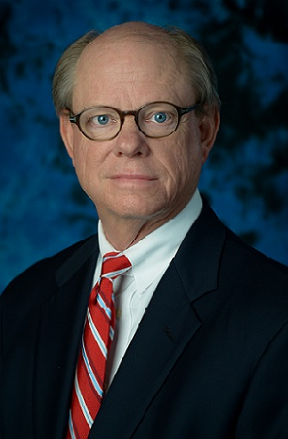 | Biographical Information:
Mr. Byerley was appointed to the Board in 2016 and is chair of the Board’s Audit
Committee. Mr. Byerley retired from PricewaterhouseCoopers LLP (PwC) in 2014.
From 1988 through 2014, Mr. Byerley was a Partner with PwC, serving as an
Assurance Partner on various audit engagements primarily for energy sector
clients. From 1988 through 1990, Mr. Byerley served in the PwC National Office
Accounting Services Group. Mr. Byerley received a Bachelor of Business
Administration degree in 1975 and a Master of Business Administration degree in
1976, both from Southern Methodist University. He is a licensed Certified Public
Accountant.
Director
Director since: 2016 | Qualifications:
Independent: Yes | Mr. Byerley’s extensive experience in public accounting and longtime service to  energy sector clients of PwC provide the Board with invaluable financial and  accounting expertise, particularly for oil and natural gas companies, as well as  strong accounting and financial oversight and risk management expertise.
Age: 71
Committees:
•Audit (Chair)
•Environmental, Social and
Corporate Governance
•Marketing and Midstream
•Executive (Ex Officio)
2025 Proxy Statement | Matador Resources Company21

MS. MONIKA U. EHRMAN | Professor of Law, Southern Methodist University Dedman  School of Law | Class I
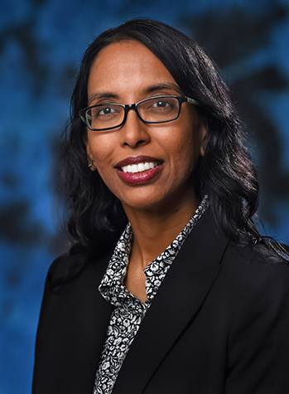 | Biographical Information:
Professor Ehrman was appointed to the Board in 2019 and is chair of the Board's
Environmental, Social and Corporate Governance Committee. She is Professor of
Law, Southern Methodist University Dedman School of Law, and a Professor of
Engineering (by courtesy), Southern Methodist University Lyle School of
Engineering. Prior to joining SMU, in 2023, she was Associate Professor of Law,
University of North Texas at Dallas College of Law and a tenured Professor of Law
at the University of Oklahoma College of Law, where she led the Oil & Gas,
Natural Resources, and Energy (ONE) Program and served as the Faculty
Director of the ONE Center. While at OU, she taught in the J.D. and graduate
programs at the College of Law and in the Executive Energy Management
Program at the Price College of Business. Professor Ehrman joined the University
of Oklahoma College of Law in 2013 as Associate Professor of Law. Prior to
teaching, she served as in-house legal counsel for two oil and natural gas
companies from 2008 to 2012 and as an associate oil and natural gas attorney at
an international law firm from 2005 to 2008. Before law school, Professor Ehrman
worked as a petroleum engineer in the upstream, midstream and pipeline sectors
of the energy industry. In addition to serving on various oil and natural gas law
committees, she also served as an Editor of the Oil and Gas Reporter for the
Institute for Energy Law. Professor Ehrman is currently Chair of the Association of
American Law Schools' Section on Natural Resources and Energy, a Trustee of
The Foundation for Natural Resources and Energy Law and she is on the Editorial
Board of the Journal of World Energy Law & Business (published by Oxford
University Press). Professor Ehrman received her Bachelor of Science degree in
Petroleum Engineering from the University of Alberta; J.D. from Southern
Methodist University Dedman School of Law; and Master of Laws degree from
Yale Law School.
Director
Director since: 2019
Independent: Yes
Age: 47
Committees:
•Environmental, Social and
Corporate Governance
(Chair)
•Marketing and Midstream
•Executive
•Nominating
•Operations and Engineering
•Prospect
•Strategic Planning and
Compensation
 | Qualifications:
Professor Ehrman provides valuable insight to our Board on our engineering and
midstream operations as well as legal and governance matters.
22Matador Resources Company | 2025 Proxy Statement

MR. TIMOTHY E. PARKER | Former Portfolio Manager and Analyst—Natural Resources,  T. Rowe Price & Associates | Class III
 | Biographical Information:
Mr. Parker was appointed to the Board in 2018, serves as lead independent
director and is chair of the Board’s Capital Markets and Finance Committee. Mr.
Parker currently serves as a contractor in charge of research for Brightworks
Wealth Management, LLC. Mr. Parker retired in 2017 as Portfolio Manager and
Analyst—Natural Resources for T. Rowe Price & Associates. Mr. Parker joined T.
Rowe Price in 2001 as an equity analyst before becoming a portfolio manager in
2010. He managed the New Era fund from 2010 to 2013 and managed the energy
and natural resources portions of T. Rowe Price’s Small Cap Value, Small Cap
Stock and New Horizons funds from 2013 to 2017. Prior to joining T. Rowe Price,
Mr. Parker was an investment banking analyst at Robert W. Baird & Co., Inc. Mr.
Parker holds a Bachelor of Science degree in Commerce from the University of
Virginia and a Master of Business Administration degree from the Darden School
of Graduate Business (University of Virginia).
Lead Independent Director
Director since: 2018
Independent: Yes
Age: 50
Committees: | Qualifications:
•Capital Markets and Finance  (Chair) | Mr. Parker’s experience with a large institutional shareholder and his extensive  familiarity with the oil and natural gas industry and capital markets provide the  Company with valuable insight.
•Audit
•Environmental, Social and
Corporate Governance
•Executive
•Nominating
•Prospect
•Strategic Planning and
Compensation
2025 Proxy Statement | Matador Resources Company23

MR. KENNETH L. STEWART | Retired EVP, Compliance and Legal Affairs, Children’s Health  System of Texas; Retired Partner, Chair—United States,  Norton Rose Fulbright US LLP | Class I
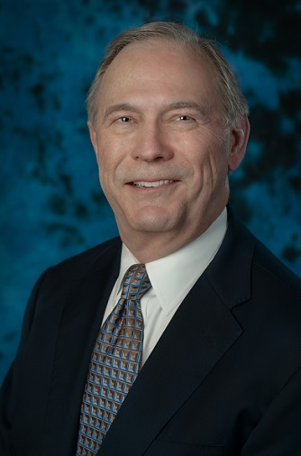 | Biographical Information:
Mr. Stewart was appointed to the Board in 2017 and is chair of the Board's
Nominating Committee and Shareholder Advisory Committee for Board
Nominations. Mr. Stewart was most recently employed as Executive Vice
President, Compliance and Legal Affairs, for Children’s Health System of Texas
from January 1, 2019 until he retired on January 2, 2021. At that time, Children’s
Health System of Texas and its affiliates constituted one of the ten largest
pediatric hospital systems in the United States. Previously, effective December 31,
2018, Mr. Stewart retired from Norton Rose Fulbright US LLP, the United States
operations of Norton Rose Fulbright, an international legal practice, which then
had over 3,700 legal professionals in over 50 cities worldwide. At his retirement,
Mr. Stewart was a Partner with Norton Rose Fulbright and held the position of
Chair—United States. Mr. Stewart began his legal career with Fulbright & Jaworski
LLP, the predecessor to Norton Rose Fulbright US LLP, and previously held
positions of Global Chair of the international organization, Managing Partner of the
United States region and Partner-in-Charge of the Dallas office. Prior to entering
into full-time management for his firm in 2012, he engaged in a domestic and
international transactional legal practice, focusing principally on merger,
acquisition, financing and joint venture activities for both public and privately-held
entities. Mr. Stewart has extensive experience representing and advising
companies and their executive officers and boards of directors engaged in oil and
natural gas exploration and midstream activities. Since his retirement from Norton
Rose Fulbright, Mr. Stewart has acted, and from time to time continues to act, on a
limited basis as an independent contractor senior business consultant to family
offices for which he provided services during his legal career. Mr. Stewart
graduated from the University of Arkansas School of Business in 1976 with a
Bachelor of Science in Business Administration degree in Accounting and was
licensed as a Certified Public Accountant in Texas in 1981 (certificate now on non-
practice status). He graduated with honors from Vanderbilt Law School in 1979
and was a member of the Order of the Coif. Mr. Stewart has been active in
numerous civic and professional organizations in the Dallas area in the past,
including among others, the Dallas Regional Chamber, The Center for American
and International Law and the Dallas Citizens Council.
Director
Director since: 2017
Independent: Yes
Age: 71
Committees:
•Nominating (Chair)
•Capital Markets and Finance
•Environmental, Social and
Corporate Governance
•Executive
•Strategic Planning and
Compensation
 | Qualifications:
Mr. Stewart’s extensive experience representing public companies, and
particularly oil and natural gas companies, along with his years of management
experience, provide our Board with important legal, corporate governance and
leadership insight.
24Matador Resources Company | 2025 Proxy Statement

CORPORATE GOVERNANCE
CORPORATE GOVERNANCE
The business affairs of Matador are managed under the direction of the Board in accordance with the Texas Business
Organizations Code, the Company’s Amended and Restated Certificate of Formation (the “Certificate of Formation”) and
its Amended and Restated Bylaws (the “Bylaws”), each as amended to date. The Board has adopted Corporate
Governance Guidelines, which are reviewed annually by the Environmental, Social and Corporate Governance Committee
of the Board. The Company has a Code of Ethics and Business Conduct for Officers, Directors and Employees (“Code of
Ethics”), which is applicable to all officers, directors and employees of the Company. The Company intends to post any
amendments to, and may post any waivers of, its Code of Ethics on the Company’s website to the extent applicable to an
executive officer or a director of the Company. The Corporate Governance Guidelines and the Code of Ethics are
available on the Company’s website at www.matadorresources.com under the heading “Investor Relations—Corporate
Governance.”
The Board holds regular and special meetings and spends such time on the affairs of the Company as its duties require.
During 2024, the Board held nine meetings. The Board also meets regularly in non-management executive sessions in
accordance with NYSE regulations. The Corporate Governance Guidelines provide that one of the Company’s
independent directors should serve as lead independent director at any time when the Chief Executive Officer serves as
the Chairman of the Board. The lead independent director presides over executive sessions of the non-management
directors and the independent members of the Board (the “Independent Board”), serves as a liaison between the
Chairman of the Board and the independent directors and performs such additional duties as the Board may otherwise
determine and delegate. Because Mr. Foran serves as Chairman of the Board and Chief Executive Officer, our
independent directors have appointed Mr. Parker to serve as lead independent director and Mr. Baty to serve as deputy
lead independent director. In 2024, all incumbent directors of the Company attended at least 75% of the meetings of the
Board and the committees on which they served. It is our policy that each of our directors is expected to attend annual
meetings of shareholders, except if unusual circumstances make attendance impractical. All of our directors attended the
2024 Annual Meeting.

Independence of Directors
The Board makes all determinations with respect to director independence in accordance with the NYSE listing standards
and the rules and regulations promulgated by the SEC. The actual determination of whether a director is independent is
made by the Board on a case-by-case basis.
In connection with its preparation for the Annual Meeting, the Board undertook its annual review of director independence
and considered transactions and relationships between each director or any member of his or her immediate family and
the Company and its subsidiaries and affiliates. In making its determination, the Board applied the NYSE listing standards
and SEC rules and regulations.
The Board reviewed the independence of our directors and considered whether any director has a material relationship
with us that could compromise his or her ability to exercise independent judgment in carrying out his or her
responsibilities. After this review, our Board determined that nine of our 11 current directors are “independent directors” as
defined under the rules of the SEC and the NYSE: Mmes. Ehrman and Ward and Messrs. Baribault, Baty, Byerley, Harvey,
Howard, Parker and Stewart. No member of our Board other than Ms. Appel and Mr. Foran has a family relationship with
any executive officer or other members of our Board.
2025 Proxy Statement | Matador Resources Company25

Majority Vote in Director Elections
On December 21, 2016, the Board amended the Bylaws to implement a majority voting standard in uncontested director
elections. Pursuant to the Bylaws, in an election of directors at a meeting of shareholders at which a quorum is present,
(i) if the number of nominees exceeds the number of directors to be elected (a “contested election”), directors shall be
elected by a plurality of the votes cast by the holders of shares present in person or represented by proxy and entitled to
vote on the election of directors at such meeting and (ii) in an election of directors that is not a contested election (an
“uncontested election”), such as that being held at the Annual Meeting, directors shall be elected by a majority of the votes
cast by the holders of shares present in person or represented by proxy and entitled to vote on the election of directors at
such meeting. For purposes of the Bylaws, in an uncontested election, a “majority of the votes cast” means that the
number of shares voted “for” a director must exceed the number of votes cast “against” that director. Prior to the
amendment of the Bylaws, directors were elected by a plurality of the votes cast, whether or not the election was a
contested election.
In connection with the amendment to the Bylaws, the Board approved and adopted an amendment to the Company’s
Corporate Governance Guidelines to implement a resignation policy for directors who fail to receive the required number
of votes in an uncontested election in accordance with the Bylaws. Pursuant to the Corporate Governance Guidelines, as
amended, in an uncontested election, any nominee for director who receives a greater number of votes “against” his or
her election than votes “for” such election (a “majority against vote”) shall promptly tender his or her resignation following
certification of the shareholder vote.
The Nominating Committee shall promptly consider the resignation offer and a range of possible responses based on the
circumstances that led to the majority against vote, if known, and make a recommendation to the Board concerning
whether to accept or reject such resignation. The Board shall act on the Nominating Committee’s recommendation and
publicly disclose its decision with respect to such resignation offer within 90 days following certification of the shareholder
vote. The resignation, if accepted by the Board, will be effective at the time specified by the Board when it determines to
accept the resignation, which effective time may be deferred until a replacement director is identified and appointed to the
Board.

Board Leadership Structure
Mr. Foran serves as Chairman of the Board and Chief Executive Officer of the Company. As stated in the Corporate
Governance Guidelines, the Board does not believe that the offices of Chairman of the Board and Chief Executive Officer
must be separate. The members of the Board possess experience and unique knowledge of the challenges and
opportunities the Company faces. They are, therefore, in the best position to evaluate the current and future needs of the
Company and to judge how the capabilities of the directors and senior managers can be most effectively organized to
meet those needs. Given Mr. Foran’s deep knowledge of the Company and experience in leading it, the Board currently
believes that the most effective leadership structure for the Company is to have Mr. Foran serve as Chairman of the Board
and Chief Executive Officer.
Nine of our 11 directors are independent under the rules of the SEC and the NYSE. After considering the
recommendations of our Strategic Planning and Compensation Committee, the independent directors determine Mr.
Foran’s compensation. Further, the Company has five standing committees, a lead independent director (Mr. Parker) and
a deputy lead independent director (Mr. Baty). The Board believes that each of these measures counterbalances any risk
that may exist in having Mr. Foran serve as Chairman of the Board and Chief Executive Officer. For these reasons, the
Board believes that this leadership structure is effective for the Company.
26Matador Resources Company | 2025 Proxy Statement
As lead independent director, Mr. Parker has the following roles and responsibilities:
•chairs the executive sessions of the non-management and independent directors;
•leads the independent directors in the evaluation of the Chief Executive Officer;
•facilitates communication among the independent directors; and
•acts as a liaison between the independent directors and the Chief Executive Officer.
Mr. Parker, as lead independent director, may also perform such other duties as the Board or the Environmental, Social
and Corporate Governance Committee from time to time may assign, which may include, but are not limited to, the
following:
•help develop Board agendas and ensure critical issues are included;
•determine quality, quantity and timeliness of information from management;
•make recommendations about retaining consultants or advisors for the Board;
•interview Board candidates;
•oversee Board and director evaluations; and
•help improve communications and processes by and between management and the Board and the Chief Executive
Officer.
Mr. Baty, as deputy lead independent director, may also carry out the above duties in the absence of or at the direction of
Mr. Parker, as lead independent director.
2025 Proxy Statement | Matador Resources Company27

Board Committees
The standing committees of the Board are the Audit Committee, Environmental, Social and Corporate Governance
Committee, Executive Committee, Nominating Committee and Strategic Planning and Compensation Committee. The
Board has also established the following advisory committees: Capital Markets and Finance Committee, Marketing and
Midstream Committee, Operations and Engineering Committee and Prospect Committee. Each of the standing
committees is governed by a charter, and a copy of the charters of each of these committees is available on the
Company’s website at www.matadorresources.com under the heading “Investor Relations—Corporate Governance.”
Director membership of all of our standing and advisory committees is identified below, as of April 16, 2025. Mr. Howard's
term as a director, and as a member of the committees noted below, will expire at the 2025 Annual Meeting.
Director | Audit | Environmental,  Social and  Corporate  Governance | Executive | Nominating | Strategic  Planning and  Compensation | Capital  Markets  and Finance | Marketing  and  Midstream | Operations  and  Engineering | Prospect
Joseph Wm. Foran |  |  | C |  |  | • |  | • | •
Shelley F. Appel |  |  |  |  |  | • | • |  | •
Reynald A. Baribault | • |  | • | • | • |  |  | C | C
R. Gaines Baty |  | • | • |  | C
William M. Byerley | C | • | • |  |  |  | •
Monika U. Ehrman |  | C | • | • | • |  | • | • | •
Paul W. Harvey | • |  |  |  |  | • | •
James M. Howard | • | • |  |  |  | • | C
Timothy E. Parker | • | • | • | • | • | C |  |  | •
Kenneth L. Stewart |  | • | • | C | • | •
Susan M. Ward | • | • |  |  |  |  | C | • | •
C | Committee Chair | • | Committee Member
Audit Committee
The Audit Committee assists the Board in monitoring:
•the integrity of our financial statements and disclosures;
•our compliance with legal and regulatory requirements;
•the qualifications and independence of our independent auditor;
•the performance of our internal audit function and our independent auditor; and
•our internal control systems.
In addition, the Audit Committee is charged with the (i) review of compliance with our Code of Ethics and (ii) oversight of
the Company’s guidelines and policies to govern the process by which risk assessment and risk management are
undertaken by management, including with respect to corporate governance, financial, accounting, operational,
environmental, health and safety, regulatory and cybersecurity risks.
As of April 16, 2025, the Audit Committee consisted of Ms. Ward and Messrs. Baribault, Byerley, Harvey, Howard and
Parker, each of whom is independent under the rules of the SEC and the NYSE. Mr. Byerley is the chair of the Audit
Committee. SEC rules require a public company to disclose whether or not its audit committee has an “audit committee
financial expert” as defined by applicable SEC rules and regulations. Our Board has determined that each of Ms. Ward
and Messrs. Byerley and Parker is an “audit committee financial expert.” Mr. Howard's term as a director, and as a
28Matador Resources Company | 2025 Proxy Statement
member of the Audit Committee, will expire at the 2025 Annual Meeting. During 2024, the Audit Committee met four
times.
Environmental, Social and Corporate Governance Committee
The Environmental, Social and Corporate Governance Committee is responsible for reviewing and evaluating our
Corporate Governance Guidelines and Code of Ethics and making recommendations for changes thereto to the Board,
assessing any other matters related to our corporate governance, unless the authority to conduct such assessment has
been retained by the Board or delegated to another committee, and overseeing the process for evaluation of the Board
and management. The Environmental, Social and Corporate Governance Committee (formerly the Corporate Governance
Committee), in conjunction with the Company’s Chief Executive Officer, also oversees and makes recommendations to
the Board regarding ESG-related matters relevant to the Company’s operations.
As of April 16, 2025, the Environmental, Social and Corporate Governance Committee consisted of Mmes. Ehrman and
Ward and Messrs. Baty, Byerley, Howard, Parker and Stewart, each of whom is independent under the rules of the SEC
and the NYSE. Ms. Ehrman is the chair of the Environmental, Social and Corporate Governance Committee. Mr. Howard's
term as a director, and as a member of the Environmental, Social and Corporate Governance Committee, will expire at the
2025 Annual Meeting. During 2024, the Environmental, Social and Corporate Governance Committee met two times.
Executive Committee
The Executive Committee has authority to discharge all the responsibilities of the Board in the management of the
business and affairs of the Company, except where action of the full Board is required by statute or by our Certificate of
Formation or Bylaws, each as amended to date.
As of April 16, 2025, the Executive Committee consisted of Ms. Ehrman and Messrs. Foran, Baribault, Baty, Byerley (ex
officio), Parker and Stewart. Mr. Foran is the chair of the Executive Committee. During 2024, the Executive Committee did
not meet.
Nominating Committee
The Nominating Committee has the following responsibilities:
•identifies and recommends to the Board individuals qualified to be nominated for election to the Board consistent with
criteria approved by the Board; and
•recommends to the Board the members and chair of each committee of the Board.
Pursuant to the Nominating Committee charter, no director may serve on the Nominating Committee if such director is
subject to re-election to the Board at the next annual meeting of shareholders.
As of April 16, 2025, the Nominating Committee consisted of Ms. Ehrman and Messrs. Baribault, Parker and Stewart,
each of whom is independent under the rules of the SEC and the NYSE. Mr. Stewart is the chair of the Nominating
Committee. During 2024, the Nominating Committee met five times.
The Board has also established a Shareholder Advisory Committee for Board Nominations (the “Advisory Committee”)
that is charged with receiving and considering possible nominees for election to the Board by shareholders. Pursuant to
the Advisory Committee charter, this committee is comprised of eight to 12 persons selected by the Nominating
Committee and consists of at least:
•two members of the Nominating Committee;
•two former members of or special advisors to the Board;
•two shareholders who beneficially own Common Stock having a market value of at least $1.0 million (such value to be
based on the market value of the Common Stock immediately prior to designation of such shareholders to the
Advisory Committee); and
2025 Proxy Statement | Matador Resources Company29
•two shareholders who have beneficially owned Common Stock continuously for at least the five years prior to such
shareholder’s designation to the Advisory Committee.
The current members of the Advisory Committee are Messrs. Stewart and Parker, Walter Fister, Julie Forrester Rogers,
Robert Garrett, Kevin Grevey, David Lancaster and George Yates. Mr. Stewart is the chair of the Advisory Committee.
During 2024, the Advisory Committee met one time.
The Advisory Committee makes recommendations based on its conclusions to the Nominating Committee for its
consideration and review.
The Nominating Committee and the Advisory Committee consider individuals recommended by the Company’s
shareholders to serve on the Board in accordance with the advance notice provisions of the Bylaws and the applicable
rules and regulations of the SEC and the NYSE. In considering candidates submitted by shareholders, the Advisory
Committee and the Nominating Committee take into consideration the needs of the Board and the qualifications of the
candidate. To have a candidate considered by the Advisory Committee and the Nominating Committee, a shareholder
must submit the recommendation in writing and must include the following information:
•The name and address of the shareholder, evidence of the person’s ownership of Common Stock or derivatives,
including the number of shares owned, a description of all arrangements or understandings regarding the right to vote
shares of the Company, any short interest in any security of the Company, any rights to dividends that are separated
or separable from the underlying shares, any proportionate interest in shares or derivatives held by a general or
limited partnership whereby the shareholder is a general partner or beneficially owns an interest in the general
partner, any performance-related fees (other than an asset-based fee) that the shareholder is entitled to based on any
change in the value of the shares or derivatives, any other information relating to the shareholder that would be
required to be disclosed in connection with solicitations of proxies for the election of directors in a contested election
and a statement whether or not the shareholder will deliver a proxy to shareholders; and
•The name, age and business and residence addresses of the candidate, the candidate’s résumé or a listing of his or
her qualifications to be a director of the Company, the person’s consent to be a director if selected by the Nominating
Committee, nominated by the Board and elected by the shareholders and any other information that would be
required to be disclosed in solicitations of proxies for the election of directors.
The shareholder recommendation and information described above, and in more detail in our Bylaws, must be sent to the
Corporate Secretary at One Lincoln Centre, 5400 LBJ Freeway, Suite 1500, Dallas, Texas 75240 and must be received by
the Corporate Secretary not fewer than 45 nor more than 75 days prior to the one year anniversary date of the date the
Company’s proxy statement was mailed in connection with the previous year’s annual meeting of shareholders.
The Nominating Committee believes that a potential director of the Company must demonstrate that such candidate has:
•relevant knowledge and a depth and diversity of background and experience at the policy-making level in business,
government or education;
•a balance of the business interest and experience of the incumbent or nominated directors;
•availability and willingness to devote adequate time to Board duties;
•any unfilled expertise needed on the Board or one of its committees;
•ability to make independent analytical, probing and other inquiries;
•personal qualities of leadership, character, judgment and a reputation in the community at large of integrity, trust,
respect, competence and adherence to the highest ethical standards;
•willingness to exercise independent judgment while remaining willing to listen and learn from the other directors and
the Company’s staff; and
30Matador Resources Company | 2025 Proxy Statement
•financial independence to ensure such candidate will not be financially dependent on director compensation.
In the case of an incumbent director, the Nominating Committee will also consider such director’s past performance on the
Board.
The Nominating Committee or the Advisory Committee may identify potential nominees by asking, from time to time,
current directors and executive officers for their recommendation of persons meeting the criteria described above who
might be available to serve on the Board. The Nominating Committee or the Advisory Committee may also engage firms
that specialize in identifying director candidates. As described above, the Nominating Committee and Advisory Committee
will also consider candidates recommended by shareholders.
Once a person has been identified by the Nominating Committee or the Advisory Committee as a potential candidate, the
Nominating Committee or the Advisory Committee will make an initial determination regarding the need for additional
Board members to fill vacancies or expand the size of the Board. If the Nominating Committee or the Advisory Committee
determines that additional consideration is warranted, the Nominating Committee or the Advisory Committee will review
such information and conduct interviews as it deems necessary to fully evaluate each director candidate. In addition to the
qualifications of a candidate, the Nominating Committee or the Advisory Committee will consider such relevant factors as
it deems appropriate, including the current composition of the Board, the evaluations of other prospective nominees and
the need for any required expertise on the Board or one of its committees. Although the Nominating Committee does not
have a formal diversity policy, the Nominating Committee considers a number of factors to advance a diverse mix of
viewpoints, professional backgrounds, education, specialized skills and acumen, breadth of experience in oil and natural
gas exploration and production, midstream and marketing, executive leadership, accounting, finance or law and other
individual qualities and attributes that contribute to a variety of perspectives among the members of the Board. The
Nominating Committee does not discriminate based upon race, religion, gender, national origin, age, disability, citizenship
or any other legally protected status. The Nominating Committee’s evaluation process will not vary based on whether or
not a candidate is recommended by a shareholder.
Strategic Planning and Compensation Committee
The Strategic Planning and Compensation Committee (the “Compensation Committee”) has the following responsibilities:
•assists the Board and the Independent Board in the discharge of their fiduciary responsibilities relating to the fair and
competitive compensation of our executive officers;
•provides overall guidance with respect to the establishment, maintenance and administration of our compensation
programs, including stock and benefit plans;
•oversees and advises the Board and the Independent Board on the adoption of policies that govern our compensation
programs;
•recommends to the Board the strategic, tactical and performance goals of the Company, including those performance
and tactical goals that relate to performance-based compensation, including but not limited to goals for production,
reserves, cash flows and shareholder value;
•in conjunction with the Company’s CEO, oversees management succession planning; and
•produces and approves the annual Compensation Committee Report on executive compensation for inclusion in the
Company’s Annual Report on Form 10-K and/or annual proxy statement in accordance with applicable rules and
regulations of the SEC and the NYSE.
The Compensation Committee has the authority to form and delegate authority and responsibilities to subcommittees of
its members, so long as any subcommittee consists of at least two members of the Compensation Committee.
As of April 16, 2025, the Compensation Committee consisted of Ms. Ehrman and Messrs. Baribault, Baty, Parker and
Stewart, each of whom is independent under the rules of the SEC and the NYSE and a “non-employee director” pursuant
to Rule 16b-3 of the Securities Exchange Act of 1934, as amended (the “Exchange Act”). Mr. Baty is the chair of the
Compensation Committee. During 2024, the Compensation Committee met six times.
2025 Proxy Statement | Matador Resources Company31
Capital Markets and Finance Committee
The Capital Markets and Finance Committee provides oversight of the Company’s financial objectives, financial policies,
capital structure and financing requirements. As of April 16, 2025, the members of the Capital Markets and Finance
Committee were Ms. Appel and Messrs. Foran, Harvey, Howard, Parker and Stewart. Mr. Parker is the chair of the Capital
Markets and Finance Committee. Mr. Howard's term as a director, and as a member of the Capital Markets and Finance
Committee, will expire at the 2025 Annual Meeting.
Marketing and Midstream Committee
The Marketing and Midstream Committee provides oversight of the Company’s marketing and midstream activities,
projects, joint ventures and plans. As of April 16, 2025, the members of the Marketing and Midstream Committee were
Mmes. Appel, Ehrman and Ward and Messrs. Byerley, Harvey and Howard. Ms. Ward and Mr. Howard serve as co-chairs
of the Marketing and Midstream Committee. Mr. Howard's term as a director, and as a member of the Marketing and
Midstream Committee, will expire at the 2025 Annual Meeting.
Operations and Engineering Committee
The Operations and Engineering Committee provides oversight of the development of our prospects, our drilling,
completions and production operations and associated costs. In addition, the Operations and Engineering Committee
provides oversight of the amount and classifications of our reserves and the design of our completion techniques and
hydraulic fracturing operations and various other reservoir engineering matters. As of April 16, 2025, the members of the
Operations and Engineering Committee were Mmes. Ehrman and Ward and Messrs. Baribault and Foran. Mr. Baribault is
the chair of the Operations and Engineering Committee.
Prospect Committee
The Prospect Committee provides oversight of the technical analysis, evaluation and selection of our oil and natural gas
prospects. As of April 16, 2025, the members of the Prospect Committee were Mmes. Appel, Ehrman and Ward and
Messrs. Baribault, Foran and Parker. Mr. Baribault is the chair of the Prospect Committee.
32Matador Resources Company | 2025 Proxy Statement

CORPORATE GOVERNANCE
Board’s Role in Risk Oversight
The Audit Committee has the responsibility to oversee the Company’s guidelines and policies to govern the process by
which risk assessment and risk management are undertaken by management, including with respect to corporate
governance, financial, accounting, operational, environmental, health and safety, regulatory and cybersecurity risks. In
connection with the Audit Committee’s oversight responsibility, executive management regularly engages with employees
at various levels of seniority to identify risks facing the Company. The risks identified in these multidisciplinary reviews are
aggregated and evaluated to determine the appropriate set of key risks for that period. Management then, on a quarterly
basis, provides the Audit Committee with an assessment of these risks and a discussion of any new developments. Under
the Audit Committee’s oversight, management maintains a commercial insurance program for the Company’s benefit
covering casualty, property, workers’ compensation, well operations and cybersecurity risks, among others. The
Environmental, Social and Corporate Governance Committee further supports the Board's oversight role by monitoring
and assessing risks specifically related to environmental laws and regulations, corporate governance and other ESG-
related issues. The Compensation Committee has the responsibility to oversee that our incentive pay does not encourage
unnecessary risk taking and to review and discuss the relationship between risk management policies and practices,
corporate strategy and senior executive compensation.

Environmental, Social and Governance Practices
Affirmation of Our Commitment
At Matador, we are committed to creating long-term value in a responsible manner. This commitment extends across our
operations and includes a dedication to excellence with respect to environmental, social and governance matters. Our
guiding focus on good stewardship is reflected in our Code of Ethics and in our Corporate Governance Guidelines, which
are reviewed annually by the Environmental, Social and Corporate Governance Committee of the Board. See “Corporate
Governance” on page 24 for additional information.
Oversight and Coordination of ESG-Related Practices
Matador's management team is responsible for the day-to-day management of ESG-related matters and regularly updates
the full Board on Matador's efforts and performance in these areas.
The Environmental, Social and Corporate Governance Committee is responsible for overseeing sustainability-related
matters and monitoring the effectiveness of systems necessary to ensure compliance with ESG-related legislation,
regulatory requirements, industry standards and internal policies, programs and practices. In conjunction with senior
management, the committee has direct accountability to review and evaluate sustainability practices, risks and strategies
and to make recommendations to the full Board regarding sustainability matters.
The Audit Committee also has responsibility through its role overseeing risk assessment and risk management processes,
including with respect to operational, environmental, health and safety and regulatory risks.
Reporting on ESG-Related Practices and 2024 Performance Highlights
Matador issues an annual Sustainability Report that describes Matador's ESG-related policies and practices as well as
documents our ESG-related results with quantitative metrics aligned with standards developed by the Sustainability
Accounting Standards Board (SASB). Highlights from the Company’s 2024 ESG practices are shown below.

1 The data utilized in calculating these metrics is subject to certain reporting rules, regulatory reviews, definitions, calculation methodologies, estimates,
adjustments and other factors. As a result, these metrics are subject to change from time to time as updated data or other information becomes
available. The metrics provided reflect both Matador’s gross operated exploration & production operations and gross operated midstream operations on
a consolidated basis, except where otherwise noted or immaterial in scope.
2 Emissions and flared volumes are calculated in accordance with Environmental Protection Agency standards and reflect only Matador’s gross operated
exploration & production operations.
3 Fresh water is defined as <1,000 mg/L total dissolved solids and includes Matador’s gross operated volumes for hydraulic fracturing and completion
operations, as well as estimates for Matador’s other operations.
4 As of April 16, 2025.
2025 Proxy Statement | Matador Resources Company33

ENVIRONMENTAL, SOCIAL & GOVERNANCE HIGHLIGHTS1
EMISSIONS2 | >60%  Reduction in E&P direct  greenhouse gas intensity  from 2019 to 2024 | >85%  Reduction in E&P  methane intensity  from 2019 to 2024
WATER  MANAGEMENT | >95%  of total water consumed  in 2024 was  non-fresh water3 | >50%  of total hydraulic fracturing  fluid volume in 2024 was  recycled produced water
PIPELINE  TRANSPORTATION | 96%  of operated produced oil  barrels transported by  pipeline in 2024 | 99%  of operated produced water  barrels transported by  pipeline in 2024
SAFETY &  WORKFORCE | ZERO  Employee lost time incidents  per 200,000 employee  man-hours in 2024 | 50  Approximate average hours  of continuing education  per employee in 2024
SHAREHOLDER  ALIGNMENT | 5.8%  of common stock  held by directors  and executive officers4 | 95%  of Matador employees  participating in Employee Stock  Purchase Plan (ESPP) in 2024
SKILLED,  ENGAGED BOARD | •We continually assess whether our Board's composition appropriately relates to  Matador's current and evolving strategic needs.  •This extensive vetting process has yielded experienced and skilled directors who are  dedicated to Matador and do not serve on any other public company boards.
INDEPENDENT  OVERSIGHT | •Our lead independent director serves as a liaison between the Chairman of the Board  and the independent directors and fulfills other duties as set forth in our Corporate  Governance Guidelines.  •Our independent directors meet privately in executive session on a regular basis.
CANDID BOARD  EVALUATIONS | •Our Board and committees conduct annual evaluations of the Board, its committees  and directors, including self-evaluations.  •Our directors provide feedback on Board and committee effectiveness, including areas  such as Board composition.
34Matador Resources Company | 2025 Proxy Statement

Shareholder Engagement
At Matador, we seek to maintain strong, transparent relationships with our investors. In 2024, consistent with Matador's
regular practice, members of our Board and management team had conversations with investors on a variety of topics,
including our business, strategy, operational innovations, Company performance, executive compensation, risk
management and corporate governance matters. As a result of these engagement efforts, we met or reached out to
shareholders representing more than an estimated 70% of the outstanding shares of our Common Stock (excluding
shares held by our executive officers and directors) as of December 31, 2024. In addition, members of our management
team attended 15 investor conferences, hosted nine roadshows and participated in various investor presentation events
and calls. Five conferences or roadshows were attended for either the first time or first time in several years. In total, we
hosted over 100 meetings in 2024 and met with over 175 investment professionals.
Feedback from these conversations was shared with the full Board and served as a valuable input to our corporate
practices. We appreciate the relationship building and insights into investors' priorities that result from cultivating these
open dialogues and remain committed to engaging shareholders regularly.
SHAREHOLDER ENGAGEMENT IN 2024
(excluding shares held by our executive officers and directors)
We contacted shareholders  representing | We met with shareholders  representing | We met with shareholders  representing
>70%  of shares  outstanding | >65%  of shares  outstanding | >80%  of our top  50 shareholders
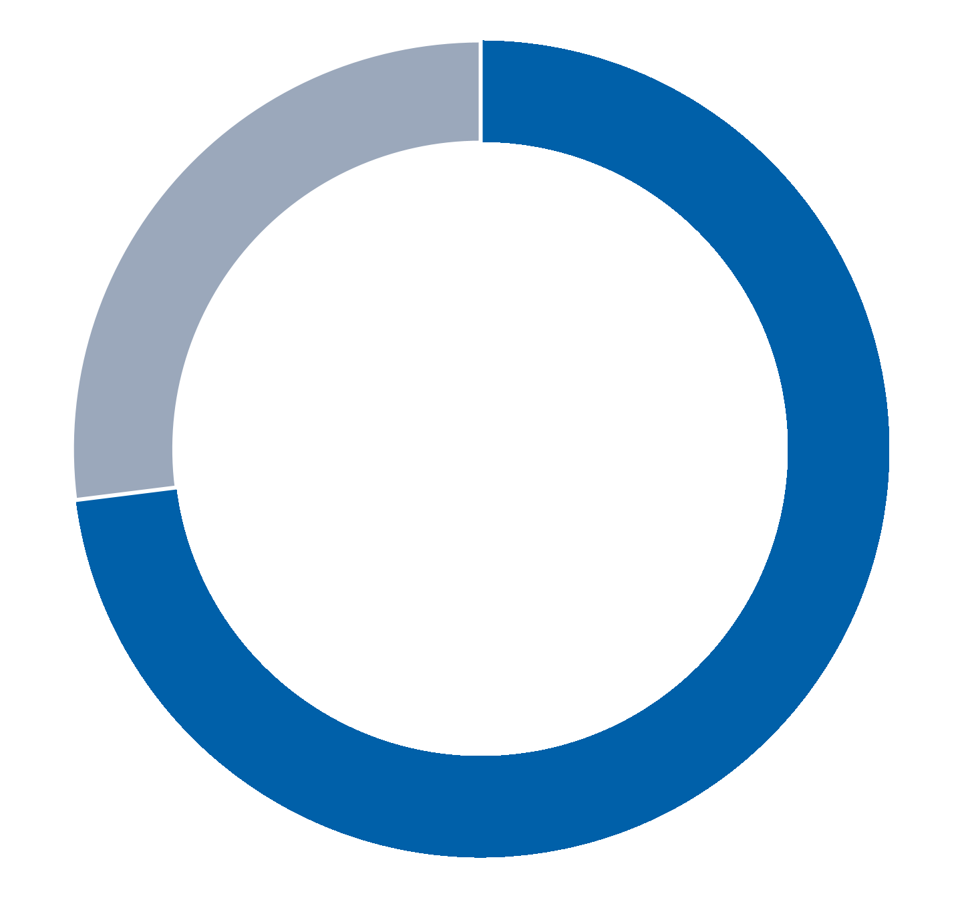
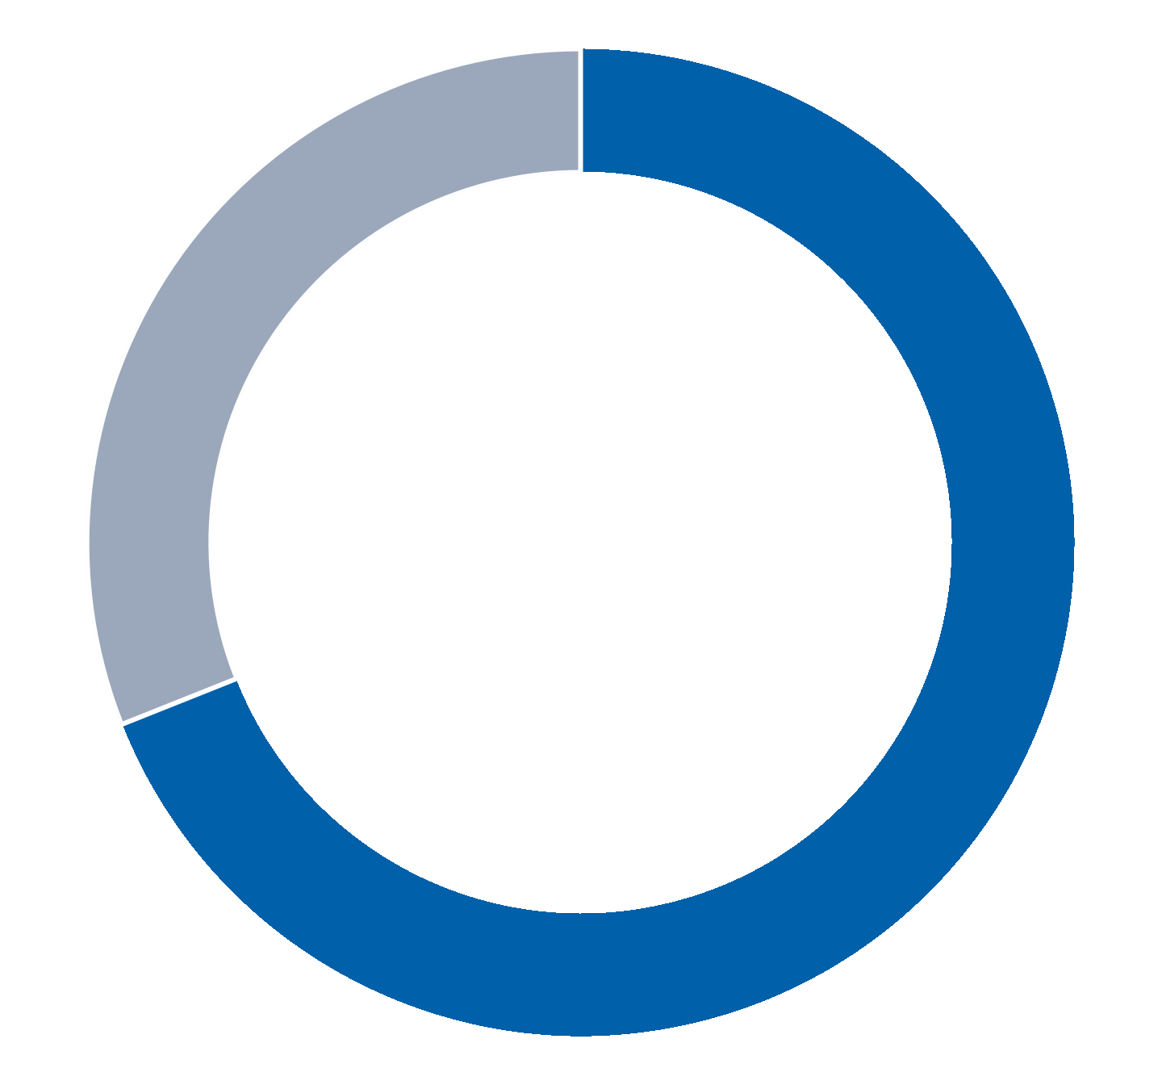
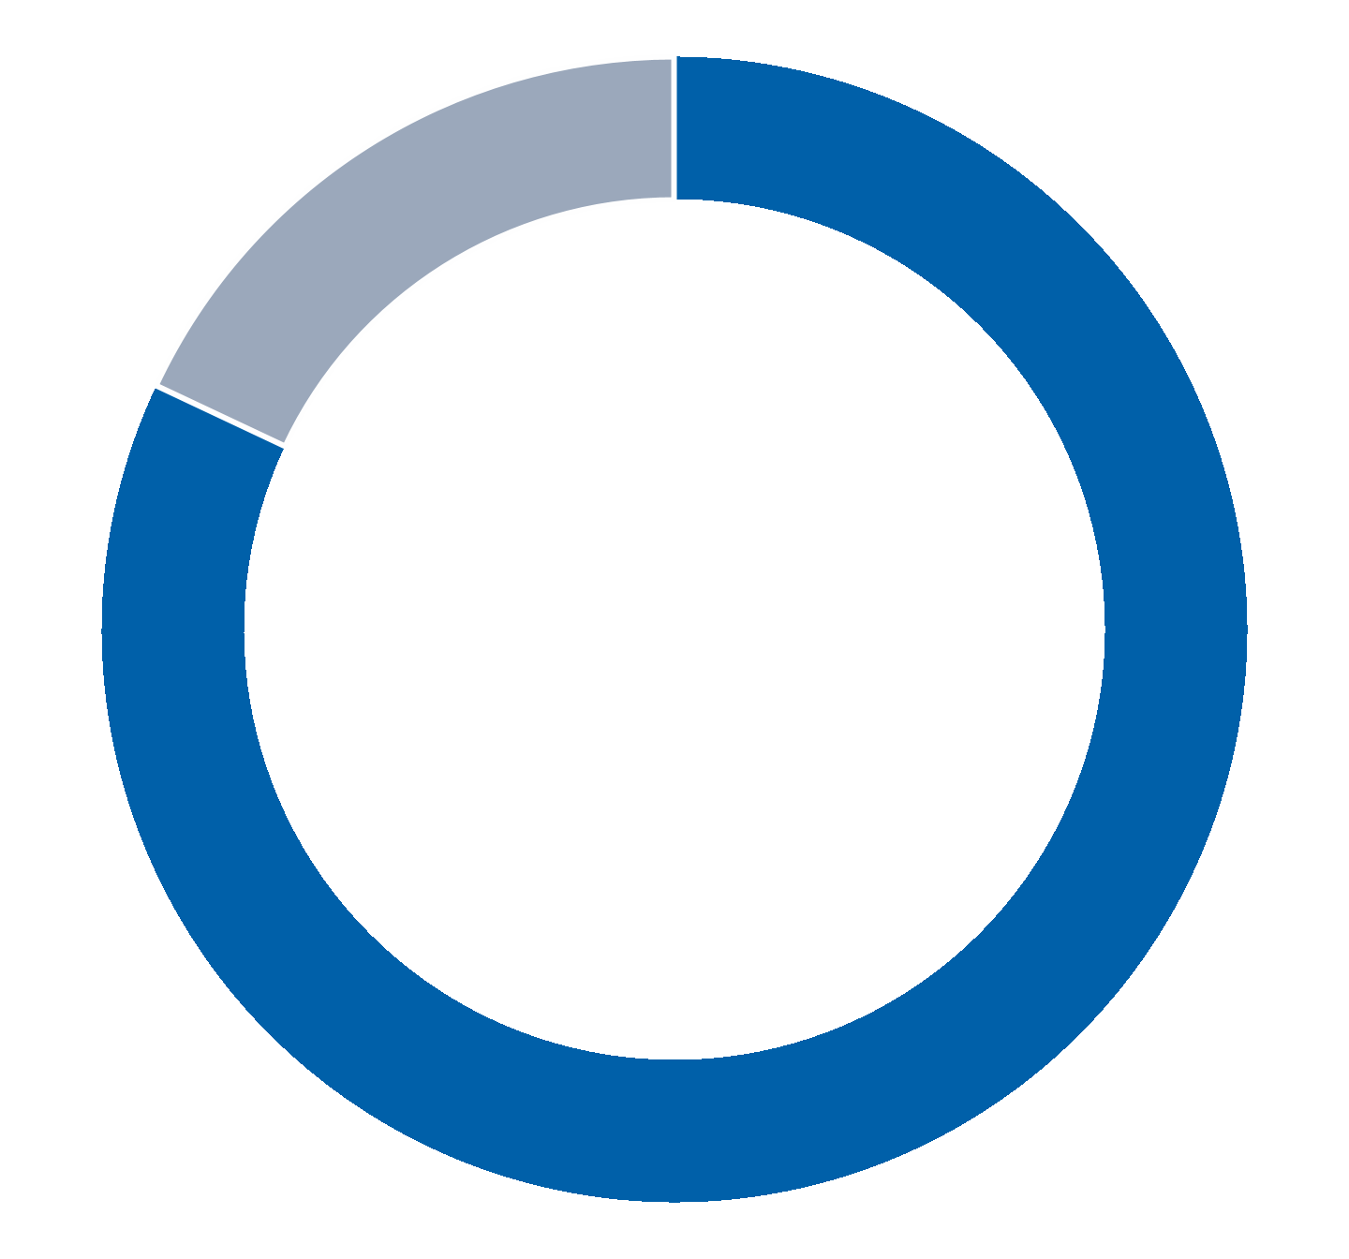

Communications with Directors
The Board has established a process to receive communications from shareholders and other interested parties by mail.
Shareholders and other interested parties may contact any member of the Board, any Board committee or the entire
Board. To communicate with the Board, any individual director or any committee, correspondence should be addressed to
“c/o Corporate Secretary” at One Lincoln Centre, 5400 LBJ Freeway, Suite 1500, Dallas, Texas 75240. Shareholders
should mark the envelope containing any such communication as “Shareholder Communication with Directors” and clearly
identify the intended recipient or recipients of the communication. The Corporate Secretary will review and forward
correspondence to the appropriate person or persons as expeditiously as reasonably practicable. However, any such
communication will not be forwarded if it does not fall within the scope of matters generally considered by the Board or
otherwise fails to comply with the requirements of any applicable policy adopted by the Board relating to the subject
matter of communications.
Any communications to the Company from one of the Company’s officers or directors will not be considered “shareholder
communications.” Communications to the Company from one of the Company’s employees or agents will only be
considered “shareholder communications” if they are made solely in such employee’s or agent’s capacity as a
shareholder. Any shareholder proposal submitted pursuant to Rule 14a-8 promulgated under the Exchange Act will not be
viewed as “shareholder communications.”
2025 Proxy Statement | Matador Resources Company35

Strategic Planning and Compensation Committee Interlocks and Insider Participation
Ms. Ehrman and Messrs. Baribault, Baty, Parker and Stewart served on the Compensation Committee during 2024. None
of these individuals is or was previously one of our officers or employees. None of our executive officers serve on the
board of directors or compensation committee of a company that has an executive officer that serves on our Board or the
Compensation Committee. No member of our Board serves as an executive officer of a company in which one of our
executive officers serves as a member of the board of directors or compensation committee of that company. There were
no compensation committee interlocks during 2024. Mr. Baribault’s sister-in-law is an employee of the Company. For more
information on this related person transaction, see “Transactions with Related Persons.”

Executive Officers and Other Senior Officers of the Company
The following table sets forth the names, ages and positions of our executive officers and certain of our other senior
officers at April 16, 2025:
Name | Age | Positions Held With Us
Executive Officers
Joseph Wm. Foran | 72 | Chairman of the Board and Chief Executive Officer
Van H. Singleton, II | 47 | President—Land, Acquisitions & Divestitures and Planning
Brian J. Willey | 48 | Executive Vice President and Chief Financial Officer
G. Gregg Krug | 64 | Executive Vice President—Marketing & Midstream Strategy
Christopher P. Calvert | 46 | Executive Vice President and Chief Operating Officer
W. Thomas Elsener | 40 | Executive Vice President—Reservoir Engineering and Senior Asset Manager
Bryan A. Erman | 47 | Executive Vice President, General Counsel and Head of M&A
Glenn W. Stetson | 40 | Executive Vice President—Production
Other Senior Officers
Michael D. Frenzel | 43 | Executive Vice President and Treasurer
Robert T. Macalik | 46 | Executive Vice President and Chief Accounting Officer
Jonathan J. Filbert | 38 | Executive Vice President—Land
Jordan M. Ellington | 33 | Executive Vice President and Asset Manager
M. Cliff Humphreys | 35 | Executive Vice President—Completions
Joshua D. Passauer | 39 | Executive Vice President—Drilling
36Matador Resources Company | 2025 Proxy Statement
The following biographies describe the business experience of our executive officers and the senior officers listed above.
Each officer serves at the discretion of our Board. There are no family relationships among any of our executive officers.
Executive Officers
Mr. Joseph Wm. Foran
Chairman of the  Board and Chief  Executive Officer | Please see the biography of Mr. Foran on page 18 of this Proxy Statement.
Mr. Van H. Singleton, II
President—Land,  Acquisitions &  Divestitures and  Planning | Mr. Singleton joined Matador Resources Company in August 2007 as a Landman and was promoted  to Senior Staff Landman in 2009 and then to General Land Manager in 2011. In September 2013,  Mr. Singleton became Vice President of Land, and he was promoted to Executive Vice President of  Land in February 2015. He became the Company’s President—Land, Acquisitions & Divestitures and  Planning in March 2022. Prior to joining Matador, Mr. Singleton founded and was President of  VanBrannon and Associates, LLC and Southern Escrow and Title of Mississippi, LLC from 1998 to  2003, which provided full-spectrum land title work and title insurance in Mississippi, Louisiana,  Texas and Arkansas. From 2003 until joining Matador in 2007, he served as general manager of his  family’s real estate brokerage in Houston, Texas. Mr. Singleton received a Bachelor of Arts degree  from the University of Mississippi in 2000. He is an active member of the American Association of  Professional Landmen, the New Mexico Landman Association, the Permian Basin Landman  Association and the Dallas Association of Petroleum Landmen.
Mr. Brian J. Willey
Executive Vice  President and Chief  Financial Officer | Mr. Willey joined Matador Resources Company in February 2014 as its Deputy General Counsel. In  January 2016, Mr. Willey was appointed as Co-General Counsel, and in August 2016, he was  promoted to Vice President and Co-General Counsel. Mr. Willey became Senior Vice President and  Co-General Counsel in July 2018, and in March 2022, he was promoted to President of San Mateo  and Senior Vice President, President and General Counsel of Midstream. In October 2022, Mr.  Willey was promoted to President and General Counsel of Midstream Operations and Executive  Vice President. In February 2023, Mr. Willey was promoted to Executive Vice President and Chief  Financial Officer. Prior to joining Matador, Mr. Willey was an attorney with Dean Foods Company  where he most recently served as Vice President, Chief Counsel – Corporate. Before Dean Foods,  Mr. Willey served as a senior associate in the Dallas office of Baker Botts L.L.P. Mr. Willey’s practice  focused on corporate matters, including mergers and acquisitions, public and private securities  offerings, venture capital transactions and SEC compliance matters as well as board of director and  corporate governance matters. Mr. Willey received a Bachelor of Science degree in Accounting in  2002 from Brigham Young University. He received his law degree in 2005 from The University of  Texas School of Law, where he graduated with High Honors and was a member of the Order of the  Coif in addition to being named a Chancellor and an Associate Editor on the Texas Law Review. Mr.  Willey also served a church mission in the Philippines from 1995 to 1997.
2025 Proxy Statement | Matador Resources Company37
Mr. G. Gregg Krug
Executive Vice  President—Marketing  & Midstream Strategy | Mr. Krug joined Matador Resources Company in April 2012 as its Marketing Manager. In September  2013 he was named Vice President of Marketing for the Company and Vice President of Longwood  Gathering & Disposal Systems, LP, and he was promoted to Senior Vice President—Marketing and  Midstream in February 2016. He was promoted to Executive Vice President—Marketing and  Midstream Strategy in April 2019. He has overall responsibility for Matador’s marketing activities of  its oil and natural gas, as well as responsibility for all business aspects for Longwood Gathering &  Disposal Systems, LP. Previously, Mr. Krug was with Unit Petroleum Company, an exploration and  production company based in Tulsa, Oklahoma, as Marketing Manager, having joined in 2006. He  and his staff were responsible for marketing, gas measurement, contract administration and  production reporting in their core areas of Oklahoma, the Texas Panhandle, East Texas and  Northwestern Louisiana. From 2005 to 2006, Mr. Krug served as Marketing Manager with Matador  Resources Company. From 2000 to 2005, Mr. Krug served as Gas Scheduling Supervisor with  Samson Resources in Tulsa, Oklahoma where he and his staff were responsible for scheduling  natural gas sales as well as procurement of natural gas supply on Samson-owned gathering systems.  From 1983 to 2000, Mr. Krug served with The Williams Companies in various capacities including in  the Kansas Hugoton Field in Ulysses, Kansas and Tulsa, Oklahoma for Williams Natural Gas Pipeline  and on the trading floor in Tulsa, Oklahoma for Williams Energy Services Company. Mr. Krug  received a Bachelor of Business Administration degree from Oklahoma City University in 1996.
Mr. Christopher P. Calvert
Executive Vice  President and Chief  Operating Officer | Mr. Calvert joined Matador Resources Company in October 2014 as a Senior Completions Engineer.  In July 2018, he was named Vice President of Completions for the Company, and he was promoted  to Senior Vice President—Operations in October 2019. Mr. Calvert was promoted to Senior Vice  President and Co-Chief Operating Officer in April 2022. In February 2023, Mr. Calvert was  promoted to Executive Vice President and Co-Chief Operating Officer. In April 2024, Mr. Calvert  became Executive Vice President and Chief Operating Officer. Prior to joining Matador, Mr. Calvert  worked as a Staff Reservoir Engineer in Chesapeake Energy Corporation’s South Texas—Eagle Ford  group focusing on A&D evaluations and production and completions optimization. At Chesapeake,  Mr. Calvert also held roles as a Senior Asset Manager responsible for completions and operations in  the Niobrara Shale, a Senior Completions Engineer responsible for Bakken/Three Forks  development and a Senior Operations Engineer focused on production and facility optimization on  the Texas Gulf Coast. Prior to Chesapeake, Mr. Calvert worked as an Operations Engineer for  Williams Production Company. In addition to his oil and natural gas industry experience, Mr. Calvert  has worked in corporate financial controls as an internal Sarbanes-Oxley compliance auditor. Mr.  Calvert received Bachelor of Science degrees in Finance and Petroleum Engineering from the  University of Wyoming in 2002 and 2008, respectively. He is a member of the Society of Petroleum  Engineers.
38Matador Resources Company | 2025 Proxy Statement
Mr. W. Thomas Elsener
Executive Vice  President—Reservoir  Engineering and  Senior Asset Manager | Mr. Elsener joined Matador Resources Company in April 2013 as an Engineer. In June 2017, he was  promoted to Vice President—Engineering and Asset Manager, and he was promoted to Senior Vice  President—Reservoir Engineering and Senior Asset Manager in October 2019. Mr. Elsener was  named Executive Vice President—Reservoir Engineering and Senior Asset Manager in April 2022.  Prior to joining Matador, Mr. Elsener served in various engineering roles at Encana Oil & Gas (USA)  in Dallas, Texas from 2007 to 2013, including reservoir, completions, drilling, business development  and new ventures. While at Encana, Mr. Elsener was involved with the exploration and  development of assets in the Barnett shale, Deep Bossier, Haynesville shale and other new  domestic ventures. Mr. Elsener received a Bachelor of Science degree in Petroleum Engineering  from Texas A&M University in 2007. He is a member of the Society of Petroleum Engineers.
Mr. Bryan A. Erman
Executive Vice  President, General  Counsel and Head of  M&A | Mr. Erman joined Matador Resources Company in January 2016 as its Co-General Counsel. In  August 2016, Mr. Erman was promoted to Vice President and Co-General Counsel. He became  Senior Vice President and Co-General Counsel in July 2018. In March 2022, Mr. Erman became  Senior Vice President and General Counsel and in October 2022, Mr. Erman was promoted to  Executive Vice President, General Counsel and Head of M&A. Prior to joining Matador, Mr. Erman  was a Partner at Carrington, Coleman, Sloman & Blumenthal, L.L.P. in Dallas, having joined the firm  in 2010. From 2003 to 2010, he was an associate in the Dallas and Washington, D.C. offices of Baker  Botts L.L.P. Mr. Erman’s practice focused on litigation matters, including oil and natural gas,  securities and other commercial litigation, as well as corporate governance matters. Before  attending law school, Mr. Erman worked for Oklahoma Governor Frank Keating. Mr. Erman received  a Bachelor of Arts degree in Political Science in 1999 from the University of Oklahoma. He received  his law degree in 2003 from Southern Methodist University Dedman School of Law, where he  graduated cum laude and was a Hatton W. Sumners Scholar, a member of the Order of the Coif and  an Articles Editor on the SMU Law Review.
Mr. Glenn W. Stetson
Executive Vice  President—  Production | Mr. Stetson joined Matador Resources Company in August 2014 as a Production Engineer, and in  July 2015, he was promoted to Asset Manager. Mr. Stetson was promoted to the role of Vice  President and Asset Manager in July 2018 and to Senior Vice President of Production and Asset  Manager in October 2019. Mr. Stetson was promoted to the role of Executive Vice President—  Production in April 2022. Prior to joining Matador, Mr. Stetson worked at Chesapeake Energy  Corporation from 2008 to 2014, holding multiple positions in both the production and completions  departments. Most of his time at Chesapeake was spent in the Barnett shale in North Texas,  although he also spent some time working in northern Pennsylvania managing the northeast  portion of Chesapeake’s Marcellus shale operated production. Mr. Stetson graduated Cum Laude  from Oklahoma State University in 2007, receiving a Bachelor of Science degree in Mechanical  Engineering Technology. Mr. Stetson is a Licensed Professional Engineer in the State of Oklahoma.
2025 Proxy Statement | Matador Resources Company39
Other Senior Officers
Mr. Michael D. Frenzel
Executive Vice  President and  Treasurer | Mr. Frenzel was named Executive Vice President and Treasurer in April 2022. Mr. Frenzel’s  responsibilities include treasury, financial planning and forecasting, budgeting, capital markets,  hedging, financial reporting and investor relations, and he has served as the primary financial officer  for San Mateo, Matador’s midstream joint venture, since San Mateo’s formation in 2017. In March  2022, Matador’s Board and CEO asked Mr. Frenzel to act as the Company’s principal financial officer  until a new CFO was appointed in February 2023. Mr. Frenzel first worked for Matador’s  predecessor company, Matador Petroleum Corporation, as an intern in the summers of 2000, 2001  and 2002. From 2006 to 2010, Mr. Frenzel worked as a Senior Financial Analyst before leaving to  obtain his Master of Business Administration degree in 2010 from Duke University’s Fuqua School  of Business. Mr. Frenzel rejoined Matador in 2013 as its Senior Strategy and Financial Analyst and  Assistant Treasurer and was promoted to Finance Director and Assistant Treasurer in January 2017.  In August 2018, Mr. Frenzel was promoted to Vice President and Treasurer. Mr. Frenzel was  promoted to Senior Vice President and Treasurer in October 2020. Before rejoining Matador in  2013, Mr. Frenzel worked as an Investment Associate for Hamm Capital, LLC and as a Financial  Analyst and Assistant to the CEO at Continental Resources. In addition to his energy industry  experience, Mr. Frenzel also has consulting experience with Deloitte Consulting LLP. Mr. Frenzel  graduated summa cum laude from Vanderbilt University in 2004, receiving a Bachelor of Arts  degree in Economics and Mathematics, and earned the designation of Fuqua Scholar while  receiving a Master of Business Administration degree from Duke University’s Fuqua School of  Business in 2012.
Mr. Robert T. Macalik
Executive Vice  President and Chief  Accounting Officer | Mr. Macalik joined Matador Resources Company in July 2015 as Vice President and Chief  Accounting Officer. He was promoted to Senior Vice President and Chief Accounting Officer in  November 2017. Mr. Macalik was named Executive Vice President and Chief Accounting Officer in  April 2022. Prior to joining Matador, from 2012 to 2015, Mr. Macalik worked at Pioneer Natural  Resources Company as Corporate Controller and, previously, as Director of Technical Accounting  and Financial Reporting. At Pioneer, Mr. Macalik supervised corporate accounting and financial  reporting functions. Prior to joining Pioneer, he was a Senior Manager with  PricewaterhouseCoopers (PwC), joining the public accounting firm in 2002. During his tenure with  PwC, Mr. Macalik conducted and managed audits for various companies, primarily public  companies in the oil and natural gas industry, and managed numerous client relationships. Mr.  Macalik received a Bachelor of Arts degree in History, a Bachelor of Business Administration degree  and a Master of Professional Accounting degree all from The University of Texas at Austin in 2002.  He is a licensed Certified Public Accountant in the State of Texas.
40Matador Resources Company | 2025 Proxy Statement
Mr. Jonathan J. Filbert
Executive Vice  President—Land | Mr. Filbert joined Matador Resources Company in February 2013 as a Senior Staff Landman. In April  2015, he was promoted to General Land Manager, and in December 2017, he was promoted to  General Land Manager and Director of Acquisitions. Mr. Filbert was promoted to the role of Vice  President of Land in July 2018 and to Senior Vice President—Land in October 2020. Mr. Filbert was  promoted to his current role of Executive Vice President—Land in October 2023. Prior to joining  Matador, Mr. Filbert worked as a landman at Chesapeake Energy Corporation from 2010 to 2013.  Most of his time at Chesapeake was spent working with the new ventures team on their Utica and  Marcellus shale assets in Ohio and northern Pennsylvania. Mr. Filbert graduated from the University  of Oklahoma in 2010, receiving a Bachelor of Business Administration degree in Energy  Management and Finance. He is an active member of the American Association of Professional  Landmen, the New Mexico Landman Association, the Permian Basin Landman Association and the  Dallas Association of Petroleum Landmen.
Mr. Jordan M. Ellington
Executive Vice  President and Asset  Manager | Mr. Ellington joined Matador Resources Company in November 2018 as a Drilling Engineer. In  October 2019, Mr. Ellington was promoted to Senior Drilling Engineer and MaxOps Coordinator. He  was promoted to Vice President and Asset Manager in April 2021, and then to Senior Vice Present  and Asset Manager in February 2023. Mr. Ellington was promoted to the role of Executive Vice  President and Asset Manager in February 2024. Prior to joining Matador, Mr. Ellington worked for  Chevron from 2014 to 2018 in various roles within the drilling and completions department. Most  of his time at Chevron was spent focusing on operations and the execution of major capital projects  and exploration and appraisal wells in the Deepwater Gulf of Mexico. Mr. Ellington graduated  summa cum laude from Texas A&M University in 2014, receiving a Bachelor of Science degree in  Mechanical Engineering. He is an active member of the Society of Petroleum Engineers and  American Association of Drilling Engineers.
Mr. M. Cliff Humphreys
Executive Vice  President—  Completions | Mr. Humphreys joined Matador Resources Company in March 2014 as a Completions Engineer. In  December 2018, Mr. Humphreys was promoted to Area Completions Manager. He was promoted to  Vice President—Completions in October 2019, and then to Senior Vice President—Completions in  April 2022. Mr. Humphreys was promoted to his current role of Executive Vice President—  Completions in October 2023. Prior to joining Matador, Mr. Humphreys was an Engineer for Encana  Oil & Gas (USA), primarily assisting with hydraulic fracturing operations in the company’s East Texas  and Louisiana developments. In his time at Matador, Mr. Humphreys has overseen completion  operations in both the Delaware Basin and Eagle Ford assets and has directed the company’s efforts  in recycling produced water for completion operations. Mr. Humphreys received a Bachelor of  Science degree in Mechanical Engineering from The University of Texas at Austin in 2013. He is an  active member of the Society of Petroleum Engineers and American Association of Drilling  Engineers, and serves on the scholarship selection committee for the Wichita Falls Area Community  Foundation.
2025 Proxy Statement | Matador Resources Company41
Mr. Joshua D. Passauer
Executive Vice  President—Drilling | Mr. Passauer joined Matador Resources Company in January 2012 as a Drilling Engineer. In his  initial role at Matador, he managed drilling rigs in the Eagle Ford and Austin Chalk plays. In 2013, he  was part of Matador’s transition to the Delaware basin. In January 2017, he was promoted to Area  Drilling Manager. In July 2018 he was promoted to Vice President of Drilling and then to Senior Vice  President of Drilling in April 2022. He also had the opportunity to work alongside management in  creating the MAXCOM team, including overseeing the technology and layout components of the  MAXCOM room. Mr. Passauer was promoted to his current role of Executive Vice President—  Drilling in October 2023. Prior to joining Matador, Mr. Passauer was an Advanced Services Engineer  with Schlumberger from 2010 to 2012, working in-house with Exco Resources in their drilling group.  While at Exco, he partnered with a team to create an innovative horizontal drill bit design that  optimized the most important portion of a horizontal well. This unique bit design won an innovation  award from British Gas, and he was honored to receive that award in London. He also co-authored  an associated article that was published in Oilfield Technology magazine. Prior to Schlumberger, Mr.  Passauer worked for Smith International in-house with Samson in Tulsa, Oklahoma. He began his  career in the oil and gas business in Midland, TX, spending two years in a field role with Smith. This  role with Smith gave him valuable field experience as he was able to visit a wide array of drilling rigs  throughout the Delaware and Midland basins. Mr. Passauer graduated from Baylor University in  2006 with a Bachelor of Science degree in Mechanical Engineering and a minor in mathematics. He  is an active member of the Society of Petroleum Engineers and the American Association of Drilling  Engineers.
Mr. Joseph Wm. Foran
42Matador Resources Company | 2025 Proxy Statement

PROPOSAL 2
PROPOSAL 2 | ADVISORY VOTE TO APPROVE NAMED EXECUTIVE
OFFICER COMPENSATION
In accordance with the requirements of Section 14A of the Exchange Act, the Company seeks a non-binding advisory vote
from its shareholders to approve the compensation of its Named Executive Officers (as defined below) as described in this
Proxy Statement.
We believe the Company’s future success and ability to create long-term value for our shareholders depends on our ability
to attract, retain and motivate highly qualified individuals in the oil and natural gas industry. Additionally, we believe that
our success also depends on the continued contributions of our Named Executive Officers. The Company’s compensation
system plays a significant role in its ability to attract, motivate and retain a high-quality workforce. As described in the
Compensation Discussion and Analysis (the "CD&A"), the Company’s compensation program for Named Executive
Officers is designed to reward, in both the short term and the long term, performance that contributes to the
implementation of our business strategies, maintenance of our culture and values and achievement of our objectives.
This proposal provides shareholders the opportunity to endorse or not endorse the Company’s executive compensation
program through approval of the following resolution:
“Resolved, that the compensation paid to the Company’s Named Executive Officers, as disclosed pursuant to Item
402 of Regulation S-K, including the Compensation Discussion and Analysis, compensation tables and related
narrative discussion, is hereby approved.”
The above-referenced CD&A and accompanying disclosures appear on pages 47-65 of this Proxy Statement.
Because this is an advisory vote, it will not be binding upon the Board. However, the Compensation Committee
and the Independent Board will take into account the outcome of the vote when considering future executive
compensation arrangements.

Vote Required
The affirmative vote of the holders of a majority of the shares present in person or represented by proxy and entitled to
vote at the Annual Meeting is required to approve this resolution on a non-binding advisory basis. If you hold your shares
through a broker and you do not instruct the broker how to vote, your broker will not have the authority to vote your
shares. Abstentions will have the effect as a vote cast against the proposal. Broker non-votes will be counted as present
for purposes of determining the presence of a quorum but will have no effect upon the outcome of the vote.
During our 2024 Annual Meeting of Shareholders, our shareholders approved a non-binding, advisory proposal to hold
advisory votes to approve our executive compensation every year. In consideration of the results of this advisory vote, the
Board has maintained its policy of providing for annual advisory votes to approve executive compensation. Unless the
Board modifies its current policy, the next advisory vote to approve executive compensation following this vote will be held
at our 2026 Annual Meeting of Shareholders.
The Board of Directors recommends that you vote FOR approval of this resolution.
2025 Proxy Statement | Matador Resources Company43

PROPOSAL 3 | RATIFICATION OF THE APPOINTMENT OF KPMG
LLP
The Audit Committee has appointed KPMG LLP (“KPMG”) as the independent registered public accounting firm of
the Company for the year ending December 31, 2025, and the Board has directed that such appointment be
submitted to our shareholders for ratification at the Annual Meeting.
The Audit Committee concluded that KPMG’s provision of non-audit services, such as tax services, does not
compromise KPMG’s independence.
If the shareholders do not ratify the appointment of KPMG, the Audit Committee will consider whether to engage a
different independent registered public accounting firm but will not be obligated to do so.
The Company has been advised that representatives of KPMG will be present at the Annual Meeting and will be
available to respond to appropriate questions and make a statement if they desire to do so.

Fees of Independent Registered Public Accounting Firm for Fiscal Years 2024 and 2023
The following table presents fees for professional audit services rendered by KPMG for the audit of the Company’s
annual financial statements for the years ended December 31, 2024 and 2023, and fees for other services rendered
by KPMG during those periods:
 | 2024 | 2023
Audit fees | $2,750,000 | $2,020,000
Audit-related fees | $55,000 | $50,000
Tax fees | $560,000 | $420,000
All other fees | — | —
Total | $3,365,000 | $2,490,000
Services rendered by KPMG in connection with the fees presented above were as follows:
Audit Fees
Audit fees for fiscal years 2024 and 2023 consisted of fees associated with the audit of the Company’s consolidated
financial statements, including the audit of the effectiveness of the Company’s internal control over financial
reporting, required reviews of our quarterly condensed consolidated financial statements and consultation on
significant accounting matters. Audit fees also included fees paid to KPMG by San Mateo for the audit of its 2024
and 2023 financial statements.
Audit-Related Fees
Audit-related fees for fiscal years 2024 and 2023 related to fees for assurance and related services for subsidiary
audits that are not included in the audit fees listed above.
Tax Fees
Tax fees for fiscal years 2024 and 2023 related to permitted tax planning services.
All Other Fees
We did not incur any other fees in 2024 or 2023.
The Audit Committee pre-approves all audit and permissible non-audit services provided by KPMG. These services
may include audit services, audit-related services, tax services and other services. The Audit Committee has
authorized the chair of the Audit Committee to pre-approve audit and permissible non-audit services provided by
44Matador Resources Company | 2025 Proxy Statement
KPMG up to $750,000. Pursuant to this delegation, the decisions of the chair must be presented to the Audit
Committee at its next meeting.

Report of the Audit Committee
We are a standing committee comprised of independent directors as currently defined by SEC regulations and the
applicable listing standards of the NYSE. The Board has determined that at least one of the members of the Audit
Committee is an “audit committee financial expert” as defined by applicable SEC rules and regulations. We operate
under a written charter adopted by the Board. A copy of the charter is available free of charge on the Company’s
website at www.matadorresources.com under “Investor Relations—Corporate Governance.”
We annually select the Company’s independent registered public accounting firm. If the shareholders do not ratify
the appointment of KPMG at the Annual Meeting, the Audit Committee will consider whether to engage a different
independent registered public accounting firm but will not be obligated to do so.
Management is responsible for the Company’s internal controls and the financial reporting process. The
independent registered public accounting firm is responsible for performing an independent audit of the Company’s
consolidated financial statements in accordance with the standards of the United States Public Company Accounting
Oversight Board (the “PCAOB”) and issuing a report thereon. As provided in our charter, our responsibilities include
the monitoring and oversight of these processes.
Consistent with our charter responsibilities, we have met and held discussions with management and the
independent registered public accounting firm. In this context, management and the independent registered public
accounting firm represented to us that the Company’s consolidated financial statements for the fiscal year ended
December 31, 2024 were prepared in accordance with U.S. generally accepted accounting principles. We reviewed
and discussed the consolidated financial statements with management and the independent registered public
accounting firm and discussed with the independent registered public accounting firm matters required to be
discussed by the applicable requirements of the PCAOB and the SEC.
The Company’s independent registered public accounting firm has also provided to us the written disclosures and
the letter required by applicable requirements of the PCAOB regarding the independent registered public accounting
firm’s communications with the Audit Committee, and we discussed with the independent registered public
accounting firm that firm’s independence.
Based upon our reviews and discussions with management and the independent registered public accounting firm
and our review of the representation of management and the report of the independent registered public accounting
firm to the Audit Committee, we recommended that the Board include the audited consolidated financial statements
in the Company’s Annual Report on Form 10-K for the year ended December 31, 2024 filed with the SEC.
Audit Committee,
William M. Byerley, Chair
Reynald A. Baribault
Paul W. Harvey
James M. Howard
Timothy E. Parker
Susan M. Ward
2025 Proxy Statement | Matador Resources Company45

Vote Required
The affirmative vote of the holders of a majority of the shares present in person or represented by proxy and entitled
to vote at the Annual Meeting is required for the ratification of the appointment of KPMG as the Company’s
independent registered public accounting firm for the year ending December 31, 2025. If the shareholders do not
ratify the appointment of KPMG, the Audit Committee will consider whether to engage a different independent
registered public accounting firm but will not be obligated to do so. Abstentions will have the effect as a vote cast
against the proposal.
The Board of Directors recommends that you vote FOR the ratification of the appointment
of KPMG as the Company’s independent registered public accounting firm for the
year ending December 31, 2025.
46Matador Resources Company | 2025 Proxy Statement

Dear Fellow Shareholders,
On behalf of the Board and the Compensation Committee, thank you for your continued support of Matador Resources
Company and for entrusting us with your investment. We are pleased to report that 2024 was another record year for
Matador, reflecting not only operational and financial excellence but also the strategic vision and leadership of our
executive team.
Thanks to their direction and execution, Matador achieved record oil and natural gas production, reaching an average of
over 170,000 barrels of oil equivalent per day. We reported net income of $885 million, delivered $2.3 billion of Adjusted
EBITDA (a non-GAAP financial measure) and generated free cash flow in all four quarters of 2024. These results
underscore the strength of our assets, the quality of our operations, and most importantly, the skill and dedication of our
management team and staff. While achieving these record results, our executive officers also drove meaningful
improvements in operational efficiency and innovation, including the increased use of 'simul-frac' and 'trimul-frac'
completions and drilling 'U-Turn' wells.
2024 also marked the successful closing of the Ameredev Acquisition, which significantly expanded our position in the
Delaware Basin and added high-quality inventory in the core of our operating area. Our ability to evaluate, close, and
begin integrating this large-scale transaction reflects the deep experience and coordination across Matador’s leadership
team. Additionally, our executive team led the strategic combination of Pronto, our wholly-owned midstream business, with
San Mateo, our midstream joint venture, into a unified platform—enhancing operational efficiencies, positioning our
midstream segment for future growth and reinforcing our long-term midstream advantage.
The Board was also pleased to approve a 25% increase in our quarterly dividend in 2024, which has been increased six
times in the last four years, further demonstrating our commitment to returning capital to shareholders. This achievement
is a direct result of our executive leadership’s disciplined capital management and long-term focus on profitable growth at
a steady pace.
As always, the Compensation Committee is guided by a “pay for performance” philosophy and believes that the
compensation of our executive officers should reflect the Company’s success and their individual contributions to it. We
are proud of what Matador accomplished in 2024 under their leadership and confident in the team’s ability to continue
driving value for shareholders.
We appreciate your trust and support and look forward to continuing our dialogue with you in the year ahead. We hope
you will join us at the 2025 Annual Meeting of Shareholders.
Sincerely,
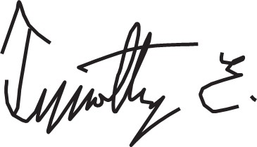  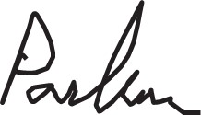 |  | 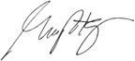
Timothy E. Parker |  | R. Gaines Baty
Lead Independent Director |  | Chair, Strategic Planning and  Compensation Committee
2025 Proxy Statement | Matador Resources Company47

EXECUTIVE COMPENSATION
EXECUTIVE COMPENSATION

Compensation Discussion and Analysis
This Compensation Discussion and Analysis, or CD&A, provides a general description of our compensation program and
specific information about its various components for the following “Named Executive Officers” or "NEOs" for 2024:
•Joseph Wm. Foran, Chairman of the Board and Chief Executive Officer;
•Van H. Singleton, II, President—Land, Acquisitions & Divestitures and Planning;
•Brian J. Willey, Executive Vice President and Chief Financial Officer;
•G. Gregg Krug, Executive Vice President—Marketing & Midstream Strategy; and
•Bryan A. Erman, Executive Vice President, General Counsel and Head of M&A.
2024 Highlights
The exceptional efforts of our executive officers and staff led to yet another record year for Matador in 2024. Highlights of
the year included significant upstream and midstream transactions, record operational and financial results and the
continued return of value to our shareholders through our fixed dividend, which increased again in 2024.
Acquisition and Integration of Ameredev
A key highlight in 2024 was the Ameredev Acquisition, which added approximately 33,500 contiguous net acres in the core
of the northern Delaware Basin, provided a significant increase in our drilling inventory with 431 gross (371 net) operated
locations, including prospective targets throughout the Wolfcamp and Bone Spring formations, and more than 25,000 BOE
per day in production. Since closing the transaction on September 18, 2024, we have been hard at work integrating the
Ameredev properties and our efforts have already resulted in at least $4 million in drilling and completion cost synergies.
Over the next five years, we expect additional drilling and completion cost synergies of over $150 million. In addition, we
estimate that we have reduced lease operating expenses on the Ameredev acreage by 35%, or more than $2 million per
month, since we began operating the Ameredev assets. The Ameredev Acquisition also included an approximate 19%
equity interest in the parent company of Piñon. Piñon was acquired by Enterprise Products Partners L.P. on October 28,
2024, and Matador received approximately $115 million in 2024 from its share of the sale proceeds.
Growing Midstream Business
In addition to significant upstream growth, our midstream business remains a critical part of Matador's success. In
December 2024, Matador contributed Pronto to San Mateo, which resulted in Matador receiving $219.8 million in cash
and the ability to earn up to $75 million in additional performance incentives. The Pronto Transaction included Pronto's
interest in the existing Marlan Plant with a designed inlet capacity of 60 million cubic feet per day of natural gas. The
Marlan Plant expansion will add an additional plant with a designed inlet capacity of 200 million cubic feet of natural gas
per day. The Marlan Plant expansion remains on time and on budget and is expected to be online in the second quarter of
2025. In addition to the financial benefits mentioned above, the Pronto Transaction also provides increased flow
assurance for Matador’s production, primarily in Lea County, New Mexico, and accelerates filling the Marlan Plant to
capacity.

48Matador Resources Company | 2025 Proxy Statement

Record Operational and Financial Results
These transactions contributed to record operational and financial results in 2024. For the year ended December 31,
2024, we achieved record oil, natural gas and average daily oil and natural gas equivalent production. In 2024, we
produced 36.5 million Bbl of oil, an increase of 33%, as compared to 27.5 million Bbl of oil produced in 2023. We also
produced 155.8 Bcf of natural gas, an increase of 26% from 123.4 Bcf of natural gas produced in 2023. Our average
daily oil and natural gas equivalent production for the year ended December 31, 2024 was 170,751 BOE per day,
including 99,808 Bbl of oil per day and 425.7 MMcf of natural gas per day, an increase of 30%, as compared to 131,813
BOE per day, including 75,457 Bbl of oil per day and 338.1 MMcf of natural gas per day, for the year ended December
31, 2023. The increase in oil and natural gas production was primarily attributable to the Ameredev Acquisition and our
ongoing delineation and development drilling activities in the Delaware Basin throughout 2024, which offset declining
production in the Eagle Ford shale and Northwest Louisiana. Oil production comprised 58% and 57% of our total oil and
natural gas production (using a conversion ratio of one Bbl of oil per six thousand cubic feet of natural gas) for the years
ended December 31, 2024 and 2023, respectively. The charts below show the five-year growth experienced by both our
exploration and production business and our midstream business.
TOTAL OIL EQUIVALENT PRODUCTION |  | TOTAL PROVED OIL |  | THIRD-PARTY MIDSREAM SERVICES
(MMBOE) |  | EQUIVALENT RESERVES (MMBOE) |  | REVENUES ($ millions)
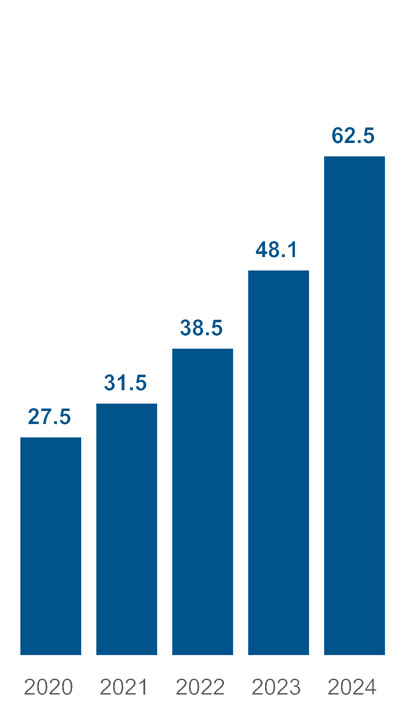
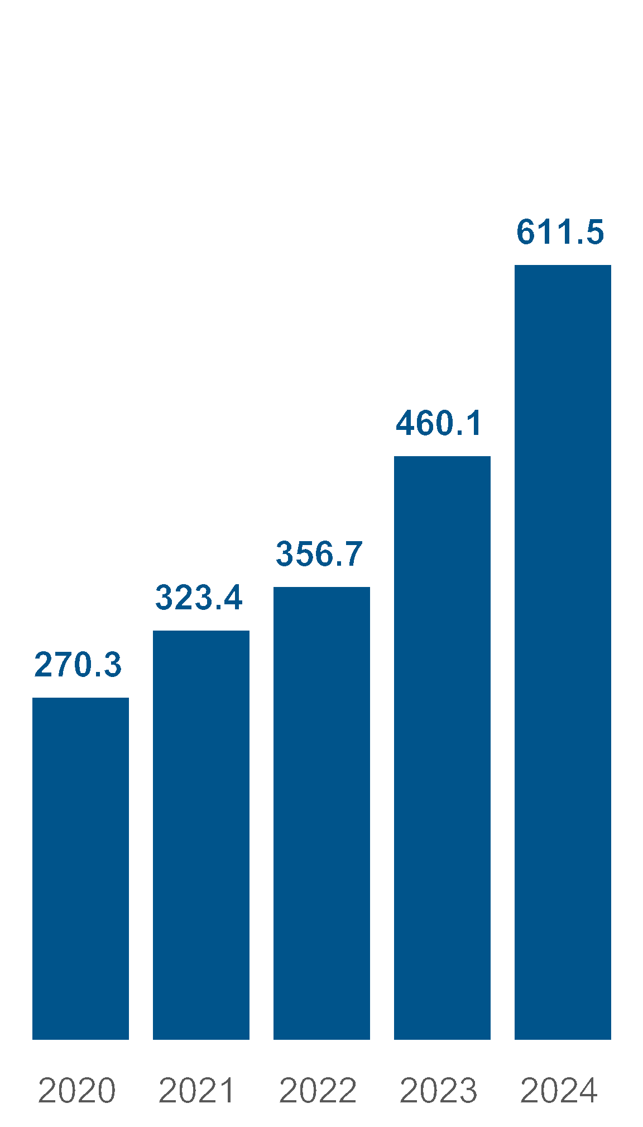
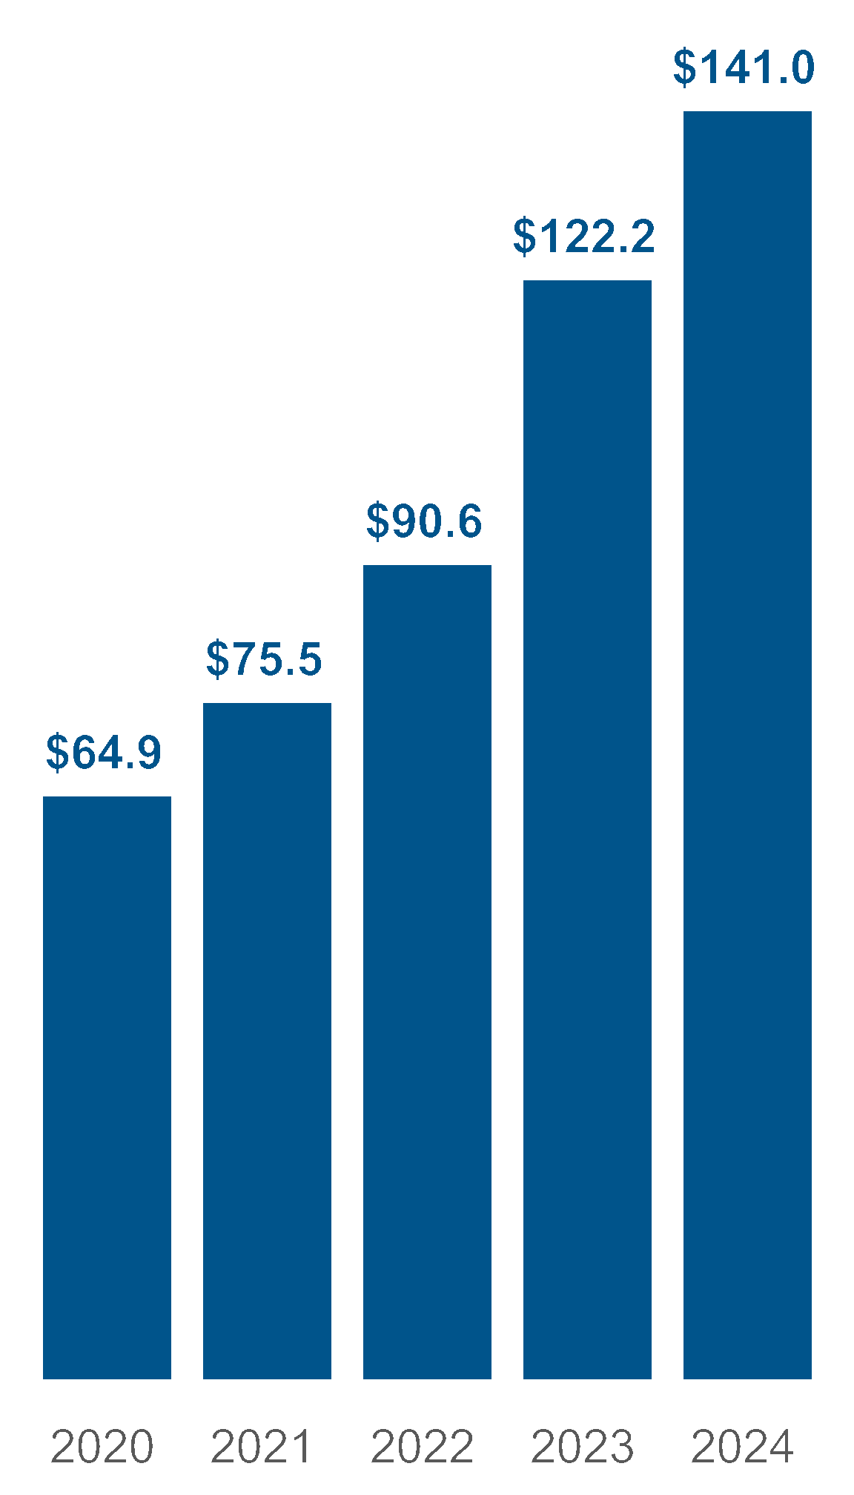

During 2024, we achieved several operational milestones in the Delaware Basin. These milestones were each achieved
when we turned to sales:
•21 Antelope Ridge wells on properties acquired in our 2023 acquisition of Advance Energy Partners Holdings, LLC in
the first half of 2024, which matched the largest single batch development project in our history;
•Five U-Turn wells in the second half of 2024, with significantly reduced drilling time as compared to our initial U-Turn
wells that we turned to sales in 2023; and
•increased efficiencies and capital savings through the introduction of "trimul-frac" operations and continued use of
"simul-frac" operations.
2025 Proxy Statement | Matador Resources Company49
In addition to achieving these key operational milestones, other operational highlights in the Delaware Basin in 2024
included:
•continued drilling of longer laterals, with average completed lateral length for operated wells turned to sales in 2024 of
approximately 9,300 feet; and
•D/C/E capital expenditures for 2024 of $1.32 billion, which was within our estimated range for 2024 D/C/E capital
expenditures of $1.15 billion to $1.35 billion as provided on October 22, 2024.
Matador finished 2024 in the best financial shape in our history with nearly $1.6 billion in liquidity under our Credit
Agreement and a leverage ratio of 1.05x. We returned value to shareholders through the generation of free cash flow in all
four quarters of 2024 and an increase to our quarterly dividend, which we have increased six times in the last four years.
We also completed several important financing transactions in 2024 that increased our operational flexibility while
preserving the strength of our balance sheet and improving our liquidity position.
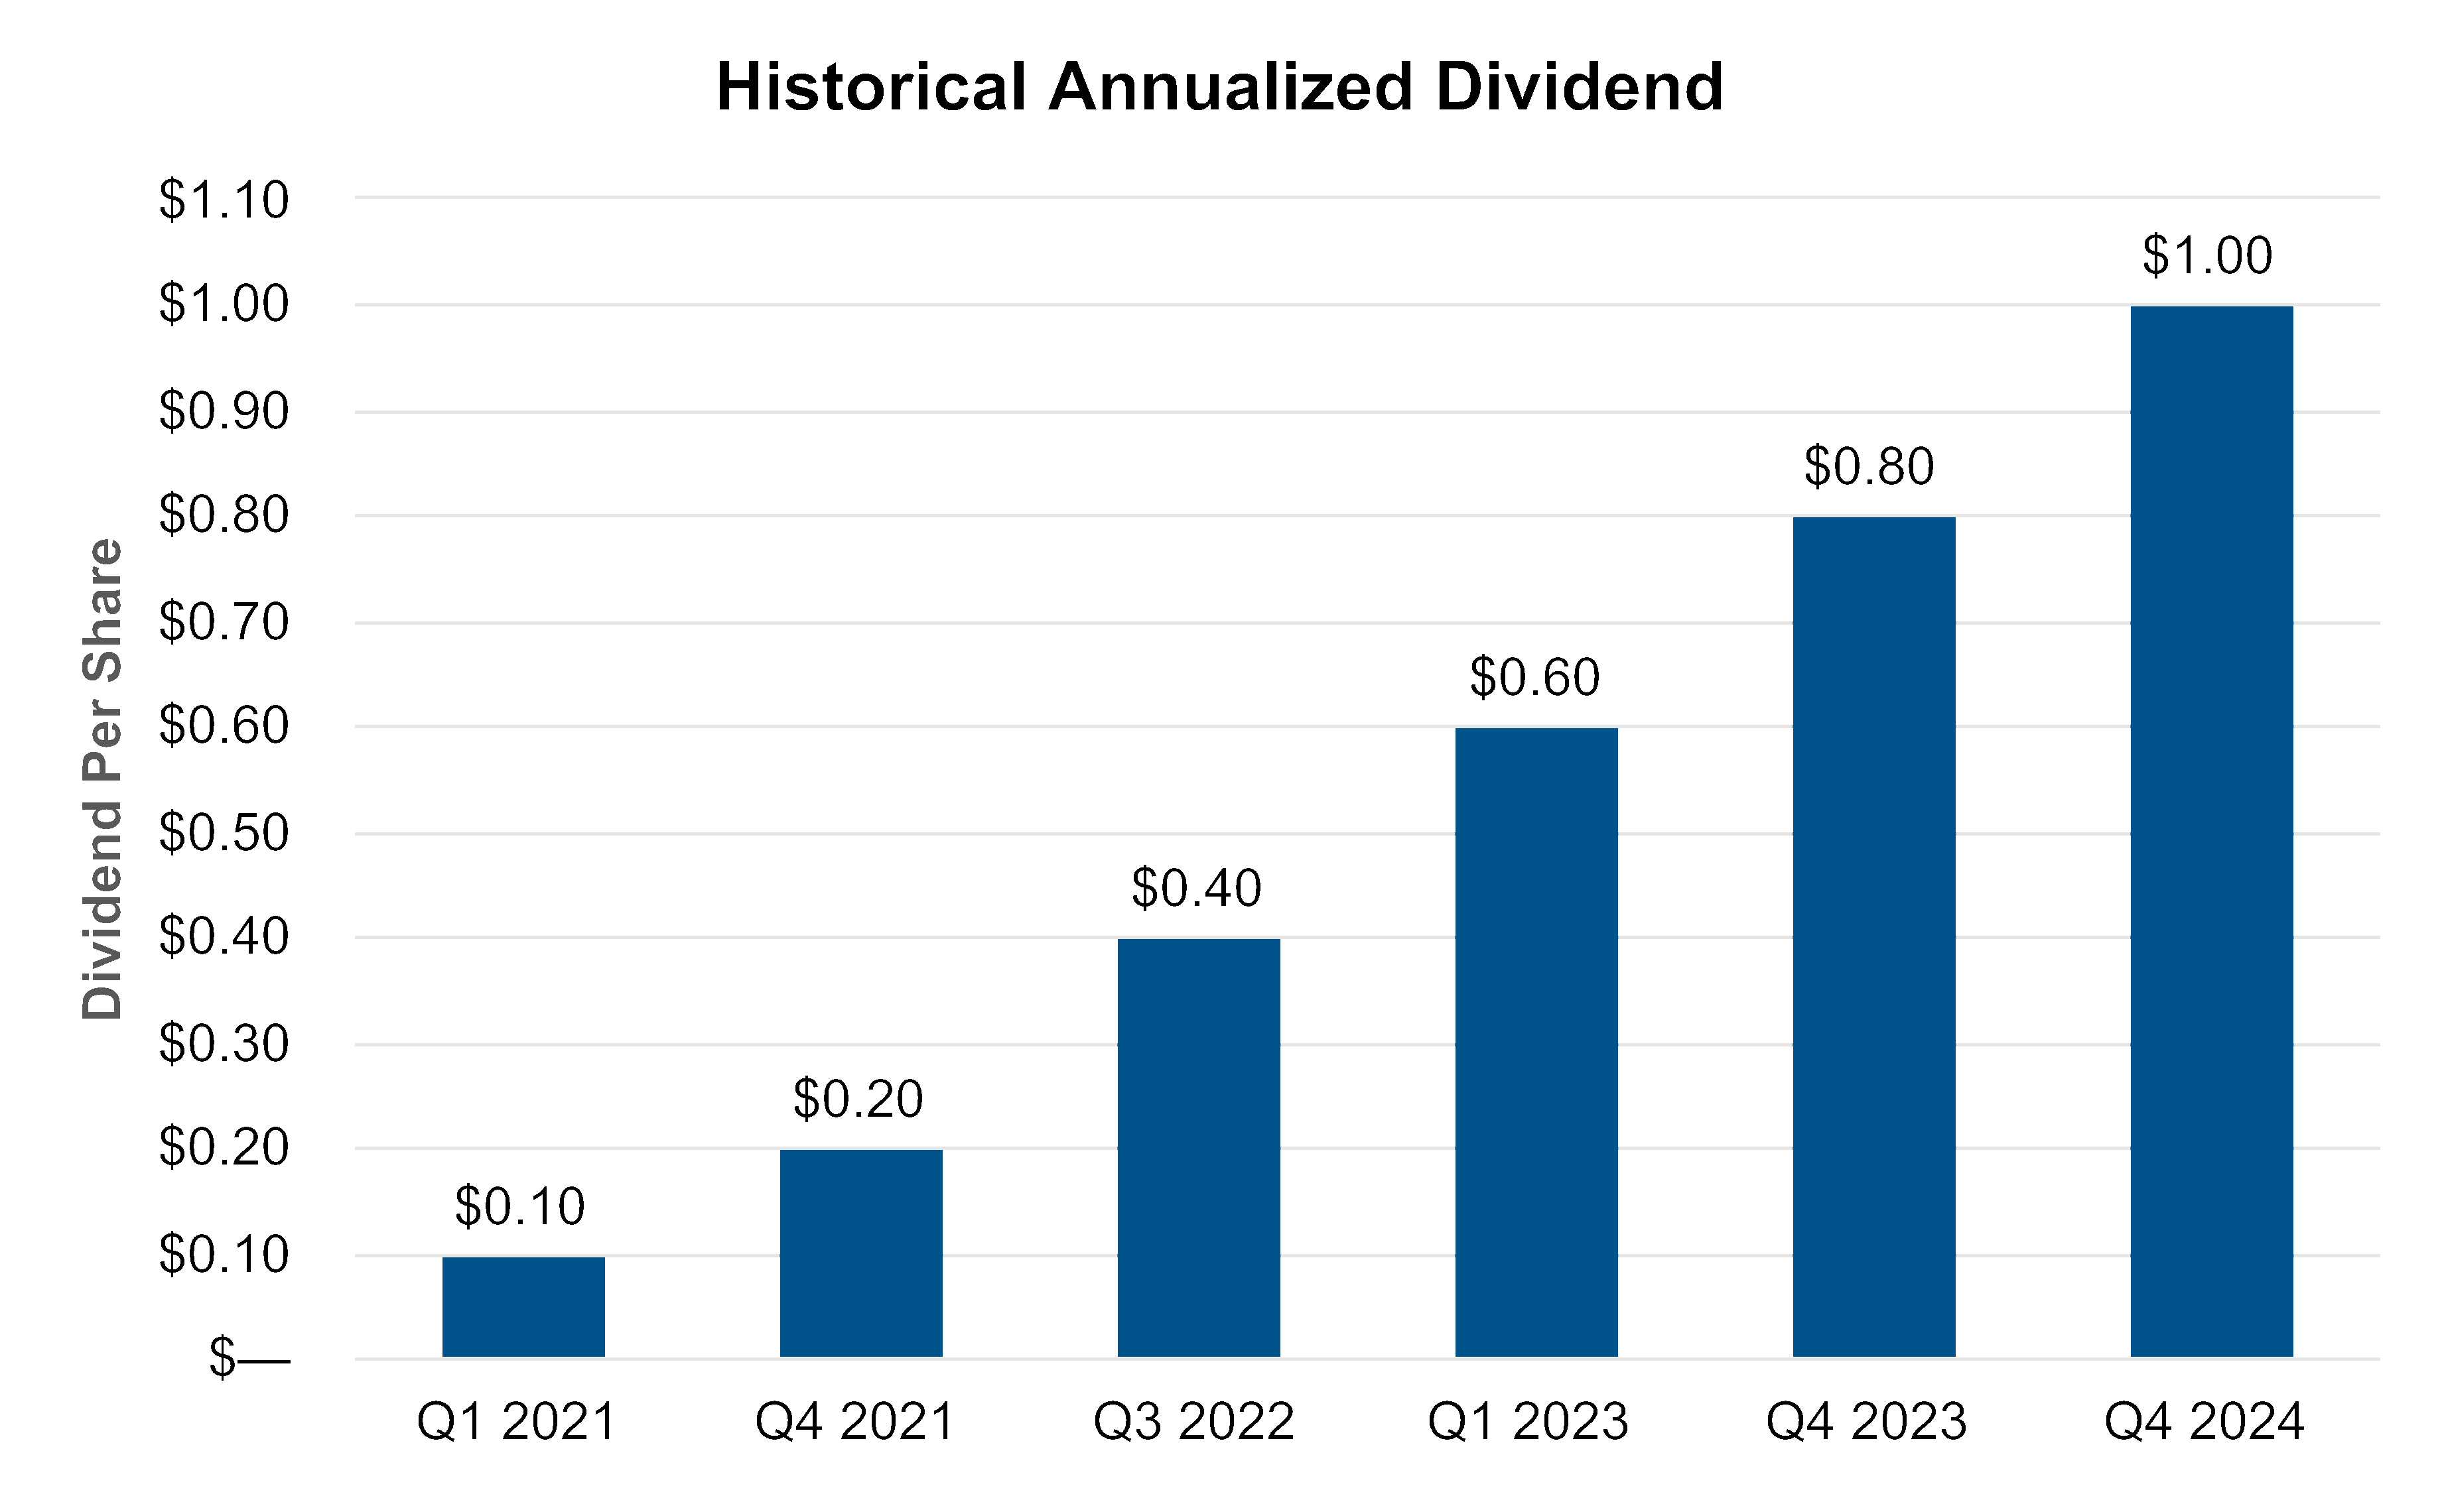
Highlights of 2024 value-generating items include:
•The generation of free cash flow in all four quarters of 2024.
•The amendment of our dividend policy in the fourth quarter of 2024, pursuant to which we increased the quarterly
cash dividend from $0.20 per share of Common Stock to $0.25 per share of Common Stock.
•The receipt of $219.8 million in special distributions from San Mateo as a result of the Pronto Transaction.
•The receipt of $23.8 million in performance incentives directly from Five Point in 2024.
•The underwritten public offering of 5,250,000 shares of Common Stock.
•The repurchase of all of the aggregate principal amount of approximately $699.2 million of our 2026 Notes through
our cash tender offer and subsequent exercise of our optional redemption right in April 2024.
•The issuance of $900.0 million in aggregate principal amount of our 2032 Notes.
50Matador Resources Company | 2025 Proxy Statement
•The issuance of $750.0 million in aggregate principal amount of our 2033 Notes.
•The spring and fall redeterminations under, and amendments of, our Credit Agreement to collectively (i) increase the
borrowing base to $3.25 billion, as compared to $2.50 billion at December 31, 2023, (ii) increase the elected
borrowing commitment to $2.25 billion, as compared to $1.325 billion at December 31, 2023, (iii) increase the
maximum facility amount to $3.50 billion, as compared to $2.00 billion at December 31, 2023, (iv) extend the maturity
date from October 31, 2026 to March 22, 2029 and (v) add five new banks to our lending group.
•The amendment of the San Mateo Credit Facility in November 2024 to (i) increase the lender commitments from
$535.0 million to $800.0 million, (ii) extend the maturity date from December 9, 2026 to November 26, 2029 and (iii)
add six new banks to San Mateo’s lending group.
ESG Highlights
During 2024, we also executed in key ESG-related performance areas and continued to publish voluntary ESG
disclosures. Among other items, our ESG achievements included the following:
•A low rate of per-barrel emissions, including the substantial reduction in direct greenhouse gas emissions intensity
from 2019 levels; the significant use of non-fresh water, including recycled water; and a high percentage of oil and
water transportation by pipeline.
•A conscientious safety record, including zero employee lost time incidents per 200,000 employee man-hours in 2024
and net spill rates of 0.001% of our oil production and 0.003% of our water production.
•Approximately 22,500 hours of employee continuing education, equating to approximately 50 hours per employee in
2024, and management’s continued focus on risk management and cybersecurity, including quarterly reports by
executive management to the Audit Committee.
•The publishing of our annual Sustainability Report, which provides Matador’s investors and other interested parties
with quantitative metrics for evaluating the Company’s sustainability practices and performance.
Compensation Program Objectives
Our Board has a “pay for performance” philosophy and recognizes the leadership of our executive officers in contributing
to the Company’s achievements. Our future success and ability to create long-term value for our shareholders depend on
our ability to attract, retain and motivate highly qualified individuals in the oil and natural gas industry. In furtherance of
these goals, our executive compensation program is designed to meet the following key objectives:
•to be fair to both the executive and the Company and be competitive with comparable positions at companies in our
peer group;
•to attract and retain talented and experienced executives in light of the intense competition for talent in our industry
and areas of operation, including from peers and larger industry competitors;
•to align the interests of our executives with the interests of our shareholders and with the performance of our
Company for long-term value creation;
•to provide financial incentives to our executives to achieve our key corporate and individual objectives with an
appropriate mix of fixed and variable pay;
•to foster a shared commitment among executives by coordinating their corporate and individual goals; and
•to provide compensation that takes into consideration the education, professional experience, knowledge,
commitment and dedication that is specific to each job and the unique qualities each executive possesses.
2025 Proxy Statement | Matador Resources Company51
2024 Say-on-Pay Results
At our 2024 Annual Meeting, support for our executive compensation program remained strong with 94% approval. The
Compensation Committee took this support into account as one of many factors it considered in connection with the
discharge of its responsibilities in exercising its judgment in establishing and overseeing our executive compensation
arrangements throughout the year, but did not make any changes to our compensation program as a direct result of the
2024 vote.
Compensation Program Best Practices
 | What We Do: |  | What We Don't Do:
✓ | We pay for performance—approximately 78% of our CEO’s  target total compensation for 2024 was variable and at risk,  with approximately 50% performance-based | × | We do not permit hedging of Company stock
✓ | We maintain robust stock ownership guidelines for officers | × | We do not provide a gross-up for excise taxes for severance  or change in control payments
✓ | Our Compensation Committee engages an independent  compensation consultant | × | We do not guarantee bonuses
✓ | We use competitive benchmarking in setting compensation | × | We do not reprice stock options without shareholder  approval
✓ | We conduct annual risk assessments of compensation  practices | × | We have no defined benefit or supplemental executive  retirement plans
✓ | We conduct regular shareholder engagement to gather  feedback on compensation practices | × | We do not allow pledging of Company stock, except in  limited circumstances
✓ | We hold an annual say-on-pay vote | × | We do not pay dividends on unvested phantom units,  restricted stock units (“RSUs”) or performance stock units  (“PSUs”)
✓ | We cap PSU payouts at target if absolute total shareholder  return is negative | × | We do not pay dividends on unvested restricted stock,  which accumulate and only settle once the underlying  shares have vested

52Matador Resources Company | 2025 Proxy Statement
Elements of 2024 Compensation Program
Our executive compensation program places a considerable amount of an executive’s compensation at risk in the form of
incentive or equity-based compensation, which can be variable from year to year. We also seek to provide an appropriate
balance between annual incentives and long-term incentives to ensure that each executive is motivated to consider
longer-term Company performance over short-term results.
For 2024, our management compensation program was comprised of the following primary elements:
2024 Element | Key Features | Why We Include This Element
Base Salary | •Fixed level of cash compensation | •Compensates each executive for his assigned  responsibilities, experience, leadership and  expected future contributions
Annual Cash Incentive  Payments | •Variable, annual, performance-based cash  compensation | •Focuses and motivates management to  achieve key corporate and individual  objectives  •Rewards achievements over the prior year
Phantom Units | •Approximately 50% of target total annual long-  term equity award value  •Vests ratably in annual installments over three  years from grant date  •Phantom Units settle in cash | •Directly aligns executive and shareholder  interests by tying the cash received on  settlement to the Company’s stock price  •Retains executives over vesting period  •Cash settlement of Phantom Units avoids  dilution of Common Stock
Performance Stock Units | •Approximately 50% of target total annual long-  term equity award value  •Vests between 0% and 200% following a three-  year performance period ending December 31,  2026 based on the Company’s relative total  shareholder return ranking as compared to our  peers  •If absolute total shareholder return is negative,  payout is capped at target (100%) | •Focuses executives on the Company’s long-  term performance as award is tied to the  Company’s total shareholder return relative to  the total shareholder return of its peers over a  three-year performance period  •Settlement in shares of the Company’s stock  increases alignment between executives and  shareholders  •Retains executives over vesting period
Severance and Change of  Control Benefits | •Specified severance pay and benefits are  provided under each Named Executive  Officer’s employment agreement in  connection with termination events, including  after a change in control | •Provides an incentive for executives to remain  with the Company despite the uncertainties of  a potential or actual change in control  •Provides a measure of financial security in the  event an executive’s employment is  terminated without cause
Other Benefits | •Broad-based 401(k) retirement, employee  stock purchase plan and health and welfare  benefits offered to all eligible employees | •Provides market competitive benefits  •Protects employees against catastrophic loss  and encourages a healthy lifestyle
2025 Proxy Statement | Matador Resources Company53
Consistent with our compensation program objectives, we provide our executive officers with a significant portion of their
total compensation in the form of variable, rather than fixed, compensation. Importantly, a significant portion of total
compensation is also performance-based. The percentages shown below reflect each executive’s 2024 target
compensation opportunity determined by the Compensation Committee and the Independent Board and do not reflect
actual payments made to the executives for 2024.


2024 CEO Target Compensation
2024 Average Other NEO Target Compensation
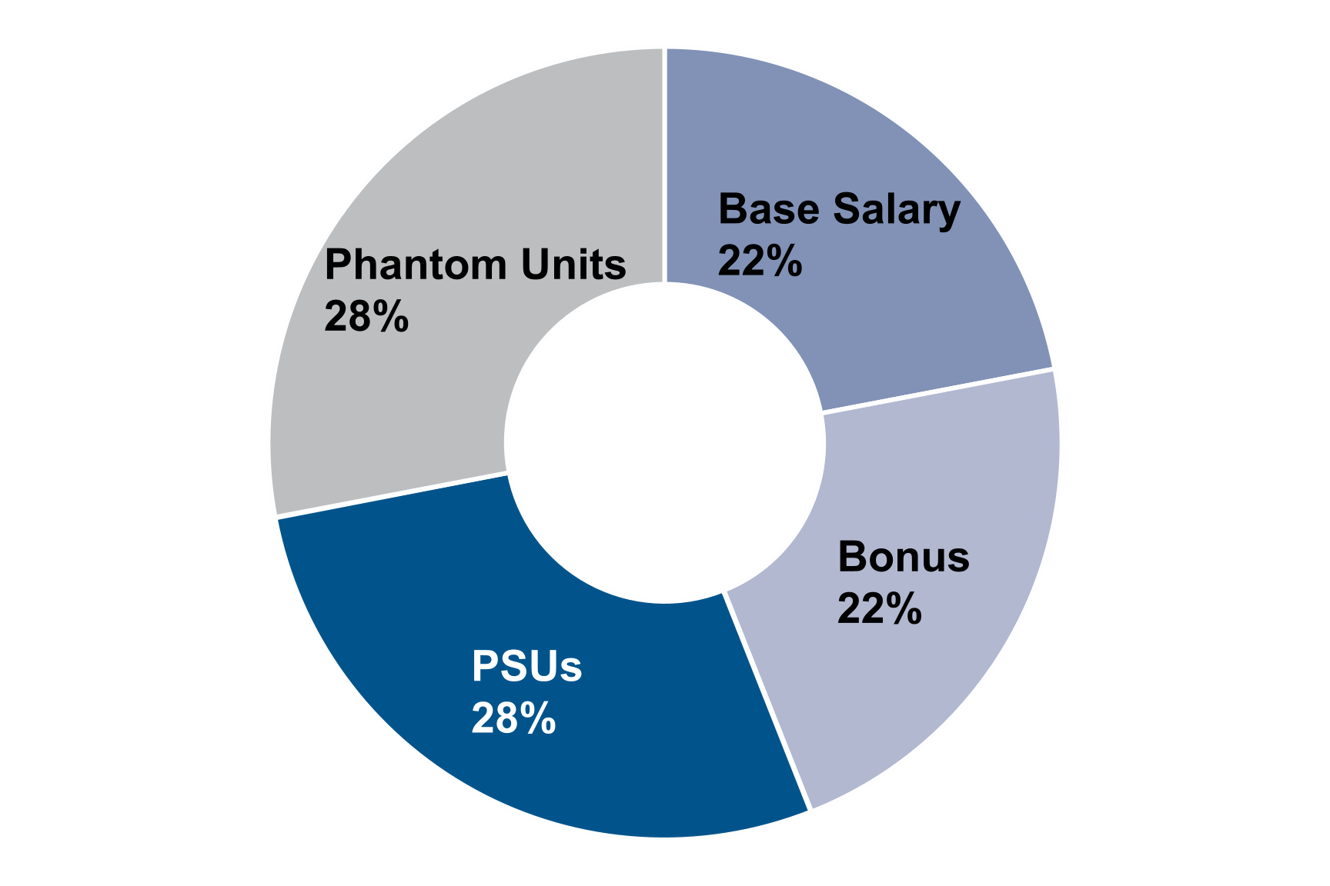


~50%
Performance-
based


~78% Variable Pay
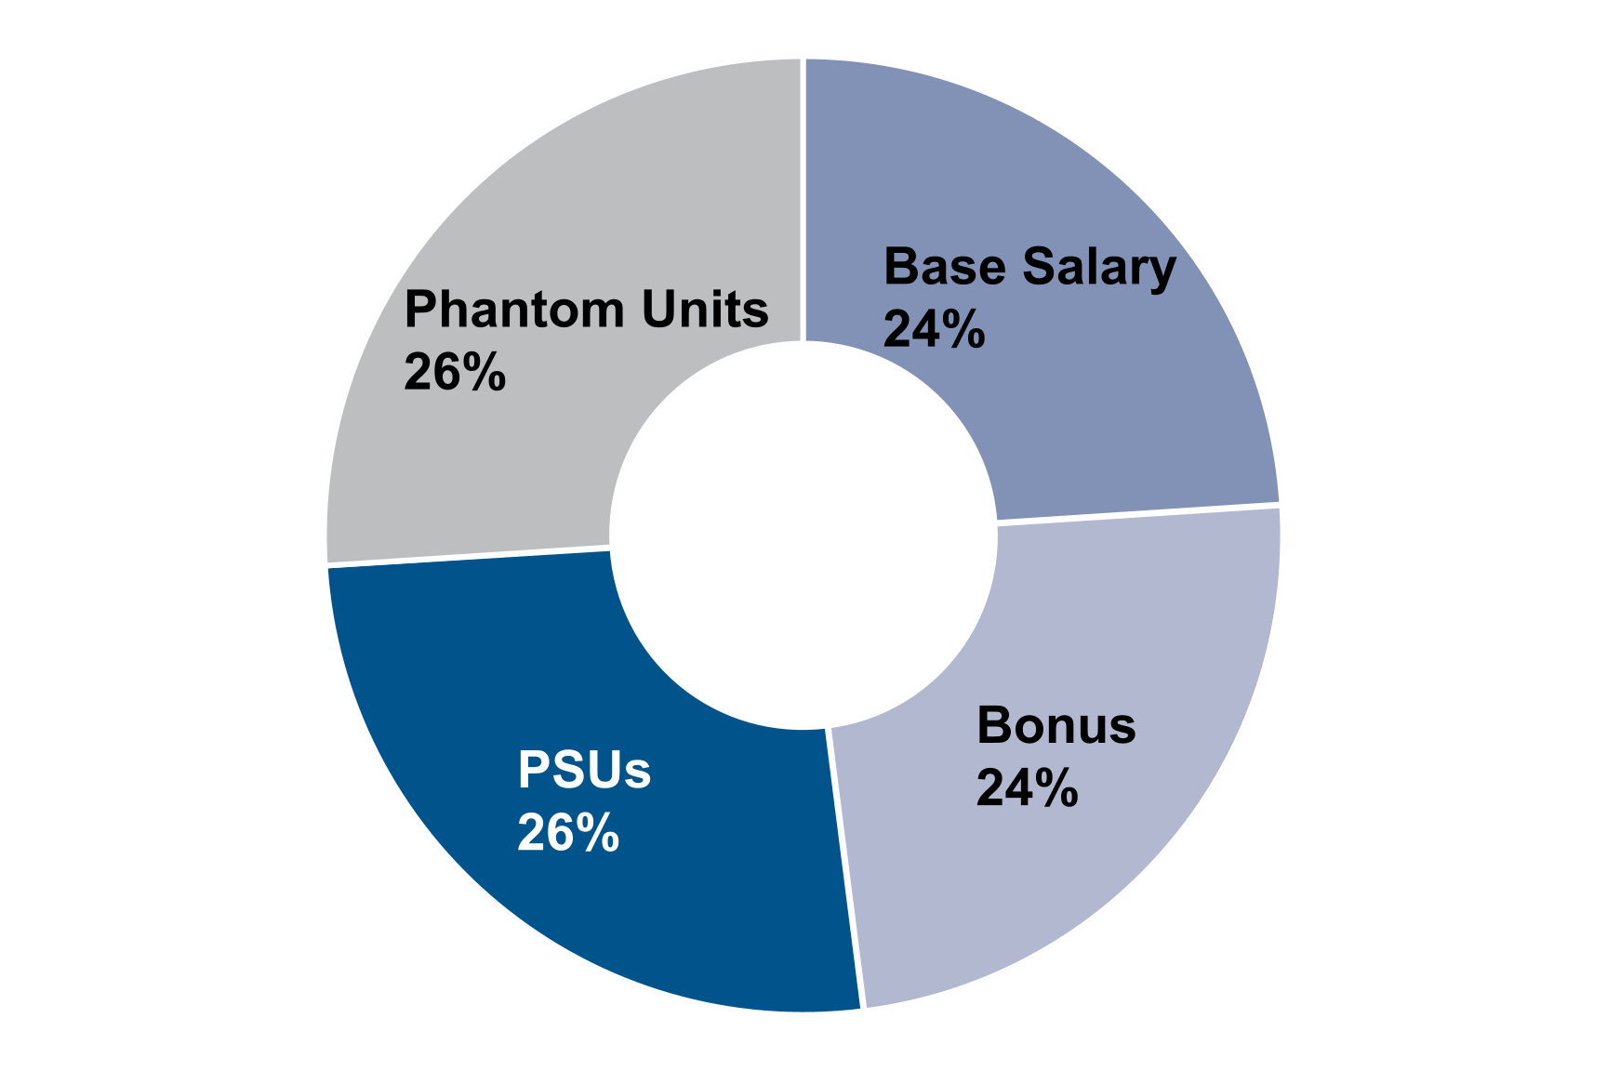

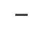
~50%
Performance-
based
~76% Variable Pay
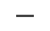
Role of the Independent Board, Compensation Committee and Management
The Compensation Committee annually evaluates each of the Company’s executive officers, including Mr. Foran, and
recommends to the Independent Board the proposed compensation structure for each of the executives, including salary,
equity and non-equity incentive compensation. Based on such recommendations, the Independent Board sets Mr. Foran’s
compensation each year. Mr. Foran consults with and provides recommendations to the Compensation Committee and
Independent Board regarding the compensation structure for each of the other Named Executive Officers. Based on the
recommendations of the Compensation Committee and Mr. Foran, the Independent Board sets the other Named
Executive Officers’ compensation each year. The members of the Independent Board are independent pursuant to the
listing standards of the NYSE and the rules and regulations promulgated by the SEC.
As part of its annual evaluations, the Compensation Committee:
•conducts an analysis of the Company’s annual performance relative to any performance criteria or targets established
under the Company's annual cash incentive plan (the "Cash Incentive Plan") and recommends to the Independent
Board the amount of the annual cash incentive award payouts;
•reviews and recommends the form of and number of shares or share-based units to be awarded pursuant to long-
term incentive awards, including vesting terms, performance metrics, performance peer groups and other material
provisions of such awards;
•reviews executive officer compensation levels as compared to the Company’s peers;
•reviews and recommends any employment agreement, severance agreement, change in control agreement or
provision or separation agreement or amendment thereof; and
•reviews and recommends any deferred compensation arrangement, retirement plan and other benefits and
perquisites.
54Matador Resources Company | 2025 Proxy Statement
In addition, the Compensation Committee confirms at least annually that our compensation policies and practices do not
encourage unnecessary risk taking and reviews the relationship between risk management, corporate strategy and
executive compensation. The Compensation Committee considers, in establishing and reviewing our compensation
program, whether the program encourages unnecessary or excessive risk taking and has concluded that it does not and is
not reasonably likely to have a material adverse effect on us. Many features of our program reflect sound risk
management practices. Base salaries are fixed in amount and thus do not encourage risk taking. While annual cash
incentive payments are tied to management’s achievements during the applicable fiscal year, they also take into account
multiple performance criteria based on the executive’s individual performance and are within the discretion of the
Independent Board, with payout limits for each participant. Thus, the Compensation Committee believes that our annual
cash incentive awards appropriately balance risk and the desire to focus executives on specific short-term goals important
to the Company’s success, and that they do not encourage unnecessary or excessive risk taking. In addition, the
Compensation Committee believes that our equity compensation program provides an appropriate balance between the
goals of increasing the price of our Common Stock and avoiding potential risks that could threaten our growth and stability
due to the fact that the phantom units and PSUs vest over three years and the PSUs vest based on our relative total
shareholder return, with an overall payout limit and a further limit if absolute total shareholder return is negative. We also
maintain policies prohibiting hedging and pledging (except in limited circumstances) and stock ownership guidelines and a
clawback policy, which we believe further mitigate the potential for unnecessary or excessive risk taking.
In addition, pursuant to its charter, the Compensation Committee reviews and recommends to the Independent Board any
proposals for the adoption, amendment, modification or termination of our incentive compensation, equity-based plans
and non-equity based plans.
Role of the Independent Compensation Consultant
The Compensation Committee has engaged Meridian Compensation Partners, LLC ("Meridian") as its independent
executive compensation advisory firm. Meridian provides assessments of the competitiveness of the Company’s executive
compensation levels and practices relative to relevant executive labor markets and performs other tasks as requested by
the Compensation Committee. For 2024, the Compensation Committee assessed the independence of Meridian pursuant
to applicable SEC and NYSE rules and concluded that Meridian’s engagement by the Compensation Committee did not
raise any conflicts of interest.
Use of Peer Group Market Data
Our independent compensation consultant benchmarks the pay levels of our officers against a group of competitor
companies in the oil and natural gas exploration and production sector (the “Benchmarking Peer Group”). In connection
with its annual review, in February of 2024, the Compensation Committee and Independent Board adopted the following
Benchmarking Peer Group in 2024, which was used in setting 2024 compensation levels:
APA Resources Corp. | Magnolia Oil & Gas Corp. | Permian Resources Corp.
Civitas Resources, Inc. | Marathon Oil Corp. | SM Energy Co.
Coterra Energy Inc. | Murphy Oil Corp. | Vital Energy, Inc.
Diamondback Energy, Inc. | Ovintiv Inc.

In addition to considering companies in the oil and natural gas exploration and production sector, the Compensation
Committee also considered company size characteristics such as assets, enterprise value and market capitalization when
approving the Benchmarking Peer Group. The Benchmarking Peer Group also includes certain companies with operations
in the Permian Basin that face similar opportunities and challenges that we face. For the 2024 Benchmarking Peer Group,
the Compensation Committee removed Callon Petroleum Co. and PDC Energy, Inc. following the announcements of their
respective acquisitions and added Civitas Resources, Inc., Murphy Oil Corp. and Vital Energy, Inc. As of December 31,
2023, the Benchmarking Peer Group had a median market capitalization of $8.6 billion, compared to the Company’s
market capitalization of $6.8 billion at such date, placing the Company at the 45th percentile of the Benchmarking Peer
Group.
2025 Proxy Statement | Matador Resources Company55
The Benchmarking Peer Group is used by the Compensation Committee and the Independent Board in setting Named
Executive Officer salaries, annual cash incentive award opportunities, long-term incentive awards and target total direct
compensation levels. The Compensation Committee and Independent Board use this data to inform their pay decisions as
one data point among many others, including Company performance, individual performance, experience and
responsibilities, leadership and professional growth.
2024 Base Salaries
The Compensation Committee recommended, and the Independent Board approved, effective January 1, 2024, the base
salary levels for the Named Executive Officers as set forth below.
Executive Officer | 2023 Base Salary(1) | 2024 Base Salary
Joseph Wm. Foran | $1,350,000 | $1,500,000
Van H. Singleton, II | $800,000 | $850,000
Brian J. Willey | $600,000 | $850,000
G. Gregg Krug | $— | $850,000
Bryan A. Erman | $— | $700,000
(1) Information is not provided for Messrs. Krug or Erman for 2023 as they were not Named Executive Officers in 2023.
The Independent Board determined that the base salary levels for each of the Named Executive Officers effective January
1, 2024 were warranted based upon each Named Executive Officer’s individual contributions to, among other items:
•the Company’s operational performance during 2023, including record oil and natural gas production;
•the Company’s financial performance during 2023, including generation of free cash flow in all four quarters of 2023;
•the Company’s stock price during 2023;
•the Company's acquisition and divestiture ("A&D") activity, including the acquisition of Advance Energy Partners
Holdings, LLC;
•the Company’s continued innovation and improvement in operational efficiencies;
•the Company’s efforts and performance in its ESG-related initiatives and disclosure of such initiatives; and
•the continued growth of the Company’s midstream business throughout 2023.
2024 Annual Cash Incentive Compensation
The Company’s 2024 annual cash incentive compensation was awarded pursuant to the Cash Incentive Plan, which is
designed to link executive decision making and performance with the Company’s goals, reinforce these goals and ensure
the highest level of accountability for the success of the Company as a whole. The Cash Incentive Plan advances
Company and shareholder interests by providing an additional means to (i) sustain and enhance the culture of personal
commitment on the part of executives, select managers and key employees to the continued growth, development and
financial success of the Company and (ii) encourage them to remain with, and devote their best efforts to, the Company.
The Cash Incentive Plan provides for the grant of cash incentive compensation awards that may be paid to a participant
based upon achievement with respect to specified performance goals for a particular performance period. In addition, the
Cash Incentive Plan provides that the Compensation Committee and Independent Board may make adjustments to the
payout for individual executive officers based upon exceptional performance and attainment of certain enumerated
strategic goals (the “Strategic Objectives Adjustment”). No specific weightings are applied to any individual performance
or strategic goals, and the Compensation Committee uses its judgment in calculating overall payouts.
56Matador Resources Company | 2025 Proxy Statement
Performance Goals
The chair of the Compensation Committee met with Mr. Foran and certain members of the executive management team to
review and discuss potential criteria for the 2024 annual Cash Incentive Plan performance goals. Based on these
meetings, the chair of the Compensation Committee proposed certain preliminary performance goal categories for 2024 to
the full Compensation Committee for consideration. The Compensation Committee then met with our executive
management team to review the proposed performance goal categories. As a result of these discussions, and upon the
recommendation of the Compensation Committee, the Independent Board determined to use the following threshold,
target and maximum performance goals for 2024, which were each achieved at or above the target level, as shown below.
Performance goals may be impacted by a variety of factors considered by the Compensation Committee, such as the
specific costs anticipated in the areas in which we plan to operate in a given year and macroeconomic factors, including
commodity prices and inflation. As a result, performance targets may not increase every year.
2024 Performance Goals | Threshold | Target | Maximum | Actual  Results | Assessment
Net Debt/Adjusted EBITDA(1)(2)(3) | 1.55x | 1.42x | 1.29x | 1.05x | Exceeded  Maximum
Adjusted operating costs per BOE, excluding  interest ($/BOE)(4) | $14.90 | $13.90 | $12.90 | $12.42 | Exceeded  Maximum
Return on Average Capital Employed  (ROACE)(5) | 25% | 28% | 31% | 32% | Exceeded  Maximum
Total Shareholder Return vs. Peer Group | — | Upper 50% | Upper 25% | Upper 50% | Achieved Target
Environmental, Social and Governance (ESG)(6) | — | — | — | — | — | (7)
(1)Adjusted EBITDA is a non-GAAP financial measure included herein solely as a reference point under the Cash Incentive Plan. It is
commonly used by similar companies in our industry. For a definition of Adjusted EBITDA and a reconciliation of Adjusted EBITDA to
Matador’s net income (loss) and net cash provided by operating activities, see Annex A to this Proxy Statement.
(2)As a reference point under the Cash Incentive Plan, Net Debt as of December 31, 2024 is calculated as (i) $2.15 billion in senior notes
outstanding, plus (ii) $648.4 million in debt under the Credit Agreement, including outstanding borrowings and letters of credit, less (iii)
$23.0 million in available cash.
(3)Attributable to Matador Resources Company shareholders after giving effect to those values attributable to third-party non-controlling
interests, including in San Mateo.
(4)Cash operating costs per BOE, excluding interest and midstream operating costs, is a non-GAAP financial measure included herein solely
as a reference point and is commonly used by similar companies in our industry. The Strategic Planning & Compensation Committee and
the Independent Board believe cash operating costs per BOE, excluding interest and midstream operating costs, is an appropriate
performance metric because it allows them to compare and to evaluate the efficiency of the Company's operations and their impact on the
Company's unit cash flows and compare its cash operating costs to prior periods and to its peers' results without regard to financing
methods or capital structure. Cash operating costs per BOE, excluding interest and midstream operating costs, can be calculated from the
Company’s audited financial statements included in the Annual Report on Form 10-K for the applicable year by adding the following
expenses per BOE: production taxes, transportation and processing; lease operating; and general and administrative.
(5)ROACE is equal to Adjusted EBITDA attributable to the Company's shareholders plus or minus (x) a discretionary adjustment for the
estimated change in the value of the Company's Delaware Basin acreage plus (y) cash inflows from (i) asset sales and other transactions
and (ii) strategic midstream transactions divided by total capitalization.
(6)Based on a quantitative and qualitative assessment of the Company’s efforts and performance in several ESG-related areas, including a
review of the Company’s results in the areas of environmental stewardship, safety processes and procedures, training of personnel, risk
management, cybersecurity and human capital management.
(7)Among other items, the Compensation Committee and Independent Board noted the substantial reduction of per-barrel emissions versus a
2019 baseline, the significant use of non-fresh water, including recycled water, the high percentage of operated produced water and
operated produced oil transported by pipeline, the Company's safety performance as reflected in the low employee lost time incident rate
and net spill rate, the number of training hours conducted by Company personnel, the Company's extensive human capital recruiting and
training programs, the publication of the Company’s annual Sustainability Report, and management’s continued focus on risk management
and cybersecurity, including quarterly reports by executive management to the Audit Committee.
2025 Proxy Statement | Matador Resources Company57
In addition to setting the 2024 performance goals outlined above, the Compensation Committee identified certain annual
financial and strategic achievements to be considered by the Compensation Committee and the Independent Board in
connection with the assessment of the performance of the Named Executive Officers during 2024 and the Strategic
Objectives Adjustment component for 2024. These additional factors included:
•Adjusted Free Cash Flow(1) of $807 million;
•percentage of oil production growth of 33%;
•reserves growth to 612 MMBOE;
•drilling and completions cost per foot of $910;
•lease operating expenses per BOE of $5.47;
•San Mateo Adjusted EBITDA(2) of $253 million; and
•the completion of numerous quality acreage, mineral and midstream transactions, including the Ameredev Acquisition
and the Pronto Transaction.
(1)Adjusted Free Cash Flow is a non-GAAP financial measure included herein solely as a reference point under the Cash Incentive Plan. It is
commonly used by similar companies in our industry. For a definition of Adjusted Free Cash Flow and a reconciliation of Adjusted Free
Cash Flow to Matador’s net cash provided by operating activities, see Annex A to this Proxy Statement.
(2)Adjusted EBITDA is a non-GAAP financial measure included herein solely as a reference point under the Cash Incentive Plan. It is
commonly used by similar companies in our industry. For a definition of Adjusted EBITDA and a reconciliation of Adjusted EBITDA to San
Mateo’s net income and net cash provided by operating activities, see Annex A to this Proxy Statement.
2024 Incentive Opportunities
In making recommendations regarding potential 2024 annual cash incentive opportunities for our Named Executive
Officers, the Compensation Committee reviewed Meridian’s recommendations and the recommendations of Mr. Foran
regarding proposed target opportunities. Based on such review, which considered the differing responsibilities of each
Named Executive Officer and Benchmarking Peer Group data, where available, for bonus levels for comparable positions,
the 2024 target annual incentive opportunities for each of our Named Executive Officers were as set forth below. Such
opportunities, as a percentage of base salary, remained unchanged from 2023 target opportunities.
Participant | 2024 Target  Annual  Incentive  Opportunity  as % of 2024  Base Salary
Joseph Wm. Foran | 100%
Van H. Singleton, II | 100%
Brian J. Willey | 100%
G. Gregg Krug | 100%
Bryan A. Erman | 100%
The maximum award opportunity for Mr. Foran was capped at 200% and for Messrs. Singleton, Willey, Krug and Erman
was capped at 175%, in each case, prior to application of the Strategic Objectives Adjustment. Our Independent Board
also determined to cap the Strategic Objectives Adjustment for each of the Named Executive Officers at 30% of such
Named Executive Officer’s otherwise calculated 2024 annual cash incentive payment.
58Matador Resources Company | 2025 Proxy Statement
2024 Performance Results
In early 2025, the Compensation Committee assessed the Company’s 2024 results in light of the performance goals,
annual financial and strategic achievements and the following individual performance milestones for each Named
Executive Officer when determining annual cash incentive award payouts:

Named Executive Officer | Individual Performance Milestones
Joseph Wm. Foran  Chairman and Chief  Executive Officer | •Provided direction and leadership throughout Matador in developing and executing  Matador’s strategy and operational plan, which resulted in record operational and financial  results  •Directed the origination, negotiation, closing and integration of the Ameredev Acquisition  •Provided leadership to the Board on various matters, including with respect to returning  value to shareholders through our fixed dividend, which increased again in 2024  •Led firmwide focus on attracting, training and retaining talent and encouraging employee  leadership development and director engagement  •Directed efforts to develop and maintain positive relationships with directors, shareholders,  vendors and other key stakeholders and aligned our strategy and operational plan  throughout the organization by effectively communicating to directors, staff, shareholders  and the public
Van H. Singleton, II  President - Land,  Acquisitions and Divestitures  and Planning | •Oversaw the Company’s land, land administration and acquisition and development activities,  including nearly 200 transactions completed in 2024  •Led the negotiation of the Ameredev Acquisition  •Coordinated business development activities and opportunities  •Served as Chairman of Greyhound Resources, LLC, the Company's joint venture with  Spearpoint Resources Company ("Greyhound")
Brian J. Willey  Executive Vice President and  Chief Financial Officer | •Led the collective effort to manage the Company's balance sheet and improve the Company's  already strong financial position through:  ◦$2.0 billion in public debt and equity offerings  ◦The revision of our Credit Agreement to, among other items, increase the elected  borrowing commitment by $900.0 million to $2.25 billion and add five new banks to  our lending group  ◦The amendment of the San Mateo Credit Facility to, among other items, increase the  lender commitments from $535.0 million to $800.0 million and add six new banks to  San Mateo’s lending group  •Coordinated and oversaw the general financial matters of the Company through the  management of the Company’s finance staff  •Served as Chairman of San Mateo  •Shared primary responsibility for investor conferences and non-deal roadshows with Mr.  Foran
2025 Proxy Statement | Matador Resources Company59
G. Gregg Krug  Executive Vice President -  Marketing and Midstream  Strategy | •Led the Company’s Marketing and Midstream business units, including San Mateo and Pronto  •Overall responsibility for the Company's oil and natural gas marketing activities  •Directed the negotiation of the Pronto Transaction  •Served as a member of the Board of Directors of San Mateo  •Shared primary responsibility for the Company's Marketing and Midstream strategy with  Mr. Foran
Bryan A. Erman  Executive Vice President,  General Counsel and Head  of M&A, Corporate  Secretary | •Coordinated and oversaw the general legal matters of the Company through the  management of the Company’s legal staff  •Head of M&A and shared responsibility with Mr. Singleton for A&D activities, including nearly  200 transactions completed in 2024  •Led the execution, closing and integration of the Ameredev Acquisition and Pronto  Transaction, including all legal documentation  •Oversaw the risk management activities of the Company, including the Company's  Environmental, Health and Safety group and the Company's insurance program  •Corporate Secretary and one of the Company's primary Board contacts  •Served as a member of the Board of Directors of Greyhound
In evaluating the Environmental, Social and Governance performance metric, the Compensation Committee performed a
qualitative assessment of the Company’s ESG record for the year. Among other items, the Compensation Committee and
Independent Board noted the publication of the Company’s 2024 Sustainability Report, the substantial reduction of per-
barrel emissions versus a 2019 baseline, the significant use of non-fresh water, including recycled water, the high
percentage of operated produced water and operated produced oil transported by pipeline, the Company's safety
performance as reflected in the low employee lost time incident rate and net spill rate, the Company’s extensive human
capital recruiting and training programs, the number of training hours conducted by Company personnel and
management’s continued focus on risk management and cybersecurity, including quarterly reports by executive
management to the Audit Committee.
In assessing performance under the Strategic Objectives Adjustment, the Compensation Committee reviewed the
individual performance milestones listed above as well as additional individual contributions to the achievement of the
Company-wide performance goals and certain financial and strategic achievements. Based on this review, the
Compensation Committee determined that each of the Named Executive Officers performed at a high level in 2024 in
contributing to the Company’s success.
60Matador Resources Company | 2025 Proxy Statement
Based on such assessment, the Compensation Committee recommended to the Independent Board the annual cash
incentive awards listed below for each Named Executive Officer under the Cash Incentive Plan, including Strategic
Objectives Adjustments equal to 30% for each of Messrs. Foran, Singleton and Krug and 26% for Mr. Erman. The
Independent Board approved such annual cash awards, which were paid to the Named Executive Officers in February
2025.
Named Executive Officer | Target Award  Payable for 2024 | Maximum Award  Payable for 2024 | Actual Award  for 2024
Joseph Wm. Foran | $1,500,000 | $3,900,000 | $3,900,000
Van H. Singleton, II | $850,000 | $1,933,750 | $1,933,750
Brian J. Willey | $850,000 | $1,933,750 | $1,487,500
G. Gregg Krug | $850,000 | $1,933,750 | $1,933,750
Bryan A. Erman | $700,000 | $1,592,500 | $1,542,500
2024 Long-Term Incentive Compensation
In February 2024, the Independent Board granted awards to the Named Executive Officers comprised of approximately
50% service-based cash-settled phantom units and approximately 50% share-settled PSUs. These long-term equity-
based awards facilitate retention of our Named Executive Officers, incentivize producing positive future results and further
align the interests of our Named Executive Officers with those of the Company’s shareholders. The table below provides
the key terms of the February 2024 equity-based awards for our Named Executive Officers:
Key Terms | Phantom Units | Performance Stock Units
Targeted percentage  of total award value | Approximately 50% | Approximately 50%
Vesting terms | Three years ratably on each  anniversary | Following three-year performance period ending December 31, 2026
Performance metric | N/A | Relative total shareholder return, with payout capped at target if  absolute total shareholder return is negative
The number of shares underlying each grant (assuming the target number of PSUs) and the target value of the 2024
annual equity grants are set forth in the table below:
Named Executive Officer | Phantom Units | Target  Performance  Stock Units | Targeted Value
Joseph Wm. Foran | 30,000 | 20,000 | $3,500,000
Van H. Singleton, II | 15,000 | 10,000 | $1,750,000
Brian J. Willey | 15,000 | 10,000 | $1,750,000
G. Gregg Krug | 15,000 | 10,000 | $1,750,000
Bryan A. Erman | 15,000 | 10,000 | $1,750,000
2025 Proxy Statement | Matador Resources Company61
The Independent Board approved the total targeted value for the year for each Named Executive Officer and then
converted that value into an approximate aggregate number of units based on the closing price of our Common Stock on
the date prior to the date of grant. The units were then granted approximately 50% in the form of phantom units and
approximately 50% in the form of PSUs (at target). The PSUs may settle between 0% and 200% of the total target PSUs
subject to the award based on our total shareholder return relative to the total shareholder return of the peer group over a
three-year performance period from January 1, 2024 through December 31, 2026. If our absolute total shareholder return
over such performance period is negative, no more than 100% of the target PSUs may vest. The applicable percentage of
vested units is shown below with respect to each percentile ranking and results are interpolated for results between the
various rankings shown below.
Company’s Relative Total Shareholder  Return Percentile Ranking | Percentage of Target PSUs  That Will Vest
0 | 0%
10th | 20%
20th | 40%
30th | 60%
40th | 80%
50th | 100%
60th | 120%
70th | 140%
80th | 160%
90th | 180%
100th | 200%
The Compensation Committee and Independent Board approved the following group of peer companies for purposes of
assessing the Company’s relative total shareholder return under the 2024 PSU grants:

APA Resources Corp. | Murphy Oil Corp.
Civitas Resources, Inc. | Ovintiv Inc.
Coterra Energy Inc. | Permian Resources Corp.
Diamondback Energy, Inc. | SM Energy Co.
Magnolia Oil & Gas Corp. | SPDR S&P OIL & GAS EXP & PR
Marathon Oil Corp. | Vital Energy, Inc.

Vesting of 2022 Performance Stock Units
The PSU awards granted to the Named Executive Officers in February 2022 vested based on the percentile level at which
the total shareholder return to the Company’s stockholders over the three-year period ending December 31, 2024 stood in
relation to the total shareholder return realized over that period by each member of a group of peer companies established
at the time of the grant of the awards. In accordance with the terms of the award agreements governing the awards, each
of Callon Petroleum Co., PDC Energy, Inc. and Marathon Oil Corp. had been acquired during the period and were
removed from the 2022 peer group and excluded from the relative total shareholder return calculation for the vesting of
the 2022 PSUs. In accordance with the terms of the award agreements, the Compensation Committee also determined
that Diamondback Energy, Inc. was no longer an appropriate comparator company and should be removed from the peer
group as a result of its acquisition of Endeavor Energy Resources, L.P. Based on our performance after such
adjustments, the Company’s total shareholder return percentile ranking was at the 86th percentile and the PSUs vested at
172% of target.
62Matador Resources Company | 2025 Proxy Statement
Benefits
We offer a variety of health and welfare programs to eligible employees, including the Named Executive Officers. The
health and welfare programs are intended to protect employees against catastrophic loss and encourage a healthy
lifestyle. Our health and welfare programs include medical, pharmacy, dental, disability and life insurance. We also offer a
401(k) plan for eligible employees, including the Named Executive Officers, to which we contribute an amount equal to 3%
of the employee’s eligible compensation, which is subject to limits established by the U.S. Internal Revenue Code of 1986,
as amended (the “Code”), and have the discretion to contribute an amount equal to up to an additional 4% of the
employee’s eligible compensation as a dollar-for-dollar matching contribution with respect to his or her elective deferral
contributions. The discretionary dollar-for-dollar match is subject to vesting based upon years of service to the Company
and the limits on the compensation that may be considered under the Code. In addition, we provide long-term care
insurance for certain of our executive officers.
Severance and Separation Arrangements
Employment Agreements
We have entered into employment agreements with each of our Named Executive Officers. Under the employment
agreements, if a termination of employment occurs pursuant to one of the following events:
•the Named Executive Officer dies;
•the Named Executive Officer is totally disabled;
•we mutually agree to end the employment agreement;
•we dissolve and liquidate; or
•the term of the employment agreement ends,
we will pay the Named Executive Officer the average of his annual cash bonus, which includes non-equity incentive
compensation, for the prior two years, pro-rated based on the number of complete or partial months completed during the
year of termination.
Also, under the employment agreements, if one of the following occurs:
•the Named Executive Officer’s employment is terminated other than (i) as set forth above, (ii) by us for "just cause" or
(iii) in connection with a “change in control” as described below; or
•the Named Executive Officer terminates his employment for “good reason,”
then, (i) for Mr. Foran, we will pay him twice his base salary and twice the average of his annual cash bonus for the prior
two years; and (ii) for Messrs. Singleton, Willey, Krug and Erman we will pay him 1.5 times his base salary and 1.5 times
the average of his annual cash bonus for the prior two years.
Finally, under the employment agreement of Mr. Foran, which was entered into in 2011, if we terminate Mr. Foran within
30 days prior to the “change in control” or within 12 months after the “change in control” without “just cause” or Mr. Foran
terminates his employment with or without “good reason” during such period, we will pay him three times his base salary
and three times the average of his annual cash bonus for the prior two years. This agreement was entered into prior to our
initial public offering. At that time, we believed a “modified single trigger” was appropriate given the Company’s size, early
stage of development and strong growth aspirations. Since that time, however, we have ceased to use “modified single
triggers” in executive employment agreements, and we intend to exclusively use “double triggers” going forward, as we
have since 2014. The agreements entered into with each of the other Named Executive Officers include a “double trigger”
such that if we terminate such executive within 30 days prior to the “change in control” or within 12 months after the
“change in control” without “just cause” or he terminates his employment with “good reason,” we will pay him three times
his base salary and three times the average of his annual cash bonus for the prior two years. In addition, if any of our
2025 Proxy Statement | Matador Resources Company63
Named Executive Officers are terminated or terminate their employment as set forth above in connection with a “change
in control,” all equity awards held by such Named Executive Officer vest immediately prior to such termination.
For definitions of “change in control,” “good reason” and “just cause,” please see the employment agreement of each
Named Executive Officer, each of which is included as an exhibit to the Company’s most recent Annual Report on Form
10-K.
Equity Plans
For equity grants under the Matador Resources Company 2019 Long-Term Incentive Plan (as amended, the “2019 Plan”),
other than the PSUs, vesting upon a “change in control” for the Named Executive Officers mirrors the terms of their
employment agreements. The PSUs vest upon a “change in control” based on performance achieved through the date of
such change in control, as it is anticipated that a change in control would make achievement of relative total shareholder
performance impractical to measure.
The “change in control” provisions in the employment agreements and the equity grants under the 2019 Plan help prevent
management from being distracted by rumored or actual changes in control. The “change in control” provisions provide:
•incentives for those Named Executive Officers to remain with us despite the uncertainties of a potential or actual
change in control;
•assurance of severance payments for terminated Named Executive Officers; and
•access to equity compensation after a change in control.
Stock Ownership Guidelines
We have adopted stock ownership guidelines for the following officers in the following designated amounts:
•Chairman and Chief Executive Officer—shares equal to five times base salary;
•President—shares equal to five times base salary;
•Executive Vice Presidents—shares equal to two and 1/2 times base salary;
•Senior Vice Presidents—shares equal to two times base salary; and
•Vice Presidents and Executive Directors—shares equal to one and 1/2 times base salary.
Newly appointed officers have until the fifth anniversary of his or her appointment as an officer of the Company within
which to achieve the stock ownership position. Shares that count toward the stock ownership guidelines include time-
based shares of restricted stock. Shares that will not count toward the stock ownership guidelines include shares
underlying unexercised stock options, unexercised stock appreciation rights, phantom units and performance-based
awards for which the performance requirements have not been satisfied.
Until each of the above officers reaches the stock ownership level required of his or her position, such officer must hold at
least 50% of all “net shares” received through restricted stock, PSU or RSU vesting or realized through stock option
exercises. For this purpose, “net shares” means all shares retained after applicable withholding of any shares for tax
purposes. Additionally, upon the vesting of restricted stock, PSUs or RSUs or the exercise of stock options, each officer
must hold the net shares for a minimum of 12 months following such vesting or exercise, or until his earlier retirement. As
of December 31, 2024, each Named Executive Officer owned shares in excess of the applicable minimum requirement set
forth in the stock ownership guidelines, and Mr. Foran held shares with a value equal to approximately 203 times his base
salary then in effect.
64Matador Resources Company | 2025 Proxy Statement
Insider Trading Policy
The Board has adopted an insider trading policy (the “Insider Trading Policy”) governing purchases, sales and other
transactions in the Company’s securities by its insiders, including its directors, officers, employees and in-house direct
contractors. The Company believes the Insider Trading Policy is reasonably designed to promote compliance with insider
trading laws, rules and regulations, as well as applicable NYSE listing standards. A copy of the Insider Trading Policy has
been filed as an exhibit to the Company’s Annual Report on Form 10-K for the year ended December 31, 2024.
Anti-Hedging and Anti-Pledging Policies
Pursuant to the Company’s Insider Trading Policy, the Company prohibits hedging of its securities by directors, officers or
employees. Specifically, no such person shall purchase or sell, or make any offer to purchase or offer to sell, derivative
securities relating to the Company’s stock, whether or not issued by the Company, or financial instruments that are
designed to hedge or offset any decrease in the market value of the Company’s stock (including but not limited to prepaid
variable forward contracts, equity swaps, collars and exchange funds) or otherwise engage in transactions that hedge or
offset, or are designed to hedge or offset, any decrease in the market value of Company equity securities (a) granted to
such person by the Company as part of the compensation of such person; or (b) held, directly or indirectly, by such
person. The Insider Trading Policy also restricts directors and executive officers from pledging more than 25% of his or
her holdings of the Company’s stock without the prior written consent of the Environmental, Social and Corporate
Governance Committee.
Equity Grant Practices
The Independent Board generally grants annual equity awards to executive officers at its regularly scheduled meeting
each February. Awards to non-executive employees are typically granted during the first half of the year. Although the
Company did not grant stock options or stock appreciation rights in 2024, eligible employees may enroll to purchase
shares of the Company’s Common Stock under the terms of the Matador Resources Company 2022 Employee Stock
Purchase Plan (the “ESPP”), with purchase dates generally in June and December of each year. In special circumstances,
including the hiring or promotion of an individual or where it is otherwise determined to be in the Company’s best interest,
the Company may approve grants to be effective at other times. The Company may change its equity grant practices in
the future. The Company does not approve grants in anticipation of the release of material nonpublic information and does
not time the disclosure of material nonpublic information for the purpose of affecting the value of executive compensation.
Clawback Policy
The Company maintains a compensation clawback policy applicable to the Company’s executive officers in accordance
with applicable NYSE listing rules, a copy of which is filed as an exhibit to the Company’s Annual Report on Form 10-K for
the year ended December 31, 2024. The Company’s clawback policy generally requires recovery of incentive-based
compensation received by executive officers during the three fiscal years preceding the date it is determined that the
Company is required to prepare an accounting restatement of its financial statements (including any such correction
recorded in the Company’s current period financial statements) due to material non-compliance with any financial
reporting requirement under the federal securities laws. The amount required to be recovered is the excess of the amount
of incentive-based compensation received over the amount that would have been received had it been determined or
calculated based on the Company’s restated financial results.
2025 Proxy Statement | Matador Resources Company65

Strategic Planning and Compensation Committee Report
We have reviewed and discussed with management the Compensation Discussion and Analysis required by Item
402(b) of Regulation S-K and based on such review and discussions, we recommended to the Board that the
Compensation Discussion and Analysis be included in this Proxy Statement and incorporated by reference to the
Company’s Annual Report on Form 10-K for the year ended December 31, 2024.
Strategic Planning and Compensation Committee,
R. Gaines Baty, Chair
Reynald A. Baribault
Monika U. Ehrman
Timothy E. Parker
Kenneth L. Stewart

Summary Compensation Table
The following table summarizes the total compensation awarded to, earned by or paid to the Named Executive Officers for
2024, 2023 and 2022. Mr. Willey was not a Named Executive Officer prior to 2023 and Messrs. Krug and Erman were not
Named Executive Officers prior to 2024. This table and the accompanying narrative should be read in conjunction with the
CD&A, which sets forth the objectives and other information regarding our executive compensation program:
Name and Principal Position | Year | Salary | Stock Awards(1) | Non-Equity  Incentive Plan  Compensation(2) | All Other  Compensation | Total
Joseph Wm. Foran | 2024 | $1,500,000 | $3,010,300 | $3,900,000 | $26,749(3) | $8,437,049
Chairman of the Board and | 2023 | $1,350,000 | $3,575,900 | $3,105,000 | $25,699 | $8,056,599
Chief Executive Officer | 2022 | $1,350,000 | $4,472,369 | $3,105,000 | $23,949 | $8,951,318
Van H. Singleton, II | 2024 | $850,000 | $1,505,150 | $1,933,750 | $24,150(4) | $4,313,050
President-Land, Acquisitions | 2023 | $800,000 | $1,787,950 | $1,610,000 | $23,100 | $4,221,050
and Divestitures and Planning | 2022 | $750,000 | $2,140,604 | $1,509,375 | $21,350 | $4,421,329
Brian J. Willey | 2024 | $850,000 | $1,505,150 | $1,487,500 | $24,150(4) | $3,866,800
Executive Vice President | 2023 | $600,000 | $1,008,980 | $1,365,000 | $23,100 | $2,997,080
and Chief Financial Officer
G. Gregg Krug | 2024 | $850,000 | $1,505,150 | $1,933,750 | $24,150(4) | $4,313,050
Executive Vice President-Marketing
and Midstream Strategy
Bryan A. Erman | 2024 | $700,000 | $1,505,150 | $1,542,500 | $24,150(4) | $3,771,800
Executive Vice President,
General Counsel and Head of M&A
(1)Reflects the grant date fair value of phantom units, PSUs or restricted stock awards, as applicable, computed in accordance with Financial
Accounting Standards Board (“FASB”) Accounting Standards Codification (“ASC”) Topic 718, excluding the effect of any estimated forfeitures.
The Company uses the Monte Carlo simulation method to measure the fair value of PSUs and the closing price of the Company's Common
Stock on the trading day prior to the grant date to measure the fair value of restricted stock and phantom unit awards. See Note 9 to the
Company’s consolidated financial statements included in its Annual Report on Form 10-K for the year ended December 31, 2024 for additional
detail regarding assumptions underlying the value of these awards. For 2024, the portion of the amount reflected in this column relating to the
PSUs is calculated based on probable outcome with respect to achievement of the applicable performance goals as of the grant date and
assumes achievement between target and maximum. The grant date fair value of PSUs granted in 2024 assuming achievement of maximum
performance is $2,243,600 for Mr. Foran and $1,121,800 for each of the other Named Executive Officers.
(2)Represents awards pursuant to the Cash Incentive Plan. See “—Compensation Discussion and Analysis—2024 Annual Cash Incentive
Compensation” above.
(3)Consists of $24,150 in 401(k) Company and matching contributions as described in “—Compensation Discussion and Analysis—Benefits”
and $2,599 in long-term care insurance premiums.
(4)Reflects 401(k) Company and matching contributions as described in “—Compensation Discussion and Analysis—Benefits.”

EXECUTIVE COMPENSATION
66Matador Resources Company | 2025 Proxy Statement
Grants of Plan-Based Awards Table
The following table sets forth certain information regarding non-equity incentive awards granted by the Independent Board
pursuant to the Cash Incentive Plan and awards of cash-settled phantom units and share-settled PSUs granted by the
Independent Board to the Named Executive Officers pursuant to the 2019 Plan during the year ended December 31,
2024:
 |  | Estimated Future Payouts Under Non-Equity  Incentive Plan Awards(1) |  |  | Estimated Future Payouts Under Equity  Incentive Plan Awards(2) |  |  | All Other  Stock  Awards:  Number of  Shares of  Stock or  Units(3) | Grant Date  Fair Value of  Stock  Awards(4)
 |  | Threshold | Target | Maximum | Threshold | Target | Maximum |  | Grant Date  Fair Value of  Stock  Awards(4)
Name | Grant Date | ($) | ($) | ($) | (#) | (#) | (#) | (#) | ($)
Joseph Wm. Foran | - | — | 1,500,000 | 3,900,000 | — | — | — | — | —
 | 2/14/24 | — | — | — | — | 20,000 | 40,000 | — | 1,327,600
 | 2/14/24 | — | — | — | — | — | — | 30,000 | 1,682,700
Van H. Singleton, II | - | — | 850,000 | 1,933,750 | — | — | — | — | —
 | 2/14/24 | — | — | — | — | 10,000 | 20,000 | — | 663,800
 | 2/14/24 | — | — | — | — | — | — | 15,000 | 841,350
Brian J. Willey | - | — | 850,000 | 1,933,750 | — | — | — | — | —
 | 2/14/24 | — | — | — | — | 10,000 | 20,000 | — | 663,800
 | 2/14/24 | — | — | — | — | — | — | 15,000 | 841,350
G. Gregg Krug | - | — | 850,000 | 1,933,750 | — | — | — | — | —
 | 2/14/24 | — | — | — | — | 10,000 | 20,000 | — | 663,800
 | 2/14/24 | — | — | — | — | — | — | 15,000 | 841,350
Bryan A. Erman | - | — | 700,000 | 1,592,500 | — | — | — | — | —
 | 2/14/24 | — | — | — | — | 10,000 | 20,000 | — | 663,800
 | 2/14/24 | — | — | — | — | — | — | 15,000 | 841,350
(1)Represents the target and maximum opportunities under the Cash Incentive Plan. See “—Compensation Discussion and Analysis—2024 Annual
Cash Incentive Compensation” and “—Summary Compensation Table— Non-Equity Incentive Plan Compensation” regarding the actual
payments made to the Named Executive Officers pursuant to the Cash Incentive Plan.
(2)Represents PSUs that provide for settlement of between 0% and 200% of the total target shares subject to the award based on achievement of
the relative total shareholder return performance metric over a three-year performance period from January 1, 2024 through December 31, 2026.
If our absolute total shareholder return over such performance period is negative, no more than 100%, the target level, of the PSUs may vest.
See “—Compensation Discussion and Analysis—2024 Long-Term Incentive Compensation.” The PSUs do not provide for a threshold number of
shares that may be earned.
(3)Represents phantom units that provide for settlement in cash. See “—Compensation Discussion and Analysis—2024 Long-Term Incentive
Compensation.”
(4)Represents the grant date fair value of phantom units or PSUs, as applicable, computed in accordance with FASB ASC Topic 718, excluding the
effect of any estimated forfeitures. The Company uses the Monte Carlo simulation method to measure the grant date fair value of PSUs and the
closing price of the Company's Common Stock on the trading day prior to the grant date to measure the grant date fair value of phantom unit
awards. See Note 9 to the Company’s consolidated financial statements included in its Annual Report on Form 10-K for the year ended
December 31, 2024 for additional detail regarding assumptions underlying the value of these awards.
2025 Proxy Statement | Matador Resources Company67

Outstanding Equity Awards at December 31, 2024
Option Awards
The following table summarizes the total outstanding shares of restricted stock, cash-settled phantom units and share-
settled PSUs held as of December 31, 2024 by each Named Executive Officer. None of the Named Executive Officers
held any unexercised stock options as of such date.
 | Stock Awards
Name | Award Type | Number of  Shares or Units  of Stock That  Have Not  Vested  (#) | Market Value of Shares  or Units of Stock That  Have Not Vested(1)  ($) | Equity Incentive Plan  Awards: Number of  Unearned Shares, Units  or Other Rights That  Have Not Vested(2)  (#) | Equity Incentive Plan  Awards: Market or  Payout Value of  Unearned Shares, Units  or Other Rights That  Have Not Vested(2)  ($)
Joseph Wm. Foran | Phantom units | 66,811 | 3,758,787 | — | —
 | PSUs | — | — | 60,000 | 3,375,600
Van H. Singleton, II | Phantom units | 33,046 | 1,859,168 | — | —
 | PSUs | — | — | 30,000 | 1,687,800
Brian J. Willey | Phantom units | 15,000 | 843,900 | — | —
 | PSUs | — | — | 26,000 | 1,462,760
 | Restricted stock | — | — | 9,214 | 518,380
G. Gregg Krug | Phantom units | 33,046 | 1,859,168 | — | —
 | PSUs | — | — | 30,000 | 1,687,800
Bryan A. Erman | Phantom units | 15,000 | 843,900 | — | —
 | PSUs | — | — | 26,000 | 1,462,760
 | Restricted stock | — | — | 9,214 | 518,380
(1)The market value is calculated based upon the closing price of our Common Stock on December 31, 2024 of $56.26 per share.
(2)In accordance with SEC rules, the number of unearned PSUs and market value presented assume: (i) vesting at the target level of 2023 PSUs
and (ii) vesting at the maximum level of 2024 PSUs, in each case calculated based upon the closing price of our Common Stock on December
31, 2024 of $56.26 per share.
The following table provides the vesting dates for restricted stock, cash-settled phantom units and share-settled PSUs
outstanding as of December 31, 2024:
Vesting Date | Award Type | Joseph Wm.  Foran | Van H. Singleton | Brian J. Willey | G. Gregg Krug | Bryan A. Erman
2/14/25 | Phantom units | 10,000 | 5,000 | 5,000 | 5,000 | 5,000
2/16/25 | Restricted stock | — | — | 2,667 | — | 2,667
2/16/25 | Phantom units | 10,000 | 5,000 | — | 5,000 | —
2/17/25 | Restricted stock | — | — | 3,880 | — | 3,880
2/17/25 | Phantom units | 16,811 | 8,046 | — | 8,046 | —
12/31/25 | PSUs(1) | 20,000 | 10,000 | 6,000 | 10,000 | 6,000
2/14/26 | Phantom units | 10,000 | 5,000 | 5,000 | 5,000 | 5,000
2/16/26 | Restricted stock | — | — | 2,667 | — | 2,667
2/16/26 | Phantom units | 10,000 | 5,000 | — | 5,000 | —
12/31/26 | PSUs(1) | 40,000 | 20,000 | 20,000 | 20,000 | 20,000
2/14/27 | Phantom units | 10,000 | 5,000 | 5,000 | 5,000 | 5,000
Total Unvested Shares and Units |  | 126,811 | 63,046 | 50,214 | 63,046 | 50,214
(1)The vesting date shown reflects the end of the performance period established by the PSU award agreements. The PSUs settle following the
Compensation Committee’s certification of the achievement of the performance goal, which must occur within 60 days of completion of the
performance period; however, continued employment is only required through the end of the performance period. The number of PSUs shown
assumes (i) vesting at the target level of 2023 PSUs and (ii) vesting at the maximum level of 2024 PSUs.
68Matador Resources Company | 2025 Proxy Statement

Option Exercises and Stock Vested
The following table provides information on the stock awards (consisting of restricted stock, cash-settled phantom units
and share-settled PSUs) that vested for each Named Executive Officer during 2024. None of the Named Executive
Officers exercised any stock options during 2024.
 | Stock Awards
Name | Number of Shares Acquired on  Vesting(1)  (#) | Value Realized on Vesting(2)  ($)
Joseph Wm. Foran | 106,897 | 6,277,987
Van H. Singleton, II | 49,820 | 2,925,199
Brian J. Willey | 24,423 | 1,434,147
G. Gregg Krug | 49,820 | 2,925,199
Bryan A. Erman | 24,423 | 1,434,147
(1)Reflects the aggregate number of shares of restricted stock, cash-settled phantom units and share-settled PSUs that vested. Pursuant to the
terms thereof, the phantom units were settled in cash, and the grantee did not acquire any shares upon vesting.
(2)Reflects the number of shares of restricted stock, cash-settled phantom units and share-settled PSUs vested multiplied by the closing price of our
Common Stock on the applicable vesting date.
2025 Proxy Statement | Matador Resources Company69

EXECUTIVE COMPENSATION
Potential Payments upon Termination or Change in Control
Long-Term Incentive Plans
Equity awards under the 2019 Plan, other than the PSUs, vest upon a “change in control” for the Named Executive
Officers according to the terms of their employment agreements described below.
Pursuant to the terms of the PSU award agreements, upon a “change in control,” the Named Executive Officer would vest
in the number of PSUs that would have otherwise vested based on the Company’s performance through an abbreviated
performance period that ends immediately prior to the effective date of such change in control. For definition of “change in
control,” please see the 2019 Plan, which is included as an exhibit to the Company’s most recent Annual Report on Form
10-K.
Employment Agreements
As described under “—Compensation Discussion and Analysis—Severance and Separation Arrangements—Employment
Agreements,” in contemplation of our initial public offering, on August 9, 2011, we entered into an employment agreement
with Mr. Foran and, in each of October and December 2011, amended Mr. Foran’s employment agreement. Effective
February 2016, we entered into an employment agreement with Mr. Krug and, in July 2019, amended Mr. Krug's
employment agreement. In addition, in February 2015, we entered into an employment agreement with Mr. Singleton and,
in April 2024, we entered into employment agreements with Messrs. Willey and Erman. The principal difference in Messrs.
Singleton, Willey, Krug and Erman’s employment agreements as compared to the employment agreement of Mr. Foran is
that their agreements do not include a “modified single trigger” that would have allowed them to receive “change in
control” severance if they terminated their agreements without “good reason” within 30 days prior to or 12 months after a
change in control. In addition to not including a “modified single trigger,” Messrs. Willey and Erman's employment
agreements do not include termination for good reason as a trigger to receive severance payments and benefits except
following a change in control and include a longer non-compete covenant, as discussed below. Pursuant to the terms of
the employment agreements, we may be required to make certain payments to one or more of our Named Executive
Officers upon the occurrence of certain events resulting in such Named Executive Officer’s termination. The employment
agreements do not provide for gross-ups for excise taxes on severance or other payments in connection with a change in
control. For a detailed description of the events that may trigger such payments, see “—Compensation Discussion and
Analysis—Severance and Separation Arrangements—Employment Agreements.”
The employment agreements each contain a non-disclosure of confidential information provision that requires each
Named Executive Officer to maintain, both during and after employment, the confidentiality of information used by such
Named Executive Officer in the performance of his job duties.
Additionally, each of the employment agreements contains a non-competition provision, pursuant to which each Named
Executive Officer has agreed that: (i) for six months following termination by us for total disability, or by such Named
Executive Officer (excluding Messrs. Willey and Erman) for good reason or (ii) for 12 months, with respect to Messrs.
Foran, Singleton and Krug and 18 months with respect to Messrs. Willey and Erman, following termination (a) by us for
just cause, (b) by such Named Executive Officer other than for good reason (excluding Messrs. Willey and Erman, who
are subject to such 18-month restriction upon any voluntary resignation) or (c) upon a termination without just cause or for
good reason in connection with a change in control (24 months with respect to Messrs. Willey and Erman), such Named
Executive Officer shall not, without our prior written consent (not to be unreasonably withheld if the Named Executive
Officer’s employment is terminated by the Named Executive Officer other than for good reason (excluding Messrs. Willey
and Erman)), directly or indirectly: (x) invest in (other than investments in publicly-owned companies which constitute not
more than 1% of the voting securities of any such company) a competing business with significant assets in the restricted
area or (y) participate in a competing business as a manager, employee, director, officer, consultant, independent
contractor or other capacity or otherwise provide, directly or indirectly, services or assistance to a competing business in a
position that involves input into or direction of such competing business’s decisions within the restricted area.
For definitions of “change in control,” “good reason,” “just cause,” “competing business,” “significant assets” and “restricted
area,” please see the employment agreement of each Named Executive Officer, each of which is included as an exhibit to
the Company’s most recent Annual Report on Form 10-K.
70Matador Resources Company | 2025 Proxy Statement
Furthermore, other than Mr. Foran’s employment agreement, each employment agreement contains a non-solicitation
provision, pursuant to which, during the restricted periods described above (except Messrs. Willey and Erman’s restricted
period is six months for disability termination and 24 months for the other terminations specified above), subject to certain
exceptions, Messrs. Singleton, Willey, Krug and Erman shall not, without our prior written consent, solicit for employment
or a contracting relationship, or employ or retain any person who is or has been, within six months prior to such time,
employed by or engaged as an individual independent contractor by us or our affiliates or induce or attempt to induce any
such person to leave his or her employment or independent contractor relationship with us or our affiliates.
For the Named Executive Officer to receive any severance payments and benefits described below for termination by us
without just cause, by the Named Executive Officer for good reason or, following a change in control, by us without cause
or by the Named Executive Officer with good reason, with respect to Messrs. Singleton, Willey, Krug and Erman, or with or
without good reason, with respect to Mr. Foran, the Named Executive Officer must comply with the applicable non-
disclosure, non-competition and non-solicitation provisions described above.
Finally, as a condition to receiving any severance payments and benefits under their respective employment agreements,
each Named Executive Officer is required to execute a separation agreement and release in favor of us.
To describe the payments and benefits that are triggered for each event of termination, we have created the following
table estimating the payments and benefits that would be paid to each Named Executive Officer under each element of
our compensation program assuming that such Named Executive Officer’s employment agreement terminated on
December 31, 2024, the last day of our 2024 fiscal year. In all cases, the accelerated equity awards were valued as of
December 31, 2024, based upon, where applicable, $56.26 per share (the closing price of our Common Stock on such
date). The amounts in the table below are calculated as of December 31, 2024 pursuant to SEC rules and are not
intended to reflect actual payments that may be made. Actual payments that may be made would be based on the dates
and circumstances of the applicable event.
2025 Proxy Statement | Matador Resources Company71
 | Payment Upon Change in Control or Termination
Named Executive Officer | Category of Payment | Upon Mutual  Agreement,  Dissolution/  Liquidation, Death  or Total Disability  ($)(1) | Termination by  Us Without Just  Cause or by  Named Executive  Officer for Good  Reason ($)(1) | Termination  Following a  Change in Control  Without Cause or  by Named  Executive Officer  With or Without  Good Reason  ($)(2)(3) | Change in Control  Without  Termination ($)(3)
Joseph Wm. Foran | Salary | — | 3,000,000(4) | 4,500,000(5) | —
 | Bonus | 3,502,500(6) | 7,005,000(7) | 10,507,500(8) | —
 | Vesting equity:(9)
 | Phantom Units | — | — | 3,758,787 | —
 | PSUs | — | — | 2,250,400 | 2,250,400
 | Total | 3,502,500 | 10,005,000 | 21,016,687 | 2,250,400
Van H. Singleton, II | Salary | — | 1,275,000(10) | 2,550,000(5) | —
 | Bonus | 1,771,875(6) | 2,657,813(11) | 5,315,625(8) | —
 | Vesting equity:(9)
 | Phantom Units | — | — | 1,859,168 | —
 | PSUs | — | — | 1,125,200 | 1,125,200
 | Total | 1,771,875 | 3,932,813 | 10,849,993 | 1,125,200
Brian J. Willey | Salary | — | 1,275,000(10) | 2,550,000(5) | —
 | Bonus | 1,426,250(6) | 2,139,375(11) | 4,278,750(8) | —
 | Vesting equity:(9)
 | Phantom Units | — | — | 843,900 | —
 | PSUs | — | — | 900,160 | 900,160
 | Restricted stock | — | — | 518,380 | —
 | Total | 1,426,250 | 3,414,375 | 9,091,190 | 900,160
G. Gregg Krug | Salary | — | 1,275,000(10) | 2,550,000(5) | —
 | Bonus | 1,771,875(6) | 2,657,813(11) | 5,315,625(8) | —
 | Vesting equity:(9)
 | Phantom Units | — | — | 1,859,168 | —
 | PSUs | — | — | 1,125,200 | 1,125,200
 | Total | 1,771,875 | 3,932,813 | 10,849,993 | 1,125,200
Bryan A. Erman | Salary | — | 1,050,000(10) | 2,100,000(5) | —
 | Bonus | 1,375,000(6) | 2,062,500(11) | 4,125,000(8) | —
 | Vesting equity:(9)
 | Phantom Units | — | — | 843,900 | —
 | PSUs | — | — | 900,160 | 900,160
 | Restricted stock | — | — | 518,380 | —
 | Total | 1,375,000 | 3,112,500 | 8,487,440 | 900,160
(1)Amounts due upon death, total disability, mutual agreement, dissolution or liquidation, termination by us without cause or termination by a Named
Executive Officer for good reason are payable in a lump sum on the 60th day following the date of termination unless otherwise required by
Section 409A of the Code. Messrs. Willey and Erman's employment agreements do not provide for severance payments and benefits if they
terminate for “good reason” except following a change in control.
(2)Amounts due to Messrs. Foran, Singleton and Krug in the event that such Named Executive Officer is terminated without “just cause” or
terminates his employment for “good reason” (or by Mr. Foran without good reason) within 30 days prior to, or 12 months following, a “change in
control” are payable in a lump sum on the date that immediately follows six months from the date of termination or, if earlier, within 30 days
following such Named Executive Officer’s death. Amounts due to Messrs. Willey and Erman in the event that such Named Executive Officer is
terminated without “just cause” or terminates his employment for “good reason” within 30 days prior to, or 12 months following, a “change in
control” are payable in a lump sum on the 60th day following the date of termination unless otherwise required by Section 409A of the Code.
(3)Pursuant to the terms of the PSU award agreements, upon a “change in control,” the Named Executive Officer would vest in the number of PSUs
that would have otherwise vested based on the Company’s performance through an abbreviated performance period that ends immediately prior
to the effective date of such change in control. The amount shown assumes achievement of the 50th percentile in relative total shareholder return
performance with 100% of target units vesting.
(4)Represents two times such Named Executive Officer’s base salary as of the termination date.
(5)Represents three times such Named Executive Officer’s base salary as of the termination date.
72Matador Resources Company | 2025 Proxy Statement
(6)Represents an amount equal to the average annual cash bonus pursuant to the Cash Incentive Plan paid to such Named Executive Officer for
2024 and 2023, respectively.
(7)Represents two times an amount equal to the average annual cash bonus pursuant to the Cash Incentive Plan paid to such Named Executive
Officer for 2024 and 2023, respectively.
(8)Represents three times an amount equal to the average annual cash bonus pursuant to the Cash Incentive Plan paid to such Named Executive
Officer for 2024 and 2023, respectively.
(9)Mr. Foran’s employment agreement provides for accelerated and full vesting of unvested equity incentive awards held by him in the event that he
is terminated without “just cause” or terminates his employment with or without “good reason” within 30 days prior to, or 12 months following, a
“change in control.” Messrs. Singleton, Willey, Krug and Erman’s employment agreements provide for accelerated and full vesting of unvested
equity incentive awards held by these Named Executive Officers in the event that such Named Executive Officer is terminated without “just
cause” or terminates his employment with “good reason,” within 30 days prior to, or 12 months following, a “change in control.” The amounts
disclosed reflect the closing price of our Common Stock on December 31, 2024 of $56.26 per share multiplied by the number of unvested
phantom units, restricted stock or PSUs, as applicable, held by such Named Executive Officer on December 31, 2024.
(10)Represents 1.5 times such Named Executive Officer’s base salary as of the termination date.
(11)Represents 1.5 times an amount equal to the average annual cash bonus pursuant to the Cash Incentive Plan paid to such Named Executive
Officer for 2024 and 2023, respectively.
2025 Proxy Statement | Matador Resources Company73

CHIEF EXECUTIVE OFFICER PAY RATIO
CHIEF EXECUTIVE OFFICER PAY RATIO
As required by Section 953(b) of the Dodd-Frank Wall Street Reform and Consumer Protection Act and Item 402(u) of
Regulation S-K (“Item 402(u)”), we are providing the following information regarding the ratio of the annual total
compensation of our median-compensated employee (as described below) and that of our Chairman and Chief Executive
Officer, Joseph Wm. Foran. We believe that the pay ratio reflected below is a reasonable estimate calculated in a manner
consistent with Item 402(u).
The SEC’s rules for identifying the median compensated employee and calculating the pay ratio based on that employee’s
annual total compensation allow companies to adopt a variety of methodologies, to apply certain exclusions and to make
reasonable estimates and assumptions that reflect their employee populations and compensation practices. As a result,
the pay ratio reported by other companies may not be comparable to the pay ratio reported below, as other companies
have different employee populations and compensation practices and may utilize different methodologies, exclusions,
estimates and assumptions in calculating their own pay ratios.
Pursuant to Item 402(u), we identified the median-compensated employee of all our employees (other than Mr. Foran)
using our employee population as of December 15, 2024, which consisted of 450 employees (all of which are located in
the United States), and using a compensation measure of total cash compensation, consisting of total base pay and
bonuses earned during the year ended December 31, 2024. This compensation measure was consistently applied to all
employees. Compensation was annualized on a straight-line basis for employees who did not work all of 2024.
After identifying the median-compensated employee using this consistently applied compensation measure, we then
calculated that employee’s 2024 annual total compensation in the same manner used to calculate the Named Executive
Officers’ total compensation, as reported in the Summary Compensation Table.
For 2024, the annual total compensation of our median-compensated employee was $227,238, and the annual total
compensation of Mr. Foran was $8,437,049, as reported in the Summary Compensation Table. Based on this information,
for 2024, the ratio of Mr. Foran’s annual total compensation to the annual total compensation of our median-compensated
employee was estimated to be 37 to 1.
74Matador Resources Company | 2025 Proxy Statement

PAY VERSUS PERFORMANCE
PAY VERSUS PERFORMANCE
As required by Section 953(a) of the Dodd-Frank Wall Street Reform and Consumer Protection Act and Item 402(v) of
Regulation S-K, we are providing the following information about the relationship between executive “compensation
actually paid” and certain financial performance of the Company. For further information concerning the Company’s pay
for performance philosophy and how the Company aligns executive compensation with the Company’s performance, see
“Executive Compensation—Compensation Discussion and Analysis.”
Year (a) | Summary  Compensation  Table Total for  Principal  Executive  Officer  (“PEO”)(1) (b) | Compensation  Actually Paid  to PEO(2)  (c) | Average  Summary  Compensation  Table Total for  Non-PEO  Named  Executive  Officers(3)  (d) | Average  Compensation  Actually Paid  to Non-PEO  Named  Executive  Officers(4)  (e) | Value of Initial Fixed $100  Investment Based On: |  | Net Income  (thousands)(7)  (h) | Adj. EBITDA  (thousands)(8)  (i)
 |  |  |  |  | Total  Shareholder  Return(5)  (f) | Peer Group  Total  Shareholder  Return(6)  (g) | Net Income  (thousands)(7)  (h) | Adj. EBITDA  (thousands)(8)  (i)
2024 | $8,437,049 | $9,339,737 | $4,066,175 | $4,385,440 | $320.30 | $192.16 | $885,322 | $2,298,777
2023 | $8,056,599 | $7,633,074 | $3,542,613 | $3,274,057 | $323.31 | $208.67 | $846,074 | $1,849,547
2022 | $8,951,318 | $21,872,248 | $3,126,314 | $7,943,940 | $321.55 | $196.87 | $1,214,206 | $2,127,156
2021 | $9,057,189 | $27,355,621 | $4,310,734 | $12,883,431 | $206.28 | $140.32 | $584,968 | $1,051,973
2020 | $1,689,547 | $4,092,405 | $923,071 | $2,032,796 | $67.11 | $102.23 | $(593,205) | $519,277
(1) The dollar amounts reported in column (b) are the amounts reported for Mr. Foran for each of the corresponding years in the “Total”
column of the Summary Compensation Table. See “Executive Compensation—Summary Compensation Table”.
(2) The dollar amounts reported in column (c) represent the amount of “compensation actually paid” to Mr. Foran, as computed in accordance with
Item 402(v) of Regulation S-K, and do not reflect the total compensation actually realized or received by Mr. Foran. These amounts reflect the
amounts included in the “Total” column of the Summary Compensation Table for each year, adjusted in accordance with these rules as shown
below for 2024. Equity values are calculated in accordance with FASB ASC Topic 718, and the valuation assumptions used to calculate fair
values did not materially differ from those disclosed at the time of grant.
Compensation Actually Paid to PEO | 2024
Summary Compensation Table Total | $8,437,049
Less, value of “Stock Awards” reported in Summary Compensation Table | $(3,010,300)
Plus, year-end fair value of outstanding and unvested equity awards granted in  the year | $3,055,200
Plus (less), year over year change in fair value of outstanding and unvested equity  awards granted in prior years | $(135,887)
Plus (less), change in fair value from prior year-end to vesting date of equity  awards granted in prior years that vested in the year | $993,675
Compensation Actually Paid to PEO | $9,339,737
(3) The dollar amounts reported in column (d) represent the average of the amounts reported for the Named Executive Officers as a group (excluding
Mr. Foran) in the “Total” column of the Summary Compensation Table in each applicable year. Each of the Named Executive Officers included for
these purposes (the “Non-PEO Named Executive Officers”) in each applicable year are as follows: (i) for 2024, Messrs. Singleton, Willey, Krug
and Erman; (ii) for 2023, Messrs. Singleton, Willey, Billy E. Goodwin, Craig N. Adams and Michael D. Frenzel; (iii) for 2022, Messrs. Goodwin,
Singleton, Adams, Frenzel and David E. Lancaster and (iv) for 2021 and 2020, Messrs. Adams, Goodwin, Lancaster and Matthew V. Hairford.
(4) The dollar amounts reported in column (e) represent the average amount of “compensation actually paid” to the Non-PEO Named Executive
Officers, as computed in accordance with Item 402(v) of Regulation S-K. These amounts reflect the average of the amounts in the “Total” column
of the Summary Compensation Table for each year, adjusted in accordance with these rules as shown below for 2024. Equity values are
calculated in accordance with FASB ASC Topic 718, and the valuation assumptions used to calculate fair values did not materially differ from
those disclosed at the time of the grant.
2025 Proxy Statement | Matador Resources Company75
Average Compensation Actually Paid to Non-PEO Named Executive Officers | 2024
Average Summary Compensation Table Total | $4,066,175
Less, average value of "Stock Awards" reported in Summary Compensation Table | $(1,505,150)
Plus, average year-end fair value of outstanding and unvested equity awards  granted in the year | $1,527,600
Plus (less), average year over year change in fair value of outstanding and  unvested equity awards granted in prior years | $(53,698)
Plus (less), average change in fair value from prior year-end to vesting date of  equity awards granted in prior years that vested in the year | $350,513
Average Compensation Actually Paid to Non-PEO Named Executive Officers | $4,385,440
(5) Total Shareholder Return is calculated by dividing (a) the sum of (i) the cumulative amount of dividends for the measurement period, assuming
dividend reinvestment, and (ii) the difference between the Company’s share price at the end of each fiscal year shown and the beginning of the
measurement period by (b) the Company’s share price at the beginning of the measurement period. The beginning of the measurement period
for each year in the table is December 31, 2019.
(6) The peer group used for this purpose is the following published industry index: Russell 2000 Energy Index.
(7) The dollar amounts reported represent the amount of net income reflected in the Company’s audited financial statements for the
applicable year.
(8) We determined Adjusted EBITDA to be the most important financial performance measure used to link Company performance to "compensation
actually paid" to our PEO and Non-PEO Named Executive Officers in 2024. Adjusted EBITDA is a non-GAAP financial measure. For a definition
of Adjusted EBITDA and a reconciliation of Adjusted EBITDA to Matador’s net income (loss) and net cash provided by operating activities, see
Annex A to this Proxy Statement. This performance measure may not have been the most important financial performance measure for prior
years and we may determine a different financial performance measure to be the most important financial performance measure in future years.
Description of Certain Relationships between Information Presented in the Pay Versus Performance Table
As described in more detail in the section “Executive Compensation—Compensation Discussion and Analysis,” the
Company’s executive compensation program reflects a variable pay-for-performance philosophy. While the Company
utilizes several performance measures to align executive compensation with Company performance, all of those
Company measures are not presented in the Pay Versus Performance table. Moreover, the Company generally seeks to
incentivize long-term performance, and therefore does not specifically align the Company’s performance measures with
compensation that is actually paid (as computed in accordance with SEC rules) for a particular year. In accordance with
SEC rules, the Company is providing the following descriptions of the relationships between information presented in the
Pay Versus Performance table.
76Matador Resources Company | 2025 Proxy Statement
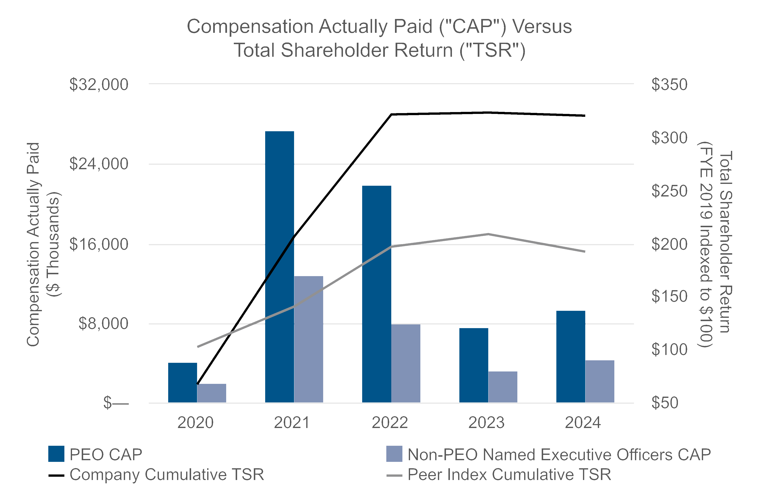
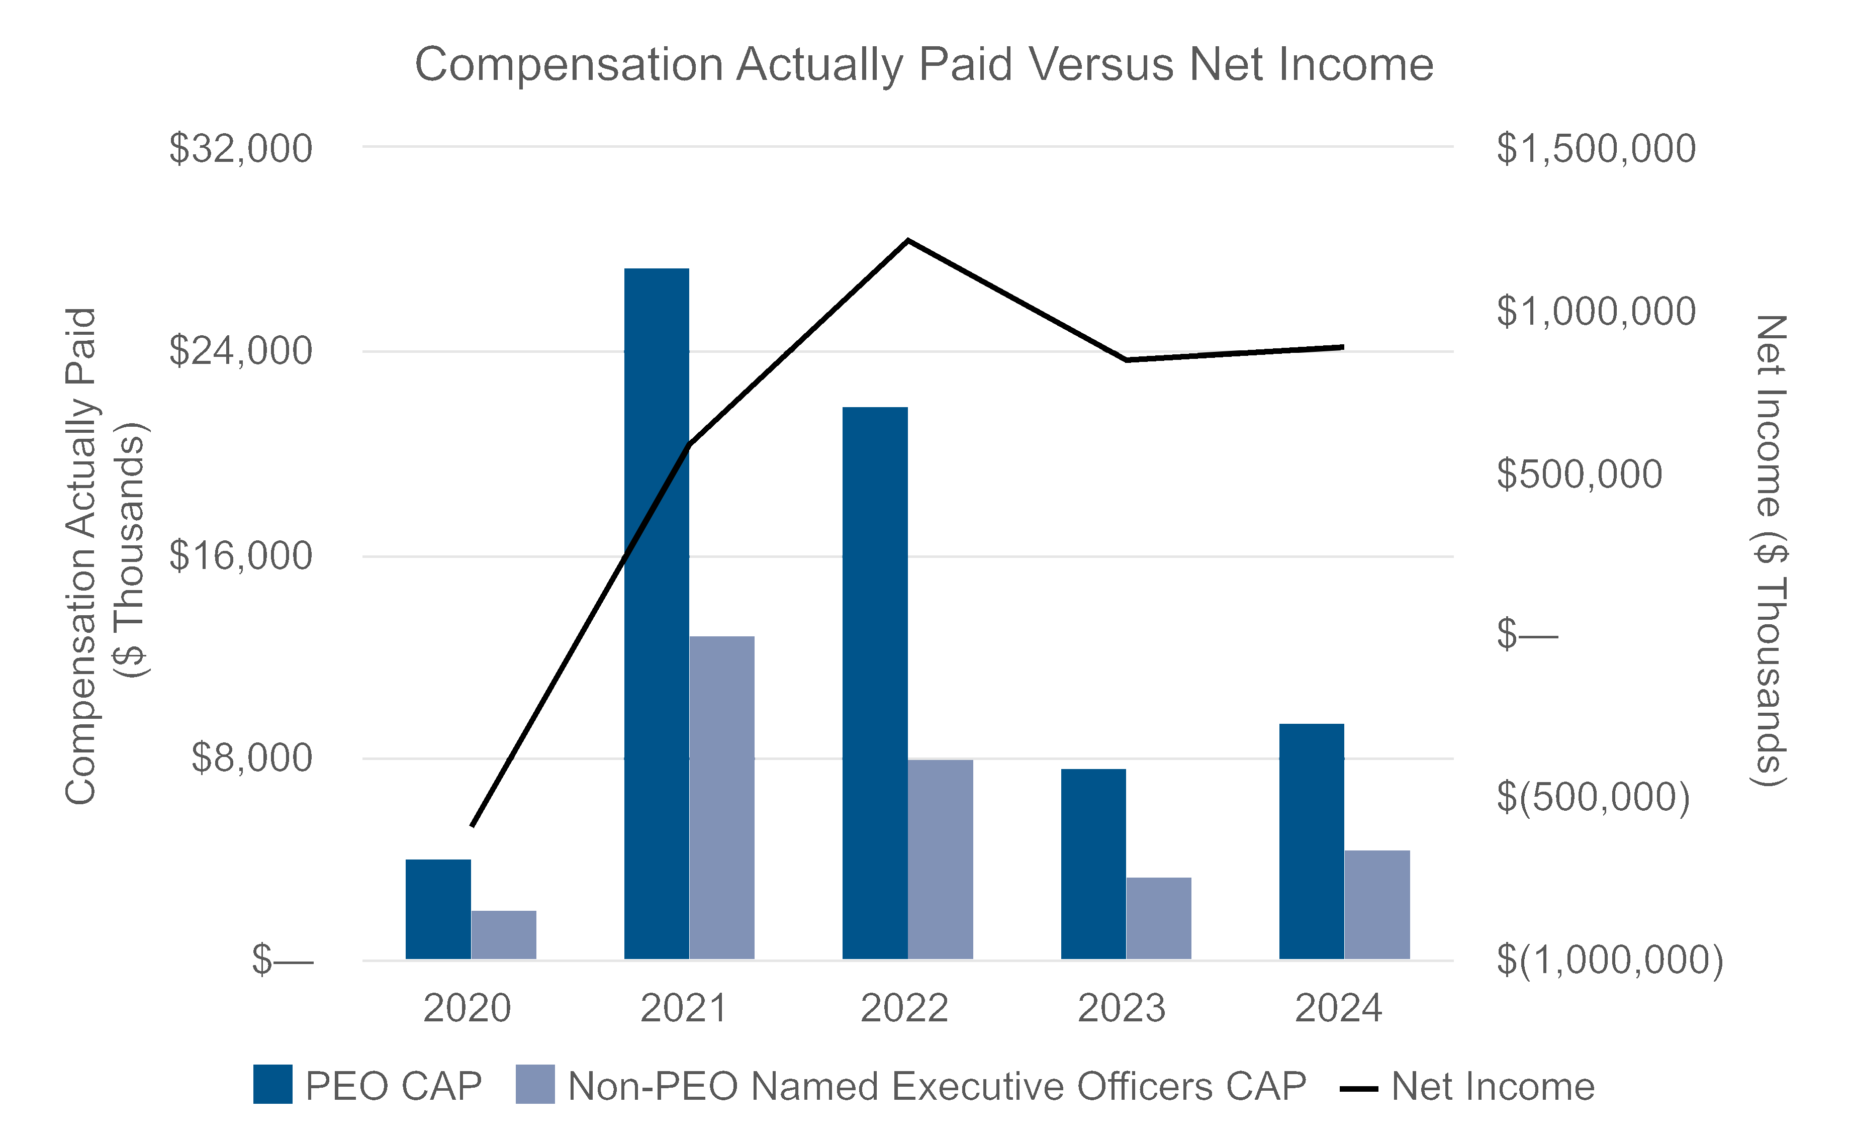
2025 Proxy Statement | Matador Resources Company77
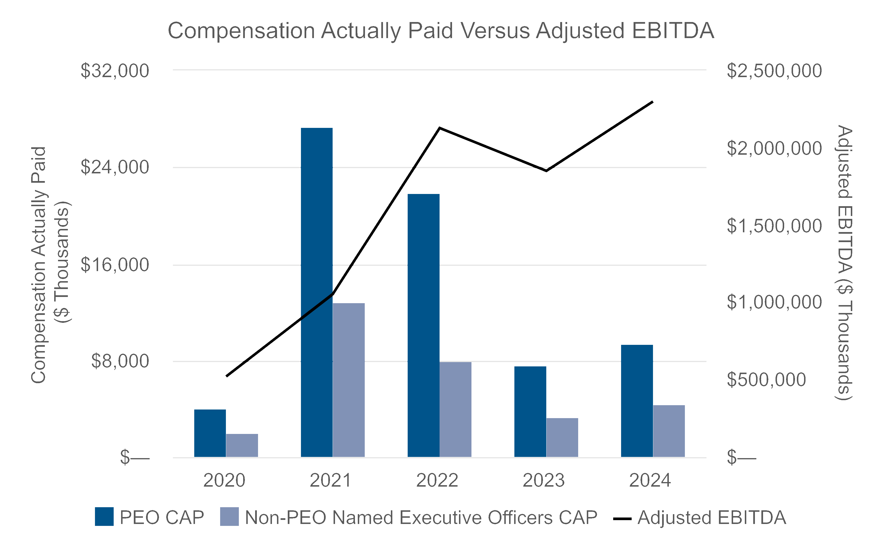
Financial Performance Measures
As described in greater detail under “Executive Compensation—Compensation Discussion and Analysis,” the Company’s
executive compensation program reflects a variable pay-for-performance philosophy. The metrics that the Company uses
for both our long-term and short-term incentive awards are selected based on an objective of incentivizing our Named
Executive Officers to increase the value of our enterprise for our shareholders. The most important financial performance
measures used by the Company to link executive compensation actually paid to the Company’s Named Executive
Officers, for the most recently completed fiscal year, to the Company’s performance are as follows:
1.Total Shareholder Return
2.Adjusted EBITDA
3.Net Debt / Adjusted EBITDA
4.Adjusted Operating Costs per BOE
5.Return on Average Capital Employed
78Matador Resources Company | 2025 Proxy Statement

DIRECTOR COMPENSATION
DIRECTOR COMPENSATION
The following table summarizes the total compensation awarded or paid to non-employee directors during the year
ended December 31, 2024. Mr. Foran did not receive any additional compensation for serving as a director in 2024. His
compensation for his services as our Chairman and Chief Executive Officer is reflected in the Summary Compensation
Table.
Name | Fees Earned or  Paid in Cash | Stock Awards (1) | Total
Shelley F. Appel(2) | $128,750 | $149,979 | $278,729
Reynald A. Baribault | $178,750 | $149,979 | $328,729
R. Gaines Baty(3) | $189,167 | $149,979 | $339,146
William M. Byerley | $128,750 | $149,979 | $278,729
Monika U. Ehrman | $109,583 | $149,979 | $259,562
Julia P. Forrester Rogers | $52,500 | $— | $52,500
James M. Howard | $103,750 | $149,979 | $253,729
Timothy E. Parker(4) | $203,750 | $149,979 | $353,729
Kenneth L. Stewart | $93,333 | $149,979 | $243,312
Susan M. Ward | $89,005 | $149,979 | $238,984
(1)Reflects the grant date fair value of RSUs, calculated in accordance with FASB ASC Topic 718, excluding the effect of any estimated forfeitures.
See Note 9 to the Company’s consolidated financial statements included in its Annual Report on Form 10-K for the year ended December 31,
2024 for additional detail regarding assumptions underlying the value of these awards. RSUs granted for 2024-2025 service vest immediately
prior to the election of the nominees for director at the 2025 Annual Meeting. See “—Compensation for 2024-2025.” As of December 31, 2024,
each individual who served as a director during 2024, other than Ms. Forrester Rogers, held the following outstanding unvested stock awards,
all of which were RSUs. Ms. Forrester Rogers did not hold any unvested RSUs at the end of 2024 as her term as director expired at the 2024
Annual Meeting.
Name | Outstanding Stock Awards
Shelley F. Appel | 2,533
Reynald A. Baribault | 2,533
R. Gaines Baty | 2,533
William M. Byerley | 2,533
Monika U. Ehrman | 2,533
James M. Howard | 2,533
Timothy E. Parker | 2,533
Kenneth L. Stewart | 2,533
Susan M. Ward | 2,533
(2)Ms. Appel serves as ESG coordinator. The ESG coordinator receives an additional cash retainer of $50,000 annually.
(3)Mr. Baty serves as deputy lead independent director. The deputy lead independent director receives an additional cash retainer of $50,000
annually.
(4)Mr. Parker serves as lead independent director. The lead independent director receives an additional cash retainer of $100,000 annually.
Mr. Harvey was appointed to the Board on January 27, 2025 and did not receive any director compensation in 2024.
2025 Proxy Statement | Matador Resources Company79

Compensation for 2024-2025
For the period commencing at the 2024 Annual Meeting and ending at the 2025 Annual Meeting, our non-employee
directors’ compensation program was as set forth below:
•annual cash retainer of $85,000;
•the chair of each of the below committees received the following additional, annual cash retainer:
Committee | Retainer
Operations and Engineering | $50,000
Prospect | $50,000
Audit | $50,000
Strategic Planning and Compensation | $50,000
Environmental, Social and Corporate Governance | $35,000
Nominating | $25,000
Capital Markets and Finance | $25,000
Marketing and Midstream | $25,000
•the lead independent director received an additional cash retainer of $100,000;
•the deputy lead independent director received an additional cash retainer of $50,000;
•the ESG coordinator received an additional cash retainer of $50,000; and
•at the meeting of the Board immediately following the 2024 Annual Meeting, each non-employee director received an
annual grant of RSUs equal to approximately $150,000 in value, which vests on the earlier of the first anniversary of
the 2024 Annual Meeting or immediately prior to the election of the nominees for director at the 2025 Annual Meeting
(the “2024 RSU Award”).
If a director was appointed or elected to the Board at any time following the 2024 Annual Meeting but prior to the 2025
Annual Meeting, such director was granted the applicable percentage of the 2024 RSU Award detailed below, effective on
the date of such director’s appointment: (i) if a director was appointed or elected to the Board within 90 days after the
2024 Annual Meeting, such director was entitled to receive 100% of the 2024 RSU Award; (ii) if a director was appointed
or elected to the Board more than 90 days but 180 or fewer days after the 2024 Annual Meeting, such director was entitled
to receive 75% of the 2024 RSU Award; (iii) if a director was appointed or elected to the Board more than 180 days but
270 or fewer days after the 2024 Annual Meeting, such director was entitled to receive 50% of the 2024 RSU Award and
(iv) if a director was appointed or elected to the Board more than 270 days after the 2024 Annual Meeting but prior to the
2025 Annual Meeting, such director was entitled to receive 25% of the 2024 RSU Award.
Mr. Harvey was appointed to the Board effective January 27, 2025, which date was more than 180 days but fewer than
270 days after the 2024 Annual Meeting. As a result, Mr. Harvey received a grant of 1,267 RSUs in early 2025,
representing 50% of the 2024 RSU Award.
In addition, we reimburse our directors for travel, lodging and related expenses incurred in attending Board and committee
meetings.

Director Stock Ownership Guidelines
Our non-employee directors are expected to follow our voluntary stock ownership guidelines for non-employee directors.
Within three years of becoming a director, each non-employee director is expected to own $350,000 of Common Stock
and continue to hold such shares while serving as a director. As of December 31, 2024, all directors owned or were on
track to own within three years of becoming a director in excess of $350,000 of Common Stock. Shares that count toward
the stock ownership guidelines include RSUs. Until a director reaches the expected stock ownership level, such director
is expected to hold all shares received upon the vesting of RSUs.
80Matador Resources Company | 2025 Proxy Statement

EQUITY COMPENSATION PLAN INFORMATION
The following table presents information with respect to our equity compensation plans as of December 31, 2024:
Committee | Number of Shares to  be Issued Upon  Exercise of  Outstanding Options,  Warrants and Rights  (a)(2) | Weighted- Average  Exercise Price of  Outstanding Options,  Warrants and Rights  (b)(3) | Number of Shares  Remaining Available for  Future Issuance Under  Equity Compensation Plans  (Excluding Shares Reflected  in Column (a))  (c)(4)
Equity compensation plans approved by security holders(1) | 1,090,557 | $14.80 | 7,850,907
Equity compensation plans not approved by security holders | — | — | —
Total | 1,090,557 | $14.80 | 7,850,907
(1)Includes shares authorized under the Matador Resources Company Amended and Restated 2012 Long-Term Incentive Plan (as amended,
the “2012 Plan”), the 2019 Plan and the ESPP.
(2)Reflects the number of PSUs granted under the 2019 Plan based on the maximum level of achievement, which may be more than the
number of shares issued in settlement of PSUs that are ultimately earned.
(3)Reflects the weighted-average exercise price of stock options granted under the 2019 Plan. Restricted stock, phantom units, RSUs and
PSUs are not reflected in this column as they do not have an exercise price.
(4)Includes 3,959,799 shares reserved for future issuance under the 2019 Plan and 3,891,108 shares reserved for future issuance under the
ESPP. No further awards may be granted under the 2012 Plan, although awards remain outstanding thereunder.
2025 Proxy Statement | Matador Resources Company81

TRANSACTIONS WITH RELATED PERSONS
TRANSACTIONS WITH RELATED PERSONS
Except as disclosed below, during 2024, there was not, nor was there proposed as of December 31, 2024, any transaction
or series of similar transactions to which we were or are a party in which the amount involved exceeded or exceeds
$120,000 and in which any of our directors, nominees for directors, executive officers, beneficial owners of more than 5%
of any class of our voting securities or any member of the immediate family of any of the foregoing persons had or will
have a direct or indirect material interest, other than compensation arrangements with directors and executive officers,
which are described in “Executive Compensation— Compensation Discussion and Analysis” and “Director Compensation”
above.
Working Interest and Overriding Royalty Interest Owners
Joseph Wm. Foran, Chairman and Chief Executive Officer, Shelley F. Appel, member of the Board, and certain of their
affiliated entities (collectively, the “Foran Entities”) are working interest owners and/or overriding royalty interest owners in
certain properties operated by the Company. As working interest owners, the Foran Entities are required to pay their
proportionate share of all costs and are entitled to receive their proportionate share of revenues in the normal course of
business. As overriding royalty interest owners, the Foran Entities are entitled to receive their proportionate share of
revenues from the wells in which they own an interest in the normal course of business. During 2024, revenues, net of
costs, received by the Foran Entities in their capacity as working interest owners or overriding royalty interest owners were
approximately $17.2 million (the “Related Net Revenue Payments”). The Related Net Revenue Payments represent less
than 1% of our total third-party net revenue payments during 2024.
In our capacity as operator, we incur drilling and operating costs that are billed to our partners based on their respective
working interests. During 2024, our joint interest billings to the Foran Entities attributable to their share of costs were
approximately $13.7 million (the “Related Joint Interest Billings”). The Related Joint Interest Billings represent less than
1% of our total joint interest billings during 2024. As a result of this ownership by the Foran Entities, from time to time, we
will be in a net receivable or net payable position with certain of the Foran Entities. We do not consider any net
receivables from the Foran Entities to be uncollectible.
The Audit Committee reviewed the terms of the working interests and/or overriding royalty interests of the Foran Entities
for potential conflicts of interest under the Company's Related Person Transaction Policy (the "Related Person
Transaction Policy"), and, after being fully informed as to Mr. Foran’s and Ms. Appel's relationships and interests in such
transactions and all other material facts related to the Related Net Revenue Payments and Related Joint Interest Billings,
determined that such transactions and the Related Net Revenue Payments and Related Joint Interest Billings were fair to
the Company and recommended such transactions and the Related Net Revenue Payments and Related Joint Interest
Billings to the full Board for approval and ratification. The Board subsequently approved and ratified the transactions and
the Related Net Revenue Payments and Related Joint Interest Billings.
Greyhound Joint Venture
The Company has entered into a joint venture, Greyhound, with Spearpoint Resources Company (“Spearpoint”) to
generate value through a well development program in our Twin Lakes asset area. An adult child of Mr. Foran and the
sibling of Ms. Appel is the founder of Spearpoint and serves as the chief executive officer and chairman of the board of
directors of Spearpoint. Mr. Foran’s child has a Bachelor of Arts degree in Economics from Princeton University, a Master
of Science degree in Petroleum Engineering from Texas A&M University and a Master of Business Administration degree
from Rice University. Mr. Foran’s child worked for a major oil and gas company as a petroleum petrophysicist. Prior to
attending Texas A&M, Mr. Foran’s child served in the United States Marine Corp, including two tours of duty overseas, and
has continued to serve in United States Marine Corp Reserve, recently achieving the rank of Major. Mr. Foran’s child may
perform shared services to Greyhound, for which Greyhound would reimburse Spearpoint. In addition, Ms. Appel holds an
ownership interest in Spearpoint.
During 2024, the Company provided approximately $0.65 million of shared services to Greyhound and Spearpoint
provided approximately $0.30 million of shared services to Greyhound. Neither the Company nor Spearpoint made any
82Matador Resources Company | 2025 Proxy Statement
capital contributions or received any distributions from Greyhound in 2024, although such contributions and distributions
may be made or received by the Company and Spearpoint in the future.
The Audit Committee reviewed the terms of the joint venture for potential conflicts of interest under the Related Person
Transaction Policy, and, after being fully informed as to Mr. Foran’s, his adult child’s and Ms. Appel's relationships and
interests in such transactions and all other material facts related to Greyhound, determined that such transactions were
fair to the Company and recommended such transactions to the full Board for approval and ratification. The Board
subsequently approved and ratified the transactions.
Oilfield Equipment Purchase
The son-in-law of Mr. Foran and brother-in-law of Ms. Appel serves as the President of DCiii, LLC (“DC3”). During 2024,
the Company purchased certain oilfield equipment from DC3 for an aggregate amount of approximately $0.42 million (the
“Equipment Purchases”). The Audit Committee reviewed the terms of the Equipment Purchases for potential conflicts of
interest under the Related Person Transaction Policy and, after being fully informed as to Mr. Foran’s, his son-in-law’s and
Ms. Appel’s relationships and interests in such transactions and all other material facts related to the Equipment
Purchases, determined that the Equipment Purchases were fair to the Company and recommended the Equipment
Purchases to the full Board for approval and ratification. The Board subsequently approved and ratified the Equipment
Purchases.
Office Lease Renewal
R. Gaines Baty is a member of the Board. Mr. Baty’s son serves as the Vice Chairman and the Office Tenant
Representation Leader of Cushman & Wakefield’s Dallas-Fort Worth market. During 2024, Mr. Baty’s son provided tenant
representation services to the Company in connection with the Company’s renewal of its office lease for its Dallas, Texas
headquarters (the “Office Lease Renewal”). As a result of his services, Mr. Baty’s son is expected to have been
compensated in excess of $120,000. The Audit Committee reviewed the terms of the Office Lease Renewal for potential
conflicts of interest under the Related Person Transaction Policy and, after being fully informed as to Mr. Baty’s and his
son’s relationships and interests in such transactions and all other material facts related to the Office Lease Renewal,
determined that the Office Lease Renewal was fair to the Company and recommended the Office Lease Renewal to the
full Board for approval and ratification. The Board subsequently approved and ratified the Office Lease Renewal.
Certain Employment Relationships
Billy E. Goodwin served as an executive officer during 2024 until his retirement in April of 2024. During 2024, an adult
child of Mr. Goodwin was an employee of the Company and has been an employee since 2015. In 2024, Mr. Goodwin’s
child was compensated between $120,000 and $750,000. Mr. Goodwin’s child has a Bachelor of Science in Business
Administration degree in Energy Management from the University of Tulsa and a Bachelor of Arts degree in General
Business and Management from Oklahoma State University. He has over 14 years of industry experience, including as a
drilling fluids engineer for a publicly traded oilfield services company and as a landman for a publicly traded exploration
and production company. The Audit Committee reviewed the terms of the employment arrangement for potential conflicts
of interest under the Related Person Transaction Policy and, after being fully informed as to the employment arrangement
and compensation of Mr. Goodwin’s adult child, and all other material facts related to the relationship, determined that the
employment arrangement was fair to the Company and recommended the employment arrangement to the full Board for
approval and ratification. The Board subsequently approved and ratified such employment arrangements.
Reynald A. Baribault is a member of the Board. Mr. Baribault’s sister-in-law has been an employee of the Company since
2016 and was compensated in 2024, and is expected to be compensated in 2025, between $120,000 and $500,000. Mr.
Baribault’s sister-in-law has a diploma from the Executive Secretarial School and is a certified legal assistant, having
completed the Southern Methodist University Legal Assistants Program. She has over 40 years of experience as a legal
assistant. The Audit Committee reviewed the terms of the employment arrangement for potential conflicts of interest under
the Related Person Transaction Policy and, after being fully informed as to the employment arrangement and historical
and anticipated compensation of Mr. Baribault’s sister-in-law, and all other material facts related to the relationship,
determined that the employment arrangement was fair to the Company and recommended the employment arrangement
2025 Proxy Statement | Matador Resources Company83
to the full Board for approval and ratification. The Board subsequently approved and ratified such employment
arrangement.
An adult child of Mr. Foran and a sibling of Ms. Appel has been an employee of the Company since 2015 and was
compensated in 2024, and is expected to be compensated in 2025, between $120,000 and $500,000. Mr. Foran’s child
has a Bachelor of Science degree in Human Resource Development and a Master of Science degree in Human Resource
Management, both from Texas A&M University. She has more than 13 years of industry experience, including with another
publicly traded exploration and production company. The Audit Committee reviewed the terms of the employment
arrangement for potential conflicts of interest under the Related Person Transaction Policy and, after being fully informed
as to the employment arrangement and historical and anticipated compensation of Mr. Foran’s child, and all other material
facts related to the relationship, determined that the employment arrangement was fair to the Company and
recommended the employment arrangement to the full Board for approval and ratification. The Board subsequently
approved and ratified such employment arrangement.
Indemnification Agreements
We have entered into indemnification agreements with each of our directors and executive officers and expect to do so in
the future for any new directors and executive officers. The indemnification agreements provide the directors and
executive officers with contractual rights to indemnification, expense advancement and reimbursement to the fullest extent
permitted by applicable law.
Procedures for Approval of Related Person Transactions
Pursuant to the Related Person Transaction Policy in effect as of December 31, 2024, a “Related Person Transaction” is
defined as a transaction (including any financial transaction, arrangement or relationship (including any indebtedness or
guarantee of indebtedness)), or series of related transactions, or any material amendment to any such transaction, in
which a Related Person (as defined below) has or will have a direct or indirect material interest and in which we are a
participant, other than:
•a transaction involving compensation of directors that is required to be reported in our proxy statement under Item 402
of the SEC’s compensation disclosure requirements (“Item 402”);
•any employment by us of an executive officer if:
◦the related compensation is required to be reported in our proxy statement under Item 402; or
◦the executive officer is not an “immediate family member” of another executive officer or director of the
Company, the related compensation would be reported in our proxy statement under Item 402 if the executive
officer was a “named executive officer” and the Compensation Committee approved (or recommended that
the Board approve) such compensation;
•a transaction with a Related Person involving less than $120,000;
•a transaction in which the interest of the Related Person arises solely from the ownership of a class of our equity
securities and all holders of that class receive the same benefit on a pro rata basis;
•a transaction in which a Related Person has an indirect interest solely as a result of being (a) a director or, together
with all other Related Persons, a less than 10% beneficial owner of an equity interest in another entity, or both, or (b) a
limited partner in a partnership in which the Related Person, together with all other Related Persons, has an interest of
less than 10%;
•a transaction in which the rates or charges involved therein are determined by competitive bids, or a transaction that
involves the rendering of services as a common or contract carrier, or public utility, at rates or charges fixed in
conformity with law or governmental authority;
84Matador Resources Company | 2025 Proxy Statement
•any transaction with another company at which a Related Person’s only relationship is as an employee (other than an
executive officer), if the aggregate amount involved does not exceed the greater of $1,000,000, or 2% of that
company’s total annual revenues;
•any charitable contribution, grant or endowment by us to a charitable organization, foundation or university at which a
Related Person’s only relationship is as an employee (other than an executive officer), if the aggregate amount
involved does not exceed the lesser of $1,000,000, or 2% of the charitable organization’s total annual receipts;
•any transaction with another publicly traded company where the Related Person’s interest arises solely from beneficial
ownership of more than 5% of our Common Stock and ownership of a non-controlling interest in the other publicly
traded company;
•reimbursement of business expenses incurred by a director, officer or employee of the Company in the performance of
his or her duties and approved for reimbursement by the Company in accordance with the Company’s customary
policies and practices; or
•indemnification and advancement of expenses made pursuant to the Certificate of Formation or the Bylaws or
pursuant to any agreement.
“Related Person” means:
•any person who is, or at any time since the beginning of the Company’s last completed fiscal year was, one of our
executive officers or one of our directors or nominees for director;
•any person (including any entity or group) who is known by us to be the beneficial owner of more than 5% of our
Common Stock;
•any immediate family member of any of the foregoing persons, which means any child, stepchild, parent,
stepparent, spouse, sibling, mother-in-law, father-in-law, son-in-law, daughter-in-law, brother-in-law, sister-in-law or
person residing (other than a tenant or employee) in the home of a director, nominee for director, executive officer
or a beneficial owner of more than 5% of our Common Stock; and
•any entity that is owned or controlled by any of the foregoing persons or in which any of the foregoing persons is a
general partner or executive officer or in which such person, together with all other of the foregoing persons, owns
10% or more of the equity interests thereof.
Pursuant to the Related Person Transaction Policy, the Audit Committee must review all material facts of each Related
Person Transaction and recommend either approval or disapproval of the Related Person Transaction to the full Board,
subject to certain limited exceptions. In determining whether to recommend approval or disapproval of the Related Person
Transaction, the Audit Committee must, after reviewing all material facts of the Related Person Transaction and the
Related Person’s relationship and interest, determine whether the Related Person Transaction is fair to the Company and
in, or not consistent with, the interests of the Company and its shareholders. If a Related Person Transaction will be
ongoing, the Audit Committee, on at least an annual basis, will review and assess ongoing relationships with the Related
Persons to see that they are in compliance with Audit Committee guidelines. Further, the policy requires that all Related
Person Transactions be disclosed in our filings with the SEC and/or our website in accordance with applicable laws, rules
and regulations.
2025 Proxy Statement | Matador Resources Company85

SECURITY OWNERSHIP OF CERTAIN BENEFICIAL OWNERS AND
MANAGEMENT
The following table presents the beneficial ownership of our Common Stock as of April 16, 2025 for (i) each person
beneficially owning more than 5% of the outstanding shares of our Common Stock, (ii) each director and nominee for
director of the Company, (iii) each named executive officer of the Company listed in the Summary Compensation Table
and (iv) all of our directors, nominees and executive officers as a group. Except pursuant to applicable community
property laws and except as otherwise indicated, each shareholder possesses sole voting and investment power with
respect to its, his or her shares. The business address of each of our directors and executive officers is c/o Matador
Resources Company, One Lincoln Centre, 5400 LBJ Freeway, Suite 1500, Dallas, Texas 75240. The applicable
percentage ownership is based on 125,201,846 shares of our Common Stock issued and outstanding as of April 16, 2025,
plus, on an individual basis, the right of that individual to (i) obtain Common Stock upon exercise of stock options or (ii)
obtain Common Stock upon the vesting or delivery of RSUs, in each case within 60 days of April 16, 2025. The
information is based on Form 3s, Form 4s, Form 5s, Schedule 13Ds, Schedule 13Gs and Schedule 13G/As filed through
April 16, 2025.
Name | Amount and Nature of  Ownership of Common Stock | Percent of Class
Directors, Nominees and Named Executive Officers
Joseph Wm. Foran(1) | 5,403,411 | 4.3%
Shelley F. Appel(2) | 1,735,698 | 1.4%
Reynald A. Baribault(3) | 141,246 | *
R. Gaines Baty(4) | 68,317 | *
William M. Byerley(5) | 51,732 | *
Monika U. Ehrman(6) | 36,567 | *
Bryan A. Erman(7) | 82,385 | *
Paul W. Harvey(8) | 39,717 | *
James M. Howard(9) | 125,368 | *
G. Gregg Krug | 225,910 | *
Timothy E. Parker(10) | 83,790 | *
Van H. Singleton, II(11) | 292,640 | *
Kenneth L. Stewart(12) | 86,426 | *
Susan M. Ward(13) | 5,844 | *
Brian J. Willey(14) | 97,861 | *
All Directors, Nominees and Executive Officers as a Group (19 persons)(15) | 7,269,330 | 5.8%
Other 5% Owners
The Vanguard Group(16) | 12,498,860 | 10.0%
BlackRock, Inc.(17) | 10,511,588 | 8.4%
*Less than one percent (1%)
(1)Includes (i) 1,105,913 shares of Common Stock held of record by Sage Resources, Ltd., a limited partnership owned by the Foran family,
including Mr. Foran; (ii) 1,137,182 shares of Common Stock held of record, collectively, by the LRF 2011 Non-GST Trust, WJF 2011 Non-GST
Trust, JNF 2011 Non-GST Trust, SIF 2011 Non-GST Trust and MCF 2011 Non-GST Trust (collectively, the “2011 Non-GST Trusts”), for which
trusts Mr. Foran and his spouse, as settlors of each of the 2011 Non-GST Trusts, retain the power of substitution with respect to the property of
the 2011 Non-GST Trusts; (iii) 36,885 shares of Common Stock held of record by each of the JWF 2023-2 GRAT and the NNF 2023-2 GRAT, for
which Mr. Foran is the trustee and over which Mr. Foran has sole voting and investment power; (iv) 109,221 shares of Common Stock held of
record by each of the JWF 2024-1 GRAT and the NNF 2024-1 GRAT, for which Mr. Foran is the trustee and over which Mr. Foran has sole voting
and investment power; (v) 90,247 shares of Common Stock held of record by each of the JWF 2024-2 GRAT and the NNF 2024-2 GRAT, for
which Mr. Foran is the trustee and over which Mr. Foran has sole voting and investment power; (vi) 453,413 shares of Common Stock held of
record by the Foran 2012 Security Trust, for which Mr. Foran is the trustee and over which Mr. Foran has sole voting and investment power; (vii)
488,997 shares of Common Stock held of record by the Foran 2012 Savings Trust, for which Mr. Foran’s spouse is a trustee; (viii) 175,766
shares of Common Stock held of record by each of the JWF 2025-1 GRAT and the NNF 2025-1 GRAT, for which Mr. Foran is the trustee and
over which Mr. Foran has sole voting and investment power; and (ix) 1,347,912 shares of Common Stock held of record, collectively, by the LRF
2020 Non-GST Trust, WJF 2020 Non-GST Trust, SIF 2020 Non-GST Trust and MCF 2020 Non-GST Trust (collectively, the “2020 Non-GST
Trusts”), for which trusts Mr. Foran and his spouse, as settlors of each of the 2020 Non-GST Trusts, retain the power of substitution with respect
to the property of the 2020 Non-GST Trusts.
86Matador Resources Company | 2025 Proxy Statement
(2)Includes (i) 1,105,913 shares of Common Stock held of record by Sage Resources, Ltd., a limited partnership owned by the Foran family,
including Ms. Appel; (ii) 227,416 shares of Common Stock held of record by the SIF 2011 Non-GST Trust; (iii) 336,978 shares of Common Stock
held of record by the SIF 2020 Non-GST Trust; (iv) 4,742 shares of Common Stock held of record by the Individual Retirement Account of Ms.
Appel; (v) 2,150 shares of Common Stock held of record by the 401(k) account of Ms. Appel; (vi) 58 shares of Common Stock held of record by
the Health Savings Account of Ms. Appel’s spouse; and (vii) 2,533 shares of Common Stock issuable to Ms. Appel upon the vesting of RSUs.
(3)Includes 6,515 shares of Common Stock held of record by the Individual Retirement Account of Mr. Baribault. Also includes 116,118 shares of
Common Stock held of record by the Reynald A. Baribault Maritalized Revocable Living Trust and 7,818 shares of Common Stock held of record
by the Sally K. Baribault Maritalized Revocable Living Trust, for which trusts both Mr. Baribault and his spouse are trustees and share voting and
investment power. Also includes 10,795 shares of Common Stock issuable to Mr. Baribault upon the vesting and delivery of RSUs
(4)Includes 19,499 shares of Common Stock issuable to Mr. Baty upon the vesting and delivery of RSUs.
(5)Includes 27,894 shares of Common Stock issuable to Mr. Byerley upon the vesting and delivery of RSUs.
(6)Includes 2,533 shares of Common Stock issuable to Ms. Ehrman upon the vesting of RSUs.
(7)Includes 3,750 shares of Common Stock held of record by the 401(k) account of Mr. Erman and 2,400 shares of Common Stock held of record
by the Individual Retirement Account of Mr. Erman. Also includes 2,667 shares of restricted stock. Pursuant to the terms of Mr. Erman's restricted
stock grants, Mr. Erman has the right to vote such shares but may only dispose of such shares to the extent they have vested.
(8)Includes 8,500 shares of Common Stock held of record by the Individual Retirement Account of Mr. Harvey, 3,000 shares of Common Stock held
of record by Wilson Peak Limo, LLC, a limited liability company owned by Mr. Harvey and his spouse and over which Mr. Harvey and his spouse
share voting and investment authority, and 300 shares of Common Stock held of record by Mr. Harvey's son. Also includes 1,267 shares of
Common Stock issuable to Mr. Harvey upon the vesting of RSUs.
(9)Includes 50,000 shares of Common Stock held of record by the Individual Retirement Account of Mr. Howard and 50,000 shares of Common
Stock held by PBH Family Partners, Ltd., a family limited partnership owned by Mr. Howard’s family, including Mr. Howard, and over which Mr.
Howard and his spouse share voting and investment authority. Also includes 15,368 shares of Common Stock issuable to Mr. Howard upon the
vesting and delivery of RSUs. Mr. Howard's term as a director will expire at the 2025 Annual Meeting.
(10)Includes 2,533 shares of Common Stock issuable to Mr. Parker upon the vesting of RSUs.
(11)Includes 2,505 shares of Common Stock held of record by the 401(k) account of Mr. Singleton.
(12)Includes 15,065 shares of Common Stock issuable to Mr. Stewart upon the vesting and delivery of RSUs.
(13)Includes 2,533 shares of Common Stock issuable to Ms. Ward upon the vesting and delivery of RSUs.
(14)Includes 3,760 shares of Common Stock held of record by the Individual Retirement Account of Mr. Willey and 2,950 shares of Common Stock
held of record by the 401(k) account of Mr. Willey. Also includes 2,667 shares of restricted stock. Pursuant to the terms of Mr. Willey's restricted
stock grants, Mr. Willey has the right to vote such shares but may only dispose of such shares to the extent they have vested.
(15)Includes 36,003 shares of restricted stock held by our executive officers. Pursuant to the terms of such restricted stock grants, the executive
officers have the right to vote such shares but may only dispose of such shares to the extent they have vested. Also includes 100,020 shares of
Common Stock issuable to directors upon the vesting and delivery of RSUs.
(16)Information based solely on a Schedule 13G/A filed with the SEC on November 7, 2024. The Schedule 13G/A reports that The Vanguard Group
(“Vanguard”) beneficially owns 12,498,860 shares of Common Stock, has shared voting power with respect to 61,152 shares of Common Stock,
has sole dispositive power with respect to 12,315,512 shares of Common Stock and has shared dispositive power with respect to 183,348 shares
of Common Stock. According to the Schedule 13G/A, Vanguard’s address is 100 Vanguard Blvd, Malvern, PA 19355.
(17)Information based solely on a Schedule 13G/A filed with the SEC on November 12, 2024. The Schedule 13G/A reports that BlackRock, Inc.
(“BlackRock”) beneficially owns 10,511,588 shares of Common Stock, has sole voting power with respect to 10,236,625 shares of Common
Stock and has sole dispositive power with respect to 10,511,588 shares of Common Stock. According to the Schedule 13G/A, BlackRock’s
address is 50 Hudson Yards, New York, NY 10001.
2025 Proxy Statement | Matador Resources Company87

ADDITIONAL INFORMATION

Shareholder Proposals for the 2026 Proxy Statement
For shareholder proposals to be included in the Company’s proxy statement and form of proxy relating to the 2026 Annual
Meeting, such proposals must be received by the Company at its offices in Dallas, Texas, addressed to the Corporate
Secretary of the Company, no later than December 29, 2025. If the Company changes the date of the 2026 Annual
Meeting by more than 30 days from the anniversary of the 2025 Annual Meeting, shareholder proposals must be received
a reasonable time before the Company begins to print and mail the proxy materials for the 2026 Annual Meeting in order
to be considered for inclusion in the Company’s proxy statement. Upon timely receipt of any such proposal, the Company
will determine whether or not to include such proposal in the proxy statement and proxy in accordance with applicable
regulations and provisions governing the solicitation of proxies. In addition, to comply with the universal proxy rules,
shareholders who intend to solicit proxies in support of director nominees other than the Company’s nominees must
provide notice to the Company that sets forth the information required by Rule 14a-19 under the Exchange Act, no later
than April 13, 2026.

Director Nominations or Other Business for Presentation at the 2026 Annual Meeting
Alternatively, shareholders intending to place in nomination persons for election as directors at an annual meeting of
shareholders or to introduce an item of business at an annual meeting of shareholders without having the nomination or
proposal included in the Company’s proxy statement must comply with certain procedures set forth in the Bylaws. These
procedures provide, generally, among other things, that shareholders desiring to place in nomination persons for election
as directors, and/or bring a proper subject of business before an annual meeting, must do so by a written notice timely
received (on or before March 14, 2026, but no earlier than February 12, 2026, for the 2026 Annual Meeting) to the
Corporate Secretary of the Company containing the name and address of the shareholder and the number of shares of
the Company’s Common Stock beneficially owned by the shareholder. If the notice relates to a nomination for director, it
must also set forth the name, age, business and residence addresses of the candidate, the candidate’s résumé or a listing
of his or her qualifications to be a director of the Company, the person’s written consent to be a director if selected by the
Nominating Committee, nominated by the Board and elected by the shareholders and any other information that would be
required to be disclosed in solicitations of proxies for the election of directors. The Company may require any proposed
nominee to furnish such other information as may reasonably be required by the Company to determine the eligibility of
such proposed nominee to serve as director. Notice of an item of business shall include a brief description of the proposed
business and any material interest of the shareholder in such business.
The Chairman of the meeting may refuse to allow the transaction of any business not presented, or to acknowledge the
nomination of any person not made, in compliance with the foregoing procedures. Copies of the Bylaws are available from
the Corporate Secretary of the Company and on the Company’s website at www.matadorresources.com under the
heading “Investor Relations—Corporate Governance.”
See “Corporate Governance—Board Committees—Nominating Committee” for the process for shareholders to follow to
suggest a director candidate to the Nominating Committee for nomination by the Board.

Annual Report on Form 10-K
The Company’s Annual Report on Form 10-K for the fiscal year ended December 31, 2024, as filed with the SEC,
including financial statements, is being made available to our shareholders concurrently with this Proxy Statement at
www.proxyvote.com and does not form part of the proxy solicitation material. Shareholders may obtain without charge
another copy of the Annual Report on Form 10-K, excluding certain exhibits, by writing to Investor Relations, Matador
Resources Company, One Lincoln Centre, 5400 LBJ Freeway, Suite 1500, Dallas, Texas 75240.
88Matador Resources Company | 2025 Proxy Statement

OTHER BUSINESS
Management of the Company is not aware of other business to be presented for action at the Annual Meeting; however, if
other matters are presented for action, it is the intention of the persons named in the accompanying form of proxy to vote
in accordance with their judgment on such matters.
By Order of the Board of Directors,
Joseph Wm. Foran
Chairman and Chief Executive Officer
April 28, 2025
2025 Proxy Statement | Matador Resources Company89

ANNEX A
ANNEX A
Non-GAAP Financial Measures
Adjusted EBITDA
We define, on a consolidated basis and for San Mateo, Adjusted EBITDA as earnings before interest expense,
income taxes, depletion, depreciation and amortization, accretion of asset retirement obligations, property
impairments, unrealized derivative gains and losses, non-recurring transaction costs for certain acquisitions, certain
other non-cash items and non-cash stock-based compensation expense and net gain or loss on asset sales and
impairment. Adjusted EBITDA is not a measure of net income (loss) or net cash provided by operating activities as
determined by GAAP. Adjusted EBITDA is a supplemental non-GAAP financial measure that is used by
management and external users of our consolidated financial statements, such as industry analysts, investors,
lenders and rating agencies. “GAAP” means generally accepted accounting principles in the United States of
America. All references to Matador’s Adjusted EBITDA are those values attributable to Matador Resources
Company shareholders after giving effect to Adjusted EBITDA attributable to third-party non-controlling interests,
including in San Mateo.
Management believes Adjusted EBITDA is necessary because it allows us to evaluate our operating performance
and compare the results of operations from period to period without regard to our financing methods or capital
structure. We exclude the items listed above from net income (loss) in calculating Adjusted EBITDA because these
amounts can vary substantially from company to company within our industry depending upon accounting methods
and book values of assets, capital structures and the method by which certain assets were acquired.
Adjusted EBITDA should not be considered an alternative to, or more meaningful than, net income (loss) or net cash
provided by operating activities as determined in accordance with GAAP or as an indicator of our operating
performance or liquidity. Certain items excluded from Adjusted EBITDA are significant components of understanding
and assessing a company’s financial performance, such as a company’s cost of capital and tax structure. Our
Adjusted EBITDA may not be comparable to similarly titled measures of another company because all companies
may not calculate Adjusted EBITDA in the same manner.
The following table presents our calculation of Adjusted EBITDA and the reconciliation of Adjusted EBITDA to the
GAAP financial measures of net income and net cash provided by operating activities, respectively:
90Matador Resources Company | 2025 Proxy Statement
Adjusted EBITDA—Matador Resources Company
 | Year Ended
 | December 31, 2024
(In Thousands)
Unaudited Adjusted EBITDA Reconciliation to Net Income:
Net income attributable to Matador Resources Company shareholders | $885,322
Net income attributable to non-controlling interest in subsidiaries | 86,021
Net income | 971,343
Interest expense | 171,687
Total income tax provision | 292,364
Depletion, depreciation and amortization | 974,300
Accretion of asset retirement obligations | 6,027
Unrealized gain on derivatives | (13,299)
Non-cash stock-based compensation expense | 14,982
Expense related to contingent consideration and other | 5,420
Consolidated Adjusted EBITDA | 2,422,824
Adjusted EBITDA attributable to non-controlling interest in subsidiaries | (124,047)
Adjusted EBITDA attributable to Matador Resources Company shareholders | $2,298,777
 | Year Ended
 | December 31, 2024
(In Thousands)
Unaudited Adjusted EBITDA Reconciliation to Net Cash Provided by Operating Activities:
Net cash provided by operating activities | $2,246,885
Net change in operating assets and liabilities | (13,080)
Interest expense, net of non-cash portion | 155,154
Current income tax provision | 27,059
Other non-cash and non-recurring expense | 6,806
Adjusted EBITDA attributable to non-controlling interest in subsidiaries | (124,047)
Adjusted EBITDA attributable to Matador Resources Company shareholders | $2,298,777
Adjusted EBITDA - San Mateo (100%)
 | Year Ended
 | December 31, 2024
(In Thousands)
Unaudited Adjusted EBITDA Reconciliation to Net Income:
Net income | $175,557
Depletion, depreciation and amortization | 37,667
Interest expense | 37,368
Accretion of asset retirement obligations | 405
Non-recurring expense | 2,160
Adjusted EBITDA | $253,157
2025 Proxy Statement | Matador Resources Company91
 | Year Ended
 | December 31, 2024
(In Thousands)
Unaudited Adjusted EBITDA Reconciliation to Net Cash Provided by Operating Activities:
Net cash provided by operating activities | $193,030
Net change in operating assets and liabilities | 21,825
Interest expense, net of non-cash portion | 36,142
Non-recurring expense | 2,160
Adjusted EBITDA | $253,157
ANNEX
Adjusted Free Cash Flow
Adjusted free cash flow is a supplemental non-GAAP financial measure that is defined, on a consolidated basis for
the Company, as net cash provided by operating activities, adjusted for changes in working capital and cash
performance incentives that are not included as operating cash flows, less cash flows used for capital expenditures,
adjusted for changes in capital accruals. On a consolidated basis, these numbers are also adjusted for the cash
flows related to non-controlling interest in subsidiaries that represent cash flows not attributable to Matador
shareholders. Adjusted free cash flow should not be considered an alternative to, or more meaningful than, net cash
provided by operating activities as determined in accordance with GAAP or an indicator of the Company’s liquidity.
Adjusted free cash flow is used by the Company, securities analysts and investors as an indicator of the Company’s
ability to manage its operating cash flow, internally fund its D/C/E capital expenditures, pay dividends and service or
incur additional debt, without regard to the timing of settlement of either operating assets and liabilities or accounts
payable related to capital expenditures. Additionally, this non-GAAP financial measure may be different than similar
measures used by other companies. The Company believes the presentation of adjusted free cash flow provides
useful information to investors, as it provides them an additional relevant comparison of the Company’s
performance, sources and uses of capital associated with its operations across periods and to the performance of
the Company’s peers. In addition, this non-GAAP financial measure reflects adjustments for items of cash flows that
are often excluded by securities analysts and other users of the Company’s financial statements in evaluating the
Company’s cash spend.
The table below reconciles adjusted free cash flow to its most directly comparable GAAP measure of net cash
provided by operating activities. All references to Matador’s adjusted free cash flow are those values attributable to
Matador shareholders after giving effect to adjusted free cash flow attributable to third-party non-controlling interests,
including in San Mateo.
Adjusted Free Cash Flow—Matador Resources Company
 | Year Ended
 | December 31, 2024
(In Thousands)
Net cash provided by operating activities | $2,246,885
Net change in operating assets and liabilities | (13,080)
San Mateo discretionary cash flow attributable to non-controlling interest in subsidiaries(1) | (105,279)
Proceeds from contribution of Pronto to San Mateo | 219,760
Performance incentives received from Five Point | 23,800
Total discretionary cash flow | $2,372,086
Drilling, completion and equipping capital expenditures | 1,222,831
Midstream capital expenditures | 283,881
Expenditures for other property and equipment | 5,691
Net change in capital accruals | 81,902
San Mateo accrual-based capital expenditures related to non-controlling interest in subsidiaries(2) | (29,475)
Total accrual-based capital expenditures(3) | 1,564,830
Adjusted free cash flow | $807,256
(1) Represents Five Point’s 49% interest in San Mateo discretionary cash flow.
(2) Represents Five Point’s 49% interest in accrual-based San Mateo capital expenditures.
92Matador Resources Company | 2025 Proxy Statement
(3) Represents drilling, completion and equipping costs, Matador’s share of San Mateo capital expenditures plus 100% of other midstream
capital expenditures not associated with San Mateo. Pronto was wholly-owned by Matador until December 18, 2024, the date Pronto
was contributed to San Mateo in the Pronto Transaction.

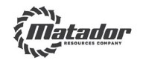  MATADOR RESOURCES COMPANY  5400 LBJ FREEWAY, SUITE 1500  DALLAS, TEXAS 75240 |   VOTE BY INTERNET - www.proxyvote.com or scan the QR Barcode above  Use the Internet to transmit your voting instructions and for electronic delivery of  information up until 11:59 p.m. Eastern Time the day before the meeting date.  Have your proxy card in hand when you access the web site and follow the  instructions to obtain your records and to create an electronic voting instruction  form.  ELECTRONIC DELIVERY OF FUTURE PROXY MATERIALS  If you would like to reduce the costs incurred by our company in mailing proxy  materials, you can consent to receiving all future proxy statements, proxy cards  and annual reports electronically via e-mail or the Internet. To sign up for electronic  delivery, please follow the instructions above to vote using the Internet and, when  prompted, indicate that you agree to receive or access proxy materials  electronically in future years.  VOTE BY PHONE - 1-800-690-6093  Use any touch-tone telephone to transmit your voting instructions up until  11:59 p.m. Eastern Time the day before the meeting date. Have your proxy card in  hand when you call and then follow the instructions.  VOTE BY MAIL  Mark, sign and date your proxy card and return it in the postage-paid envelope we  have provided or return it to Vote Processing, c/o Broadridge,  51 Mercedes Way, Edgewood, NY 11717.
TO VOTE, MARK BLOCKS BELOW IN BLUE OR BLACK INK AS FOLLOWS:
V34260-P07962 |  |  | KEEP THIS PORTION FOR YOUR RECORDS
THIS PROXY CARD IS VALID ONLY WHEN SIGNED AND DATED. |  |  | DETACH AND RETURN THIS PORTION ONLY
MATADOR RESOURCES COMPANY
 | The Board of Directors recommends you vote FOR the following:
 | 1. | Election of Director Nominees: |  |  | For | Against | Abstain
 |  | 1a. | Shelley F. Appel |  | o | o | o
 |  | 1b. | R. Gaines Baty |  | o | o | o
 |  | 1c. | Paul W. Harvey |  | o | o | o
 |  | 1d. | Susan M. Ward |  | o | o | o
 | The Board of Directors recommends you vote FOR  the following proposal: |  |  |  | For | Against | Abstain
 |  | 2. | Advisory vote to approve the compensation of  the Company's named executive officers |  | o | o | o
 | The Board of Directors recommends you  vote FOR the following proposal: |  |  |  | For | Against | Abstain |  | NOTE: The proxies are authorized to vote in their discretion on such  other business as may properly come before the meeting or any  adjournment thereof.
 |  | 3. | Ratification of the appointment of  KPMG LLP as the Company's  independent registered public  accounting firm for the year ending  December 31, 2025 |  | o | o | o
 |  |  |  |  |  | Yes | No
 | Please indicate if you plan to attend this meeting: |  |  |  |  | o | o
Please sign as your name(s) appear(s) hereon. When signing as attorney, executor, administrator, or other fiduciary, please give full
title as such. Joint owners should each sign personally. All holders must sign. If a corporation or partnership, please sign in full
corporate or partnership name by authorized officer.
 | Signature [PLEASE SIGN WITHIN BOX] |  |  |  |  | Date |  |  | Signature (Joint Owners) |  |  | Date
Important Notice Regarding the Availability of Proxy Materials for the Annual Meeting:
The Annual Report for the year ended December 31, 2024, Notice of Annual Meeting and Proxy Statement are
available at www.proxyvote.com
V34261-P07962
MATADOR RESOURCES COMPANY
Annual Meeting of Shareholders
June 12, 2025 9:30 A.M.
This proxy is solicited by the Board of Directors
As an alternative to completing this form, you may enter your vote instruction by telephone at 1-800-690-6093 or via the
internet at www.proxyvote.com. Have your proxy card in hand and follow the instructions.
The shareholder hereby appoints Joseph Wm. Foran and Timothy E. Parker, or either of them, as proxies, each with the
power to appoint his substitute, and hereby authorizes them to represent and to vote, as designated on the reverse side of
this ballot, all of the shares of common stock of MATADOR RESOURCES COMPANY that the shareholder is entitled to vote
at the Annual Meeting of Shareholders to be held at 9:30 A.M. CDT on June 12, 2025, at The Westin Galleria Dallas, Fort
Worth Ballroom, 13340 Dallas Parkway, Dallas, Texas 75240, and any adjournment or postponement thereof. The
shareholder hereby revokes any proxy or proxies heretofore given to vote upon or act with respect to such shares of stock.
This proxy, when properly executed, will be voted in the manner directed herein. If no such direction is made, this
proxy will be voted in accordance with the Board of Directors' recommendations.
Continued and to be signed on reverse side

